Name

Mathematics Advanced Year 11
Graph Transformations

Book 1 | Graph Transformations | Version: 260811  Feedback:  https://MrDingMaths.com
Contents
Syllabus Content 2
Translations 3
Reflections 15
Dilations 24
Mixed Practice 36
Combining Transformations 45
Exam Questions 59

Syllabus Content
MAV-11-03 analyses and solves algebraic and graphical problems involving transformations of functions and relations
- Establish using graphing applications that replacing $x$ by $-x$ in the equation of a graph corresponds to the reflection of the graph in the $y$-axis, and that replacing $y$ by $-y$ corresponds to a reflection in the $x$-axis
- Establish using graphing applications that replacing $x$ by $x-a$ in the equation of a graph corresponds to a horizontal translation of a graph by $a$, that replacing $y$ by $y-b$ corresponds to a vertical translation by $b$, and recognise that the sign of $a$ and $b$ determines the direction of the translation
- Describe a horizontal dilation as a stretch from the $y$-axis and a vertical dilation as a stretch from the $x$-axis
- Establish using graphing applications that replacing $x$ by $\frac{x}{k}$ in the equation of a graph corresponds to a horizontal dilation of a graph by a factor of $k$, that replacing $y$ by $\frac{y}{l}$ corresponds to a vertical dilation by a factor of $l$, and determine the effects on the graph when the magnitude of the dilation factor lies between 0 and 1
- Establish, using graphing applications, replacing $x$ by $\frac{x}{k}$ and replacing $y$ by $\frac{y}{k}$ in the equation of a graph corresponds to a dilation by a factor of $k$, that is, an enlargement of the graph when $k>1$ and a reduction of the graph when $0<k<1$
- Apply reflections, translations and dilations to functions within the scope of the Mathematics Advanced course, excluding trigonometric functions, determine the function rule and the graph of the transformed function, the domain and range of the transformed graph, any intercepts, asymptotes and discontinuities where appropriate, and describe which transformations have been applied
- Use the principles of translations to identify the centre, radius, domain and range of graphs of circles in the form ${(x-a)}^{2}+{(y-b)}^{2}=r^{2}$, where $a$, $b$ and $r$ are constants
- Find the centre and radius of circles of the form $x^{2}+y^{2}+ax+by+c=0$, where $a$, $b$ and $c$ are constants, by completing the squares
- Graph circles given their equations and find the equation of a circle from its graph
- Recognise that the order in which individual transformations are applied to functions is important

Translations

- Translations
A translation shifts, or slides, an object left, right, up, down, or a combination (diagonal).
The general size and shape of the object does not change.

We will investigate translations of curves.

- Investigation Replacing $x$ with $x-b$
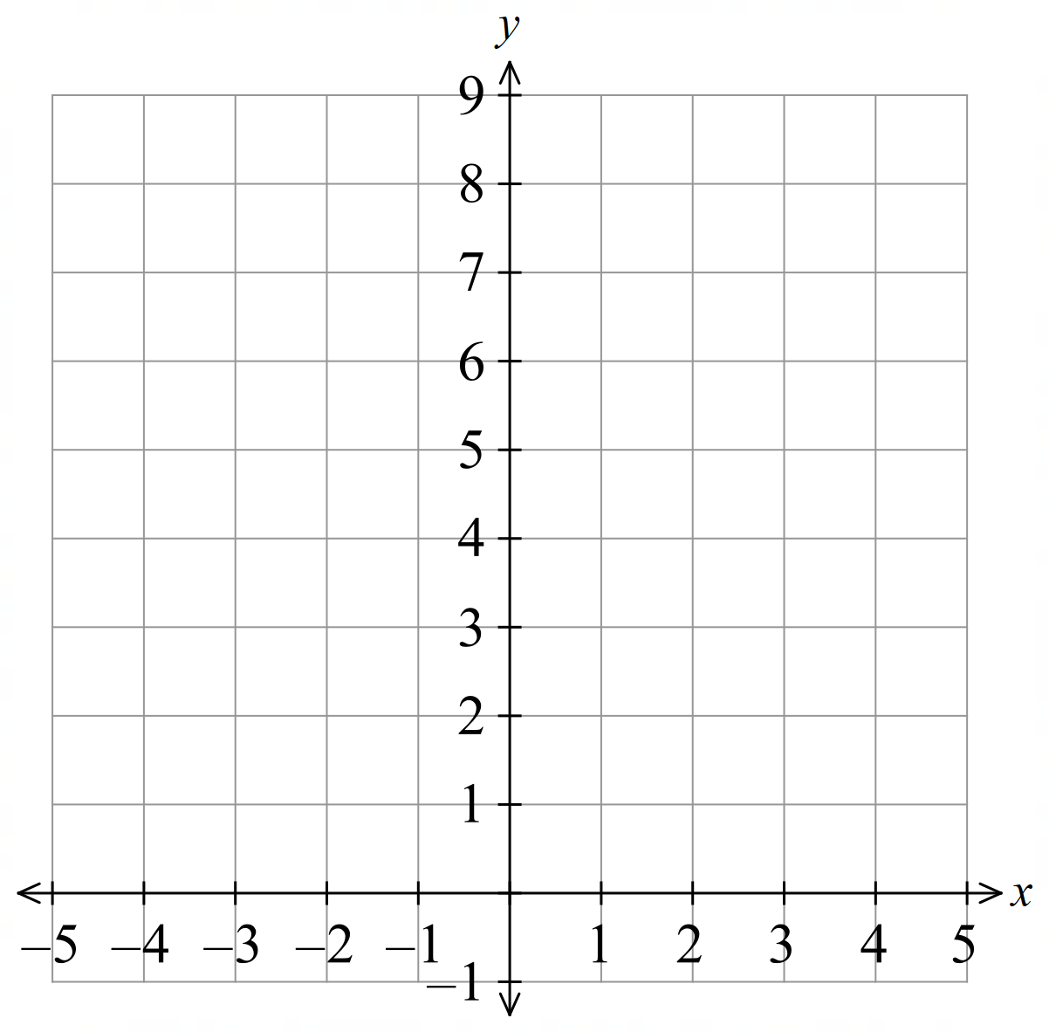
Complete the table of values for $y=x^{2}$and $y={\left(x-1\right)}^{2},$ then sketch the graphs.

$x$ | $$-3$$ | $$-2$$ | $$-1$$ | $$0$$ | $$1$$ | $$2$$ | $$3$$
$$y=x^{2}$$
$$y={\left(x-1\right)}^{2}$$

The graph of $y={\left(x-1\right)}^{2}$ is the graph of $y=x^{2}$ shifted 1 unit to the …………
This seems backwards, in that we subtract 1 but the graph gets moved …………

Instead, we should think of replacing $x$ with $x-1$.
To produce the same output as $x^{2}$, the input must be 1 unit larger, therefore, 1 unit right.

From now on, we will always consider transformations as replacements of $x$ or $y$.

- Horizontal Translations
Let $b$ be a positive number.
To translate $b$ units right: $x↦\left(x-b\right)$  $$y=f\left(x-b\right)$$  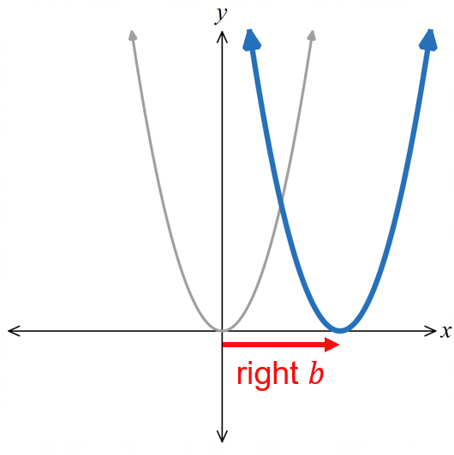 | To translate $b$ units left: $x↦\left(x+b\right)$  $$y=f\left(x+b\right)$$  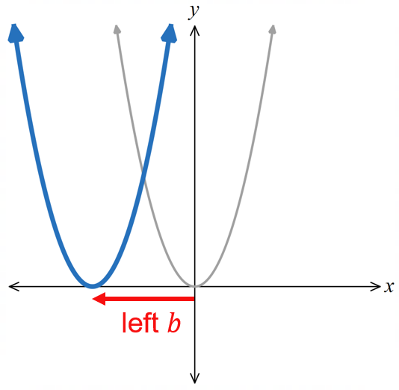

- Interpret Horizontal translations
$y=f\left(x\right)$ is given. Sketch:
- $y=f\left(x-1\right)$ | - $y=f\left(x+3\right)$ | - $y=f\left(x+3\right)$  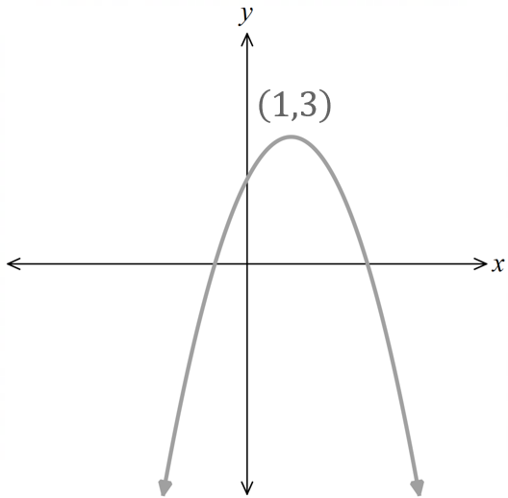  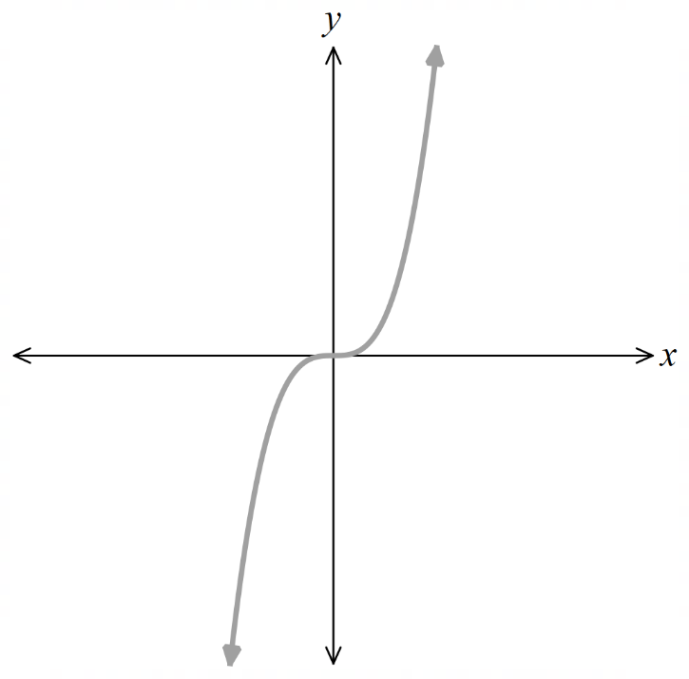  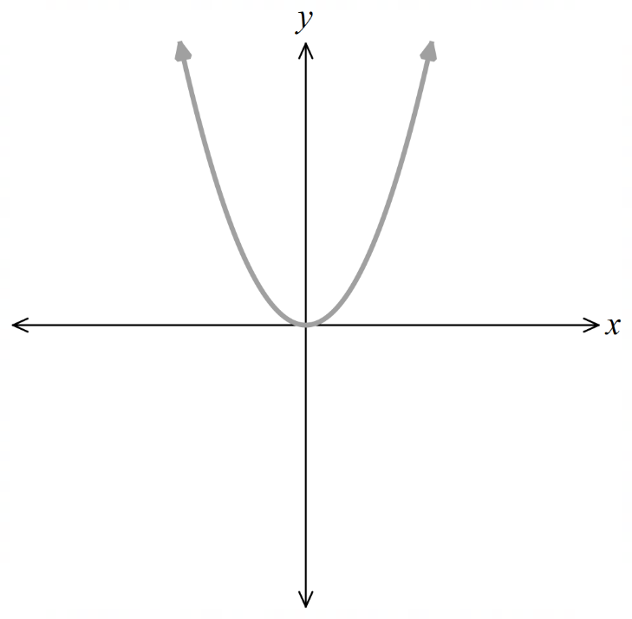
$y=f\left(x\right)$ and its transformation is shown, identify the new function in function notation.
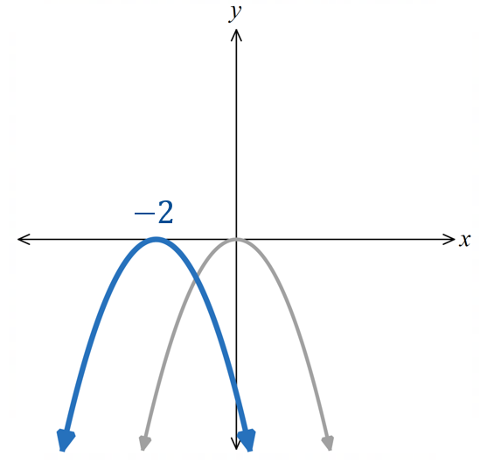 | 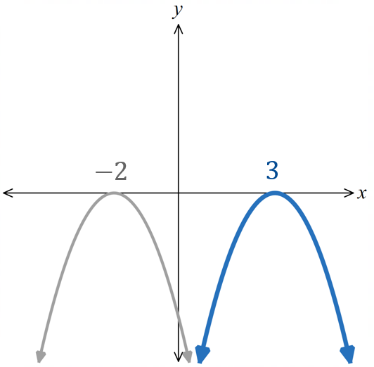 | 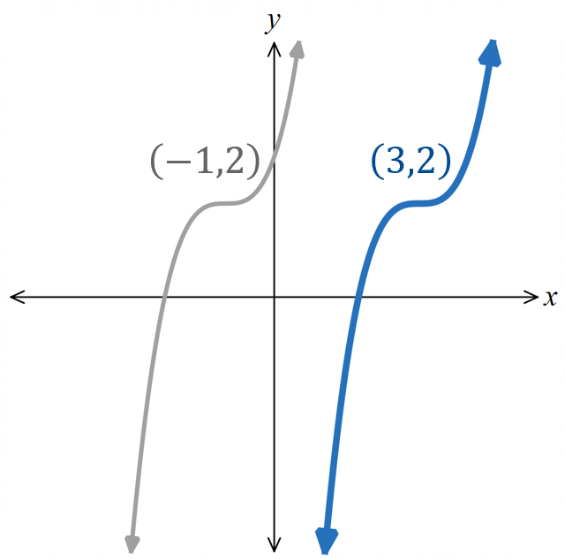

- Investigation Replacing $y$ with $y-c$
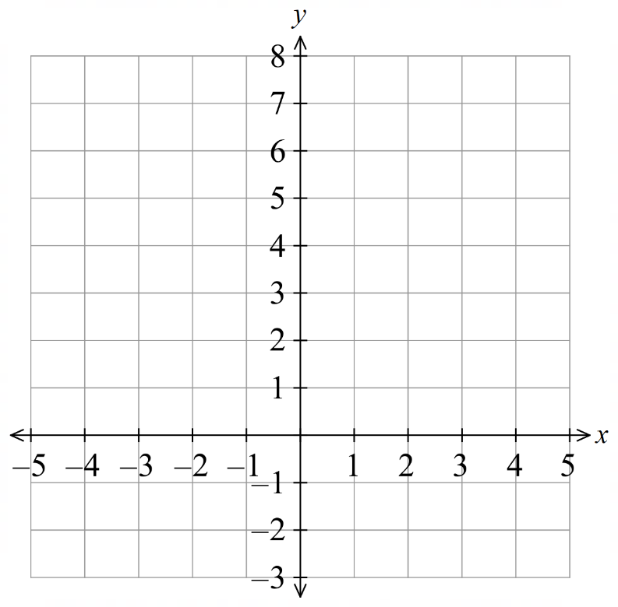
Complete the table of values for $y=x^{2}$and $y-1=x^{2},$ then sketch the graphs.

$x$ | $$-3$$ | $$-2$$ | $$-1$$ | $$0$$ | $$1$$ | $$2$$ | $$3$$
$y=x^{2}$
$$y-1=x^{2}$$

The graph of $y-1=x^{2}$ is the graph of $y=x^{2}$ shifted 1 unit …………

In function notation: $y-1=f\left(x\right)$
$y=f\left(x\right)+1$

- Vertical Translations
Let $c$ be a positive number.
To translate $c$ units up: $y↦\left(y-c\right)$  $$y-c=f\left(x\right) \\ y=f\left(x\right)+c$$  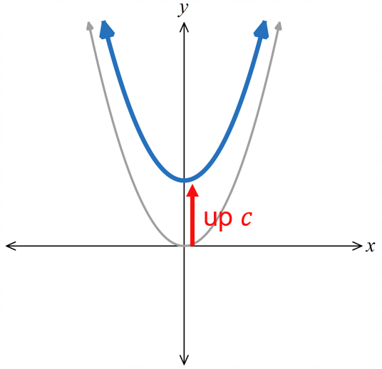 | To translate $c$ units down: $y↦\left(y+c\right)$  $$y+c=f\left(x\right) \\ y=f\left(x\right)-c$$  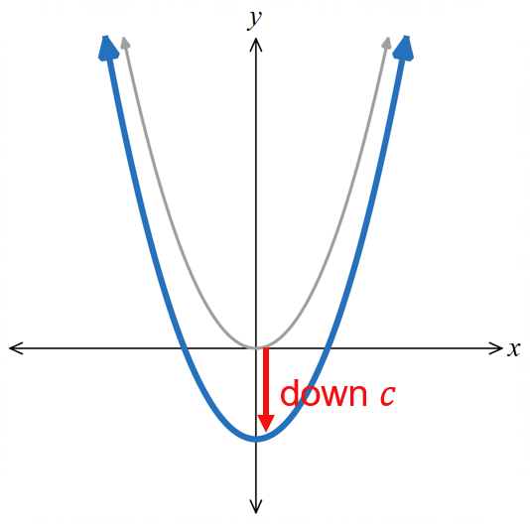

- Interpret Vertical translations
$y=f\left(x\right)$ is given. Sketch:
- $y-3=f\left(x\right)$ | - $y+2=f\left(x\right)$ | - $y+4=f\left(x\right)$
$f\left(x\right)$ and its transformation is shown, identify the new function in function notation.
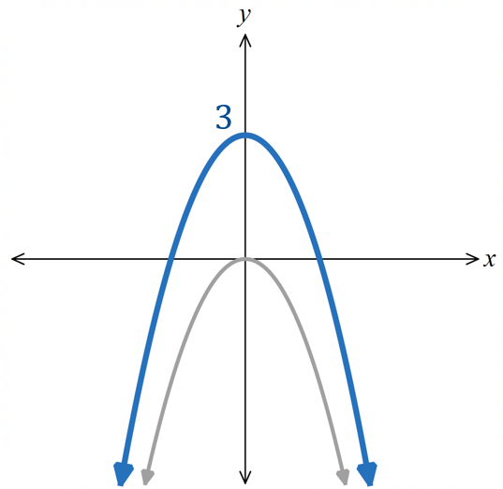 | 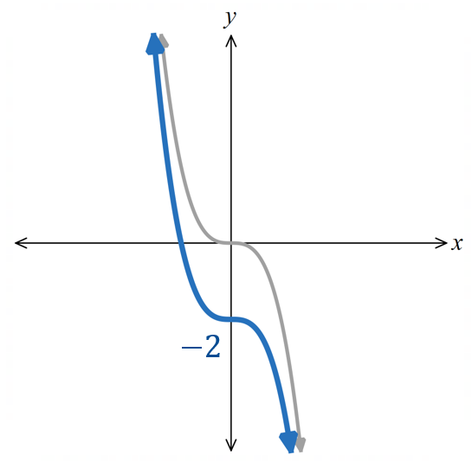 | 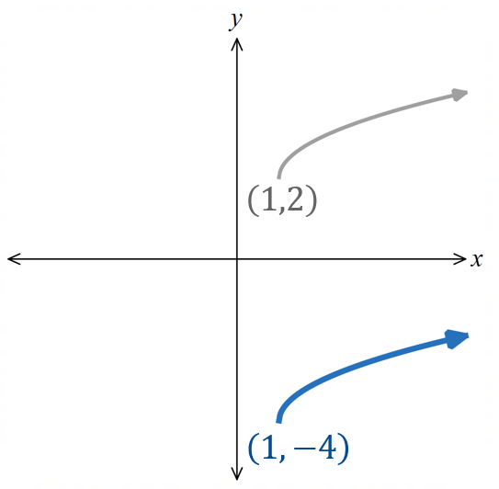

- Translations are Commutative
We can apply horizontal and vertical translations in any order. The result is the same.
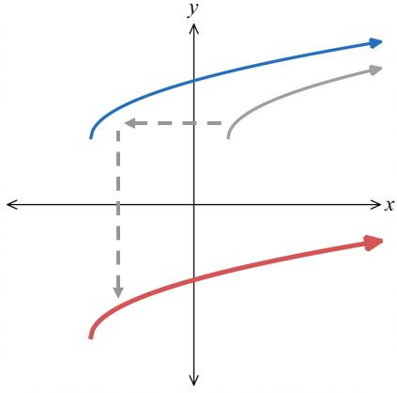
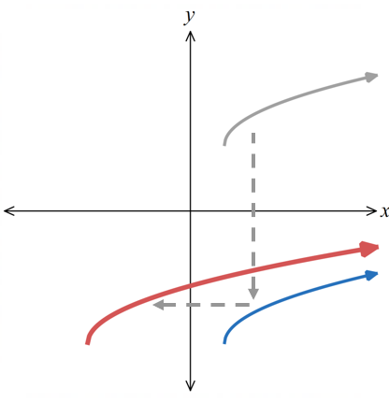

is the same as

- Example Translate using the equation.
Find the equation of the new curve if  $y=\sqrt{2x-3}$ is translated right by 1 unit.  $$y=\sqrt{2\left(x-1\right)-3} \\ y=\sqrt{2x-2-5} \\ y=\sqrt{2x-7}$$ | Find the equation of the new curve if  $y=e^{x}+1$ is translated down by 2 units.  $$y+2=e^{x}+1 \\ y=e^{x}-1$$

- Guided Practice
Find the equation of the new curve if:
- $y=\sqrt{2x-3}$ is translated left by 5 units.  $$y = \sqrt{2x + 7}$$ | - $y=e^{x+2}+1$ is translated left by 3 units.  $$y = e^{x+5}+ 1$$
- $x^{2}+y^{2}=9$ is translated down by 2 units and then right by 6 units.  $${\left(x - 6\right)}^{2}+ {\left(y + 2\right)}^{2}= 9$$ | - $2y=x^{3}-11$ is translated right by 7 units and then up by 3 units.  $$2y = {\left(x - 7\right)}^{3}- 5$$
- Identifying Translations
If you are given two equations and asked to determine the translations,
- Replace $x$ and/or $y$ in the original equation with $\left(x-b\right)$ and $\left(y-c\right)$ and
set it equal to the new equation,
- Solve to find $b$ or $c,$ equating coefficients if necessary.

- Example Identifying the translation from an equation.
$y=\sqrt{2x+4}$ was translated horizontally to produce $y=\sqrt{2x-8}$.
What was the translation?
$$\sqrt{2\left(x-b\right)+4}=\sqrt{2x-8} \\ 2x-2b+4=2x-8 \\ -2b+4=-8 \\ -2b=-12$$ $b=6$Translation 6 units right.
(Remember that $x-6$ means 6 units right)

- Guided Practice
Find the translation.
- $y=$ $\frac{1}{2x-1}$ was translated horizontally to $y=$ $\frac{1}{2x+5}$  3 units left | - $y=2x^{2}+1$ was translated horizontally to $y=2x^{2}-4x+3$.  1 unit right
- $y=2^{x}$ was translated horizontally to  $y=4×2^{x}$.  2 units left | - $y=$ $-\frac{1}{x-1}$ was translated vertically to  $y=$ $\frac{2x-3}{x-1}$  2 units up

Foundation
- Consider the parabola $f\left(x\right)=x^{2}$.
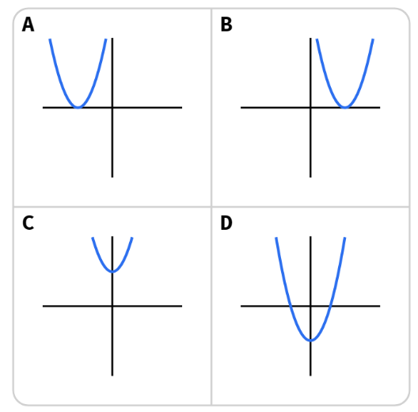  - Which of these is $y=f(x+3)$?  A | - Which of these is $y=f\left(x\right)-3$?  D

- In each case, the given equation is the result of shifting one of the curves:
$$y=x^{2}, y=\frac{1}{x}, y=2^{x}$$
State the direction of the shift and by how many units, then draw a quick sketch of the curve.
- $y-2=x^{2}$  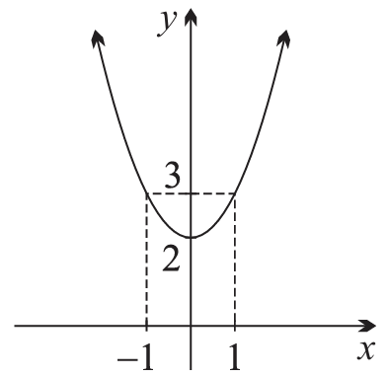  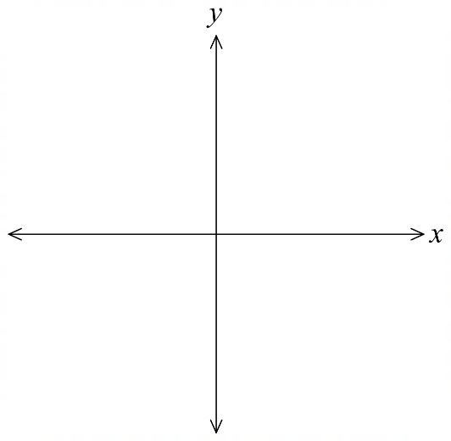  $y=x^{2}$ shifted up 2 units | - $y={\left(x+1\right)}^{2}$  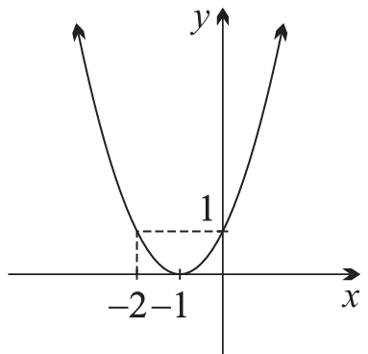  $y=x^{2}$ shifted left 1 unit | - $y=$ $\frac{1}{x-2}$  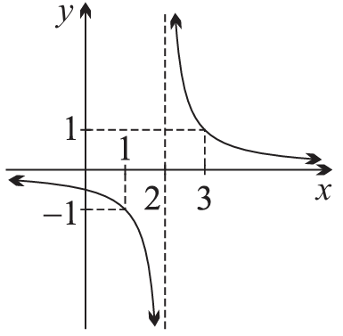  $y=$ $\frac{1}{x}$ shifted right 2 units
- $y-1=$ $\frac{1}{x}$  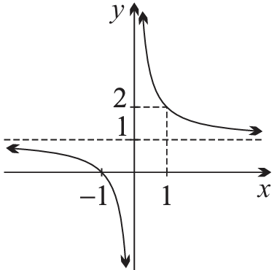  $y=$ $\frac{1}{x}$ shifted up 1 unit | - $y=2^{x-1}$  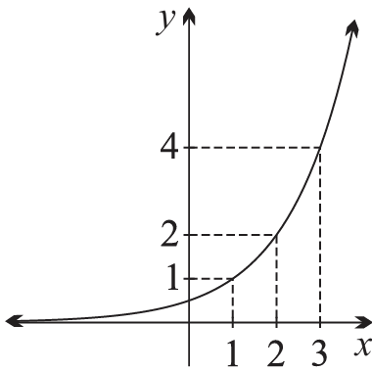  $y=2^{x}$ shifted right 1 unit | - $y=2^{x}-2$  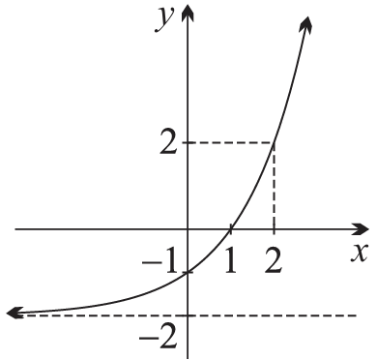  $y=2^{x}$ shifted down 2 units

- Write the equation for each relation after the given translation has been applied.
- $y=x^{2}$  right 2 units  $$y={\left(x-2\right)}^{2}$$ | - $y=2^{x}$  down 2 units  $$y=2^{x}-2$$ | - $y=x^{3}$  left 1 unit  $$y={\left(x+1\right)}^{3}$$
- $y=$ $\frac{1}{x}$  right 3 units  $$y=\frac{1}{x-3}$$ | - $x^{2}+y^{2}=4$  up 1 unit  $$x^{2}+{\left(y-1\right)}^{2}=4$$ | - $y=x^{2}-4$  left 1 unit  $$y={\left(x+1\right)}^{2}-4$$

- Here are graphs of $f\left(x\right)=x^{3}$ and $g(x)$.
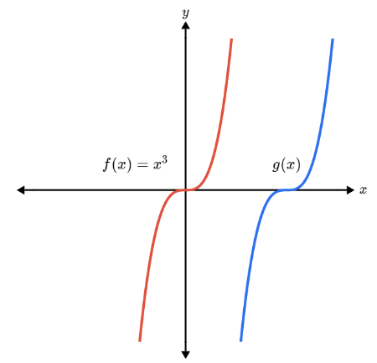  What is the equation for $g(x)$?  - $g\left(x\right)=x^{3}+4$  - $g\left(x\right)=x^{3}-4$  - $g\left(x\right)={\left(x+4\right)}^{3}$  - $g\left(x\right)={\left(x-4\right)}^{3}$  D | 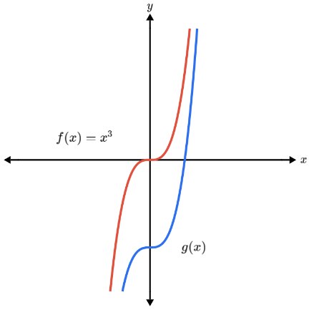  What is the equation for $g(x)$?  - $g\left(x\right)=x^{3}+4$  - $g\left(x\right)=x^{3}-4$  - $g\left(x\right)={\left(x+4\right)}^{3}$  - $g\left(x\right)={\left(x-4\right)}^{3}$  B

- Consider the cubic curve $y=x^{3}$.
- Which of the below is  $$y-3={\left(x+4\right)}^{3}$$  A | - Which of the below is  $$y={\left(x-3\right)}^{3}+2$$  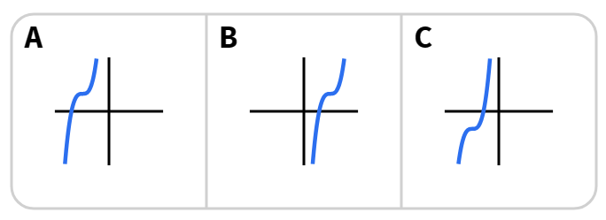  B

Development
- In each case, $y=f\left(x\right)$ has been drawn. Draw the specified function transformations.
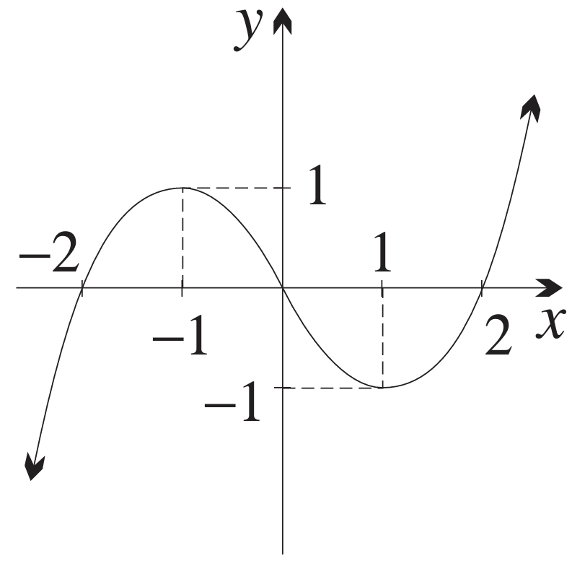 | $$y=f\left(x-2\right)$$  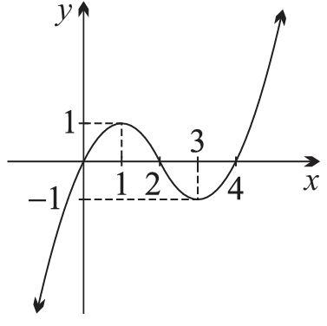 | $$y=f\left(x+1\right)$$  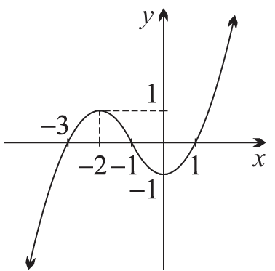
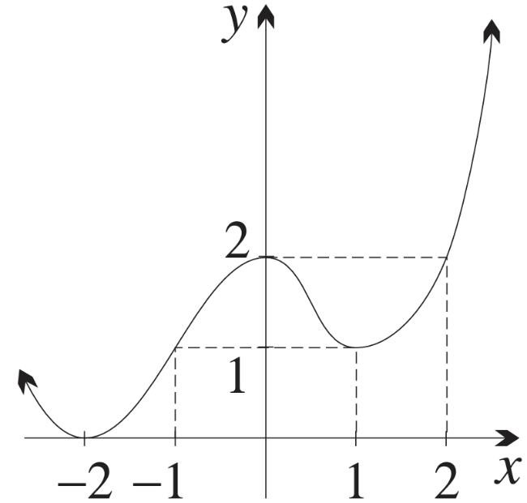 | $$y=f\left(x+2\right)$$  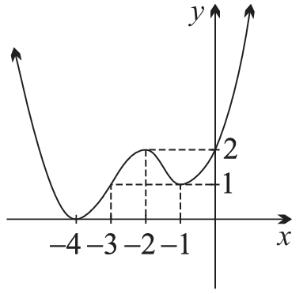 | $$y=f\left(x+1\right)$$  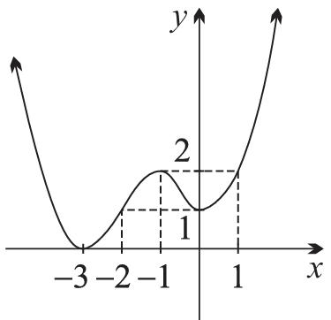
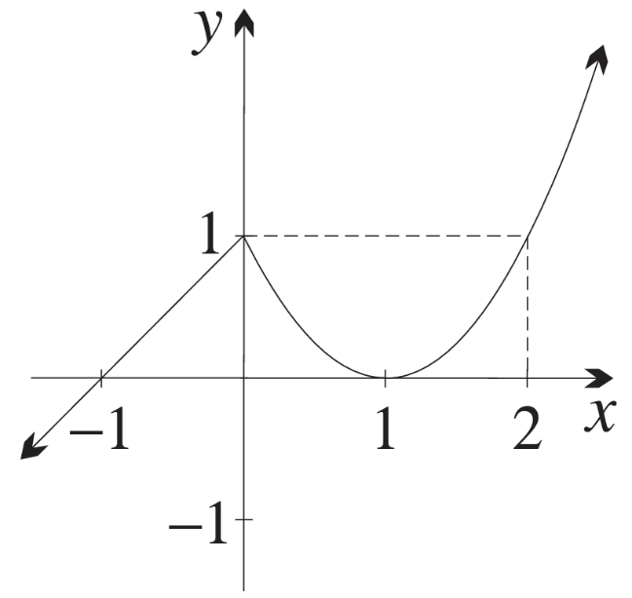 | $$y-1=f\left(x\right)$$  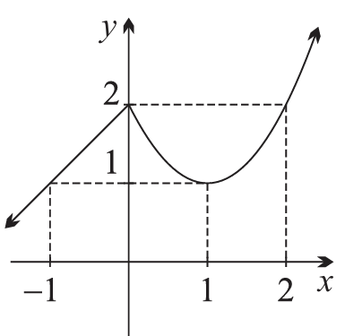 | $$y=f\left(x\right)-1$$  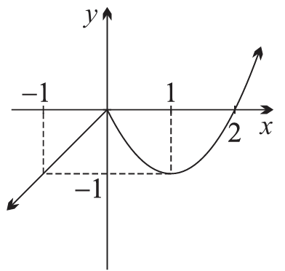
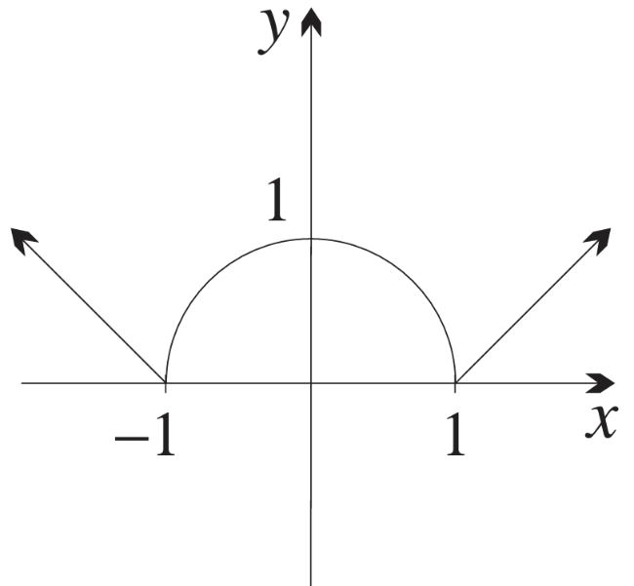 | $$y-1=f\left(x\right)$$  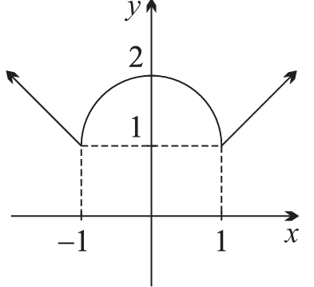 | $$y=f\left(x-1\right)$$  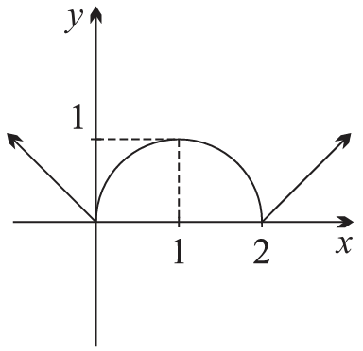

- In each part, complete the square, identify the translation of either $y=x^{2}$ or $y=-x^{2}$, then sketch the graph.
- $y=x^{2}+2x+3$  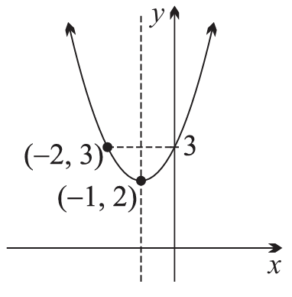  $$y={\left(x+1\right)}^{2}+2$$  $y=x^{2}$ shifted left 1 and up 2 | - $y=x^{2}-2x-2$  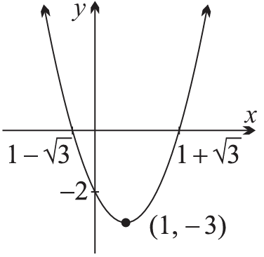  $$y={\left(x-1\right)}^{2}-3$$  $y=x^{2}$ shifted right 1 and down 3
- $y=-x^{2}+4x+1$  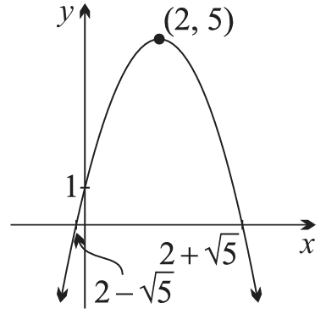  $$y=-{\left(x-2\right)}^{2}+5$$  $y=-x^{2}$ shifted right 2 and up 5 | - $y=-x^{2}-4x-5$  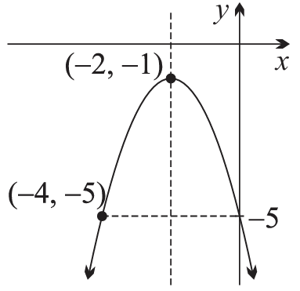  $$y=-{\left(x+2\right)}^{2}-1$$  $y=-x^{2}$ shifted left 2 and down 1

- Consider the straight line $x+2y-4=0$.
  - The line is translated 2 units left. Find the equation of the new line.

$$x+2y-2=0$$
  - The original line is translated 1 unit down. Find the equation of this third line.

$$x+2y-2=0$$
  - Comment on your answers. A sketch could help.

Both translations give the same result.

- Use shifting to sketch these graphs. $y=\frac{1}{x}$ has been sketched for you.
Show the $x$ and $y$ intercepts, and any asymptotes.
- $y=$ $\frac{1}{x-2}$  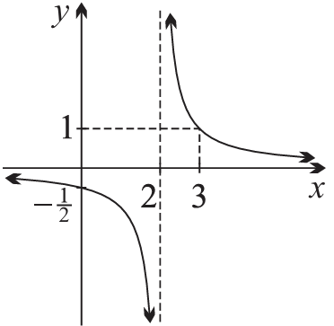  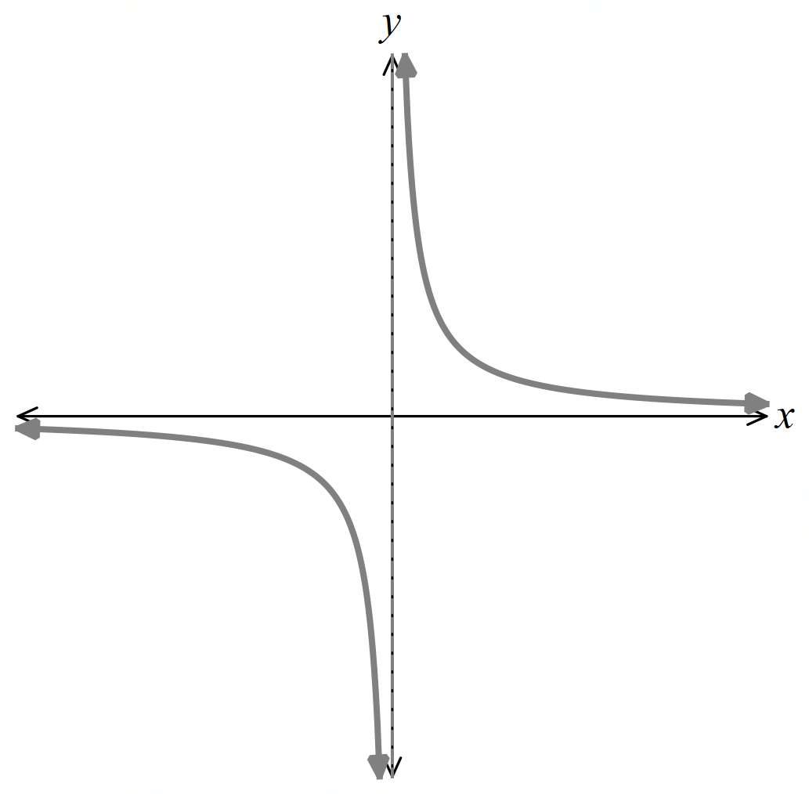 | - $y=1+$ $\frac{1}{x-2}$  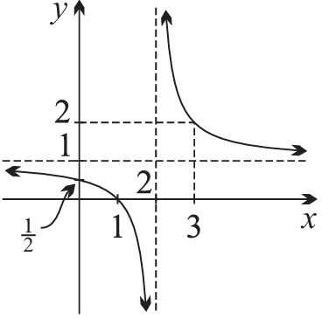 | - $y=$ $\frac{1}{x-2}$ $-2$  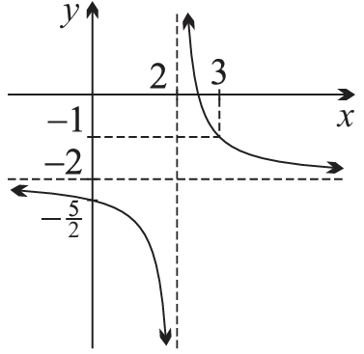
- $y=$ $\frac{1}{x+1}$ $-1$  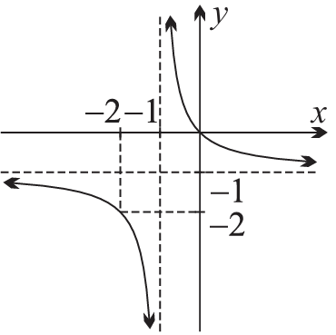 | - $y=3+$ $\frac{1}{x+2}$  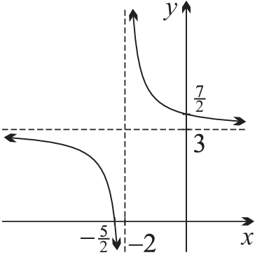 | - $y=$ $\frac{1}{x-3}$ $+4$  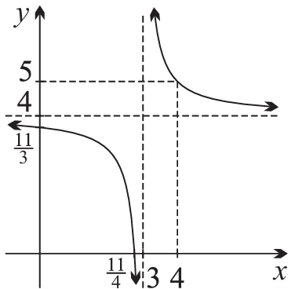

- The composition of functions can sometimes result in translations.
- Consider $y=f\left(x\right)$ below.  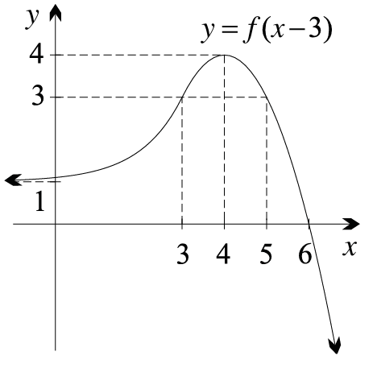  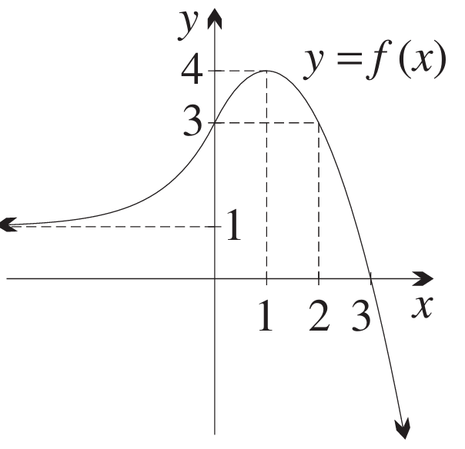  Let $h\left(x\right)=x-3$  Sketch $f\left(h\left(x\right)\right)$ on the same set of axes.  $$f\left(h\left(x\right)\right)=f\left(x-3\right)$$  Translation 3 right. | - Consider $P\left(x\right)$ below.  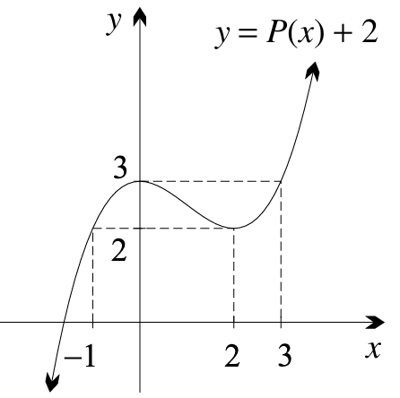  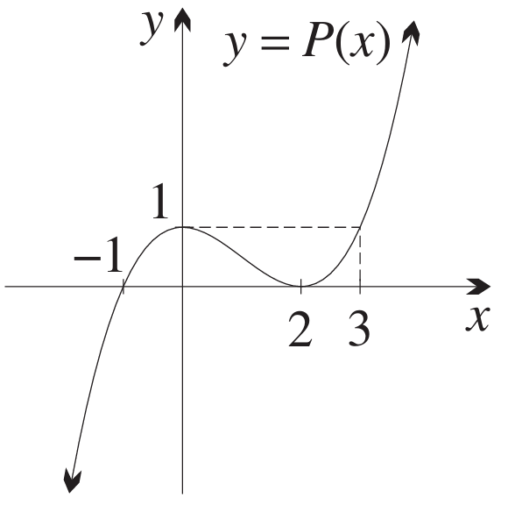  Let $k\left(x\right)=x+2$  Sketch $k\left(P\left(x\right)\right)$ on the same set of axes.  $$k\left(P\left(x\right)\right)=P\left(x\right)+2$$  Translation 2 up.

Mastery
- Consider the graphs of $f\left(x\right)={\left(2x+1\right)}^{2}$ and $g\left(x\right)={\left(2x-5\right)}^{2}$.
Jimmy says that $y=g\left(x\right)$ is $y=f\left(x\right)$ shifted right by 6 units.
  - Show that Jimmy is incorrect by actually shifting $f\left(x\right)$ to the right by 6 units $f\left(x-6\right).$

$$f\left(x-6\right)={\left(2\left(x-6\right)+1\right)}^{2}$$
$$={\left(2x-11\right)}^{2}$$
  - Determine how many units to the right $f\left(x\right)$ needs to be translated to obtain $g\left(x\right)$.

Let $f\left(x-b\right)=g\left(x\right)$
$${\left(2\left(x-b\right)+1\right)}^{2}={\left(2x-5\right)}^{2}$$
$${\left(2x-2b+1\right)}^{2}={\left(2x-5\right)}^{2}$$
$$-2b+1=-5$$
$$b=3$$
$∴$ 3 units right

- For each equation, in what direction and how many units was $f\left(x\right)$ translated to yield $g\left(x\right)$?
- $f\left(x\right)=\sqrt{2x-3}, g\left(x\right)=\sqrt{2x+7}$  5 units left | - $f\left(x\right)={\left(3x+5\right)}^{2}, g\left(x\right)={\left(3x-1\right)}^{2}$  2 units right
- $f\left(x\right)=5^{-x}, g\left(x\right)=5^{-x+1}$  1 unit right | - $f\left(x\right)=3^{-2x}, g\left(x\right)=3^{-2x+4}$  2 units right

Reflections

- Reflections
A reflection flips an object across a mirror line.
The size and shape of the object does not change.

- Investigation Reflections of curves
Complete these tables of values and sketch the graph.
$$y=2^{x}$$  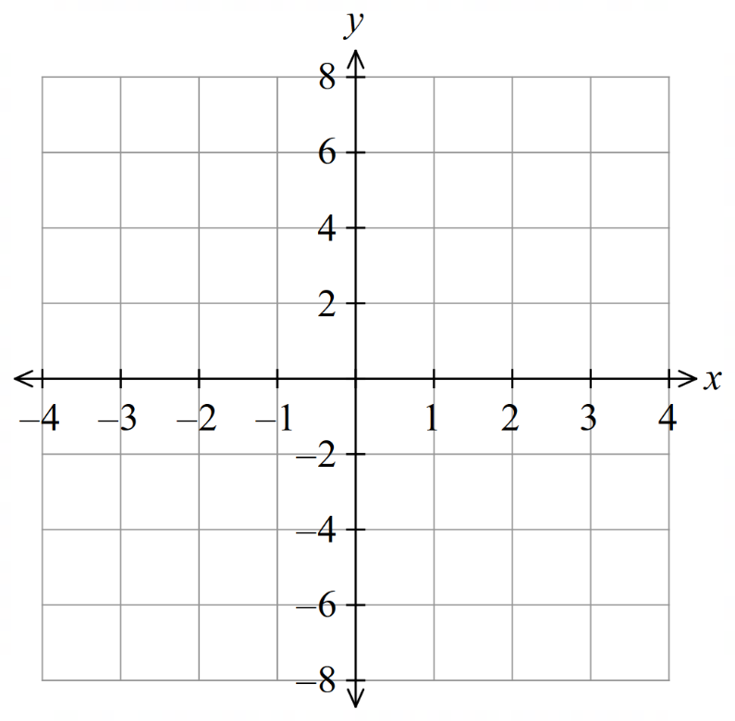 |  | $$y=2^{-x}$$
  $$x$$ | $$-3$$ | $$-2$$ | $$-1$$ | $$0$$ | $$1$$ | $$2$$ | $$3$$
  $$y$$
  $$x$$ | $$-3$$ | $$-2$$ | $$-1$$ | $$0$$ | $$1$$ | $$2$$ | $$3$$
  $$y$$
$$-y=2^{x}$$ |  | $$-y=2^{-x}$$
  $$x$$ | $$-3$$ | $$-2$$ | $$-1$$ | $$0$$ | $$1$$ | $$2$$ | $$3$$
  $$y$$
  $$x$$ | $$-3$$ | $$-2$$ | $$-1$$ | $$0$$ | $$1$$ | $$2$$ | $$3$$
  $$y$$
- Reflections
To reflect horizontally, or  reflect across $y$ axis:  $$x↦-x$$  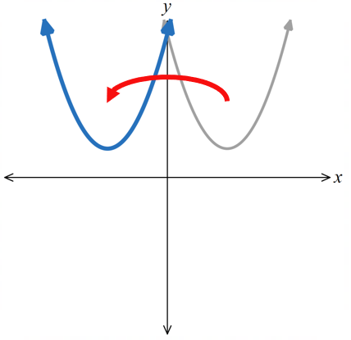  $$y=f\left(-x\right)$$ | To reflect vertically, or  reflect across $x$ axis:  $$y↦-y$$  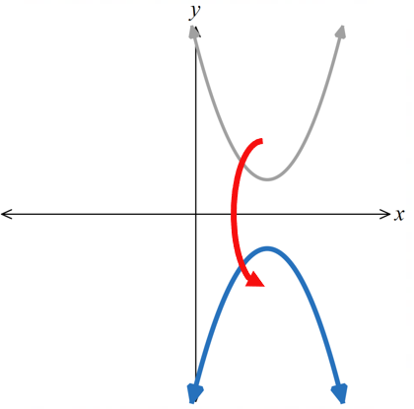  $$-y=f\left(x\right) \\ y=-f\left(x\right)$$ |  | Horizontal and vertical reflection,  rotating 180° about the origin:  $x↦-x$ and $y↦-y$  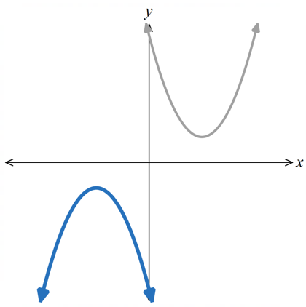  $$-y=f\left(-x\right) \\ y=-f\left(-x\right)$$
It can be difficult to visualise reflections. Follow these steps to sketch:
- Determine the new location of $x$ and $y$ intercepts.
- If specific coordinates are given, determine their new location.
Use these rules:
Reflection across $x$-axis  $$-f\left(x\right)$$ | Reflection across $y$-axis  $$f\left(-x\right)$$ |  | Rotation by 180$°$ about origin  $$-f\left(-x\right)$$
$A ( x, y )$  $$↓$$  $A'(x,-y)$ | $A ( x, y)$  $$↓$$  $A'(-x,y)$ |  | $A \left( x , y \right)$  $$↓$$  $A'(-x,-y)$

- Interpret Reflections
$y=f\left(x\right)$ is given. Sketch:
- $-y=f\left(x\right)$ | - $y=f\left(-x\right)$ | - $y=-f\left(-x\right)$  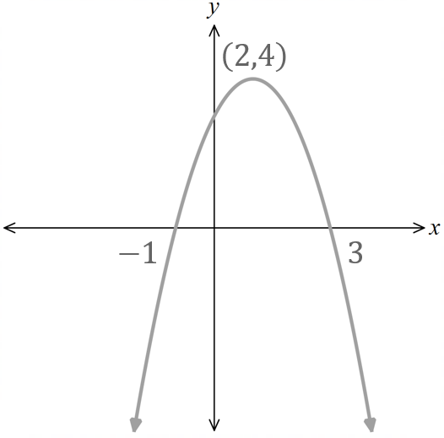

- Example Reflect using the equation.
$y=$ $\frac{x+1}{3}$ is reflected across the $y$ axis.  Find its new equation.  $$y=\frac{-x+1}{3}$$ | $x^{2}+{\left(y-1\right)}^{3}=1$ is reflected across the $x$ axis. Find its new equation.  $$x^{2}+{\left(-y-1\right)}^{3}=1 \\ x^{2}+{\left(-\left(y+1\right)\right)}^{3}=1 \\ x^{2}-{\left(y+1\right)}^{3}=1$$

- Guided Practice
Find the equation of the new curve if:
- $y=\sqrt{2x-3}$ is reflected across the $x$ axis.  $$y = -\sqrt{2x - 3}$$ | - $y=2^{x+1}$ is reflected across the $y$ axis.  $$y = 2^{1-x}$$
- $y=\left(x-1\right)\left(x-2\right)\left(x-3\right)$ is reflected across both axes.  $$y = \left(x + 1\right)\left(x + 2\right)\left(x + 3\right)$$ | - $x^{2}=y^{3}+y^{2}$ is reflected across the $x$ axis.  $$x² = y² - y^{3}$$

Foundation
- The point $P\left(a,b\right)$ is shown in the diagram below.
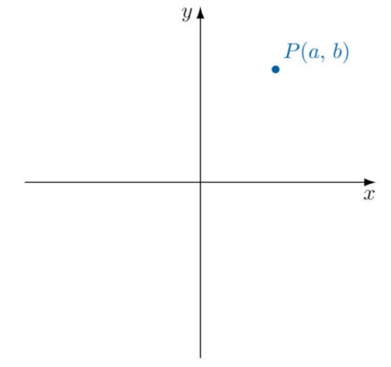
  - The point P is reflected across the $x$-axis.
Label the result Q and write the coordinates.
$$Q\left(a,-b\right)$$
  - The point P is reflected across the $y$-axis.
Label the result R and write the coordinates.
$$R\left(-a.b\right)$$
  - The point R is reflected across the $x$-axis.
Label the result S. and write the coordinates.
$$R\left(-a,-b\right)$$
  - The point Q is reflected across the y-axis.
What do you notice?
$$R\left(-a,-b\right)$$
Reflecting across $x$ then $y$ is the same as reflecting across $y$ then $x$.
- $f\left(x\right)={\left(x-2\right)}^{2}$
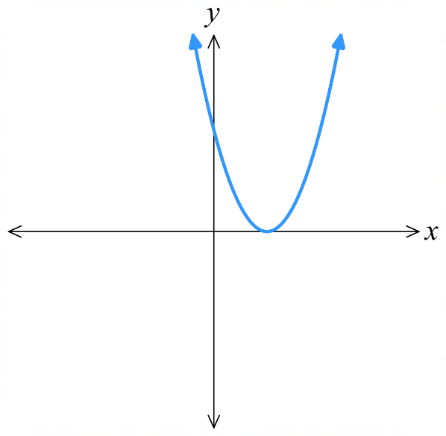
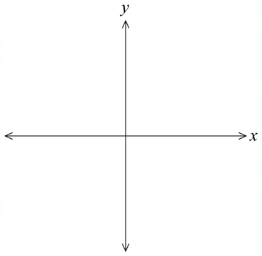
  - Sketch $y=f(x)$

  - Find the equation of:
$$y=-f(x)$$  $$y=-{\left(x-2\right)}^{2}$$ | $$y=f(-x)$$  $${y=\left(-x-2\right)}^{2}={\left(x+2\right)}^{2}$$ | $$y=-f(-x)$$  $$y=-{\left(x+2\right)}^{2}$$
  - hence sketch the graph.
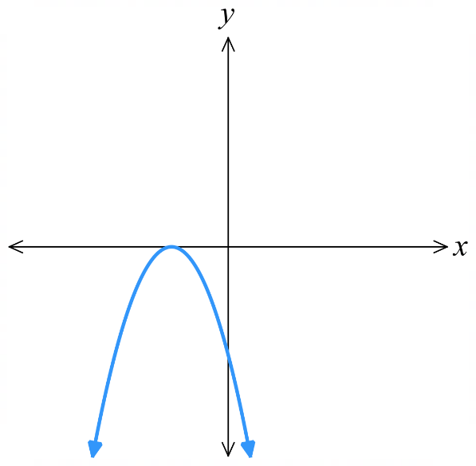
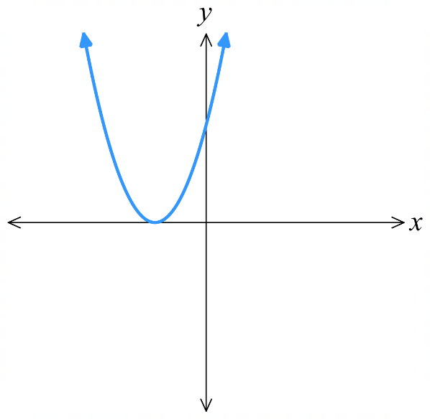
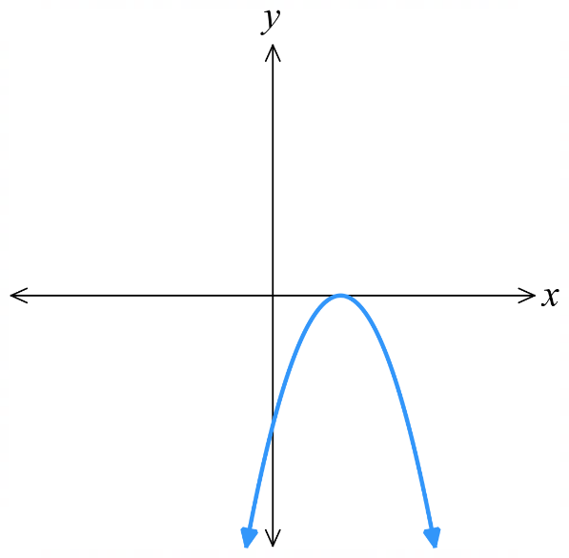

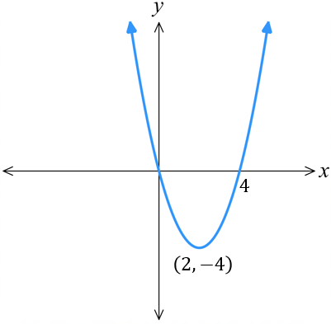
- For the graph of $f\left(x\right)=x\left(x-4\right)$,
  - Sketch the graph,
showing intercepts and vertex.

  - find the equation of the graph after:
reflection across $x$ axis  $$-f\left(x\right)=-x\left(x-4\right)$$ | reflection across $y$ axis  $$f\left(-x\right)=-x\left(-x-4\right)=x\left(x+4\right)$$ | reflection across both axes  $$-f\left(-x\right)=-x\left(x+4\right)$$
  - Hence sketch the graph after reflection.
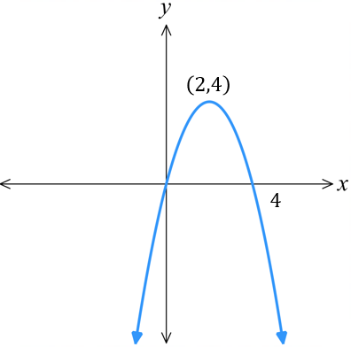 | 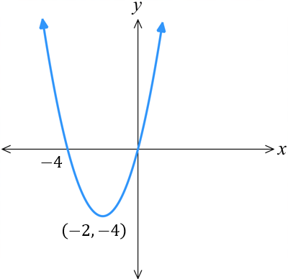 | 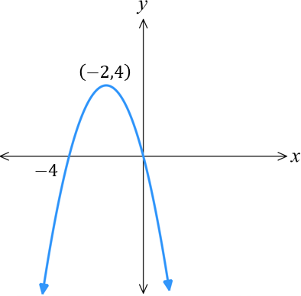

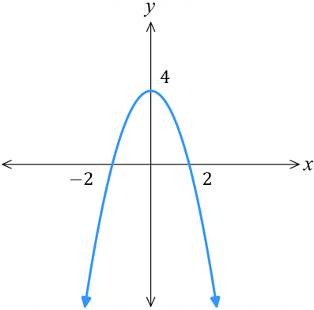
- For the graph of $f\left(x\right)=4-x^{2}$,
  - Sketch the graph,
showing intercepts and vertex.

  - find the equation of the graph after:
$180$ degree rotation  $$-f\left(-x\right)=x^{2}-4$$ | reflection across $x$ axis  $$-f\left(x\right)=x^{2}-4$$ | reflection across $y$ axis  $$f\left(-x\right)=4-x^{2}$$
  - Hence sketch the graph after reflection.
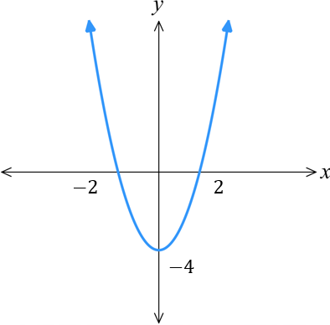 |  | 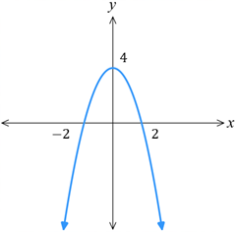

Development
- The graph of a function is given. Sketch the required reflection.
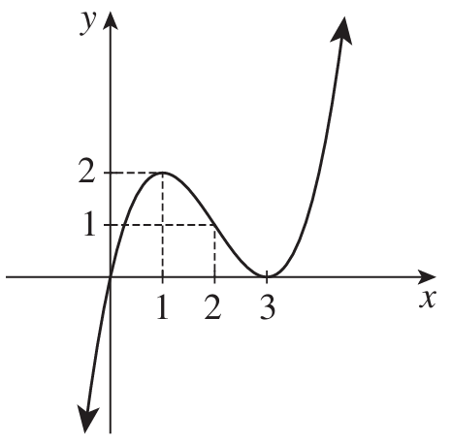  - $f(x)$  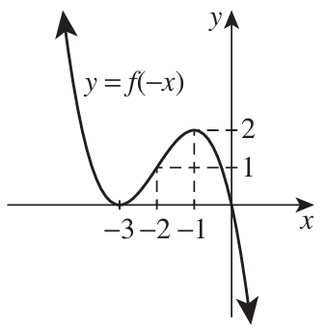 | $$f\left(-x\right)$$ | $$-f\left(x\right)$$  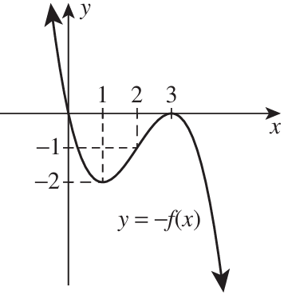
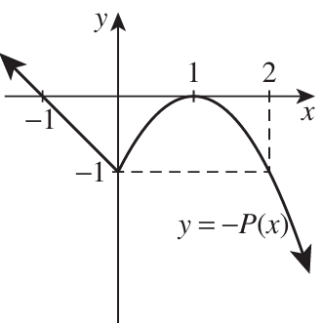  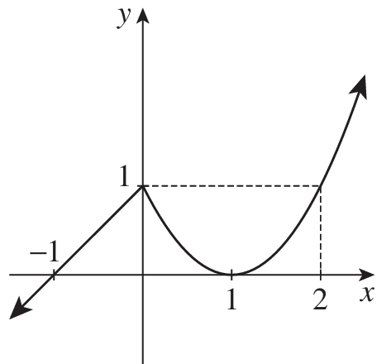  - $P\left(x\right)$ | $$-P\left(x\right)$$ | $$-P\left(-x\right)$$  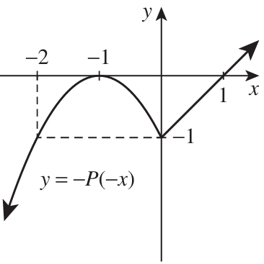
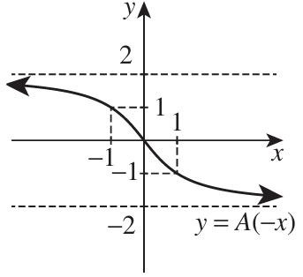  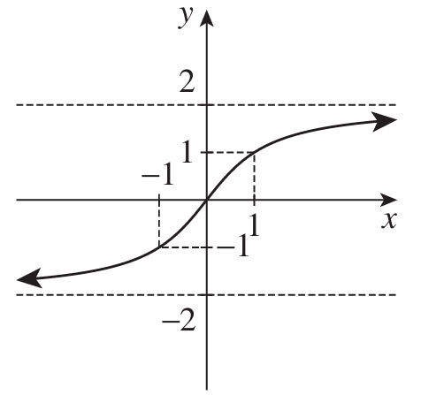  - $A\left(x\right)$ | $$A\left(-x\right)$$ | $$-A\left(-x\right)$$  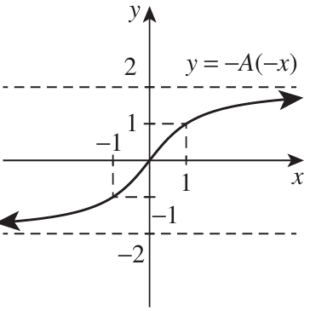

- For the function $f\left(x\right)=2x^{2}$, explain why the graph of $f(-x)$ and $f(x)$ will look the same.

$$f\left(-x\right)=2{\left(-x\right)}^{2}=2x^{2}=f\left(x\right)$$
This is an even function.
- For the function $f\left(x\right)=-x^{3}$, explain why the graph of $f(-x)$ and $-f(x)$ will look the same.

$$f\left(-x\right)=-{\left(-x\right)}^{3}=x^{3}=-f\left(x\right)$$
This is an odd function.
- The leftmost diagram shows a sketch of $y=f\left(x\right)$.
Determine the transformation $y=-f\left(x\right),y=f\left(-x\right),y=-f\left(-x\right)$ for each of these graphs.
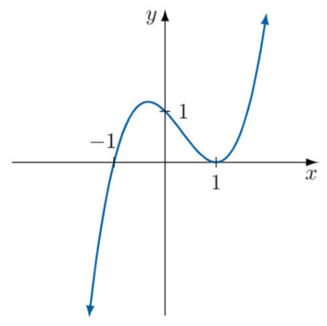 | 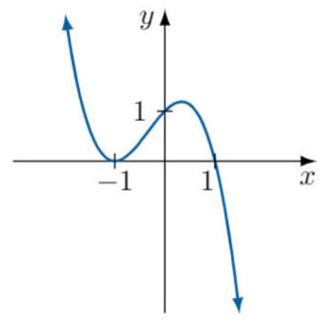  $$f\left(-x\right)$$ | 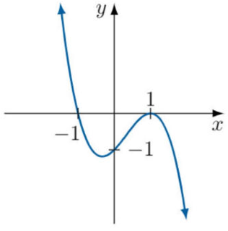  $$-f\left(x\right)$$ | 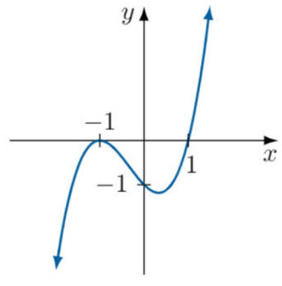  $$-f\left(-x\right)$$

- Consider $f\left(x\right)={\left(x-5\right)}^{2}$, show that $g\left(x\right)={\left(x+5\right)}^{2}$ is a reflection across the $y$ axis using function notation.

$$f\left(-x\right)={\left(-x-5\right)}^{2}={\left(x+5\right)}^{2}=g\left(x\right)$$
- Consider the function $y=\left|x-2\right|$
  - Write down the equation of the reflection across the $x$-axis.

$$-f\left(x\right)=-\left|x-2\right|$$
  - Write down the reflection of the curve from part a across the $y$-axis.

$$-f\left(-x\right)=-\left|-x-2\right|=-\left|x+2\right|$$
  - Verify you get the same result by reflecting $y=\left|x-2\right|$ across the $y$-axis then $x$-axis.

$$f\left(-x\right)=\left|-x-2\right|=\left|x+2\right|$$
$$-f\left(x\right)=-\left|x+2\right|$$

Mastery
- For each equation, determine whether the subsequent equation is a reflection or a rotation of the first equation, then sketch each graph.
- $y=3^{x}$  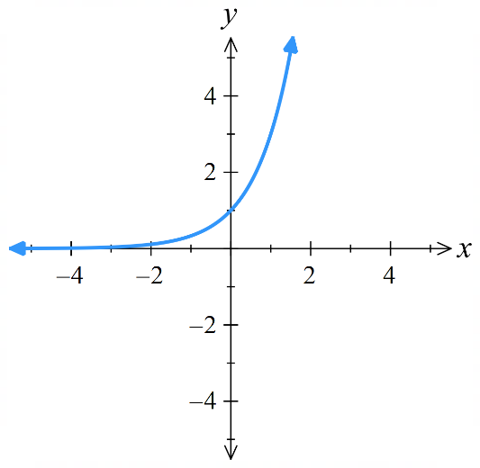 | $$y=-3^{x}$$  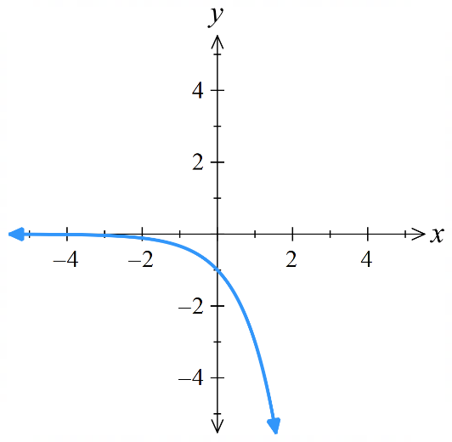  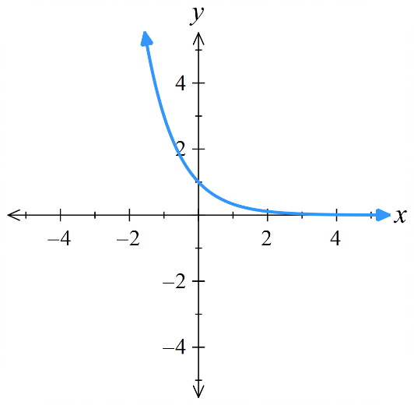  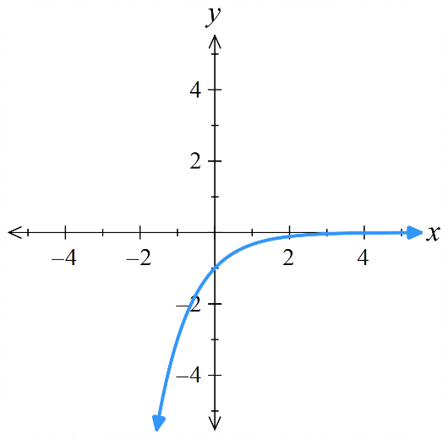  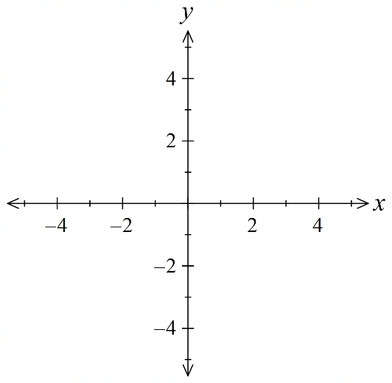  $-f\left(x\right)$, reflection across $x$ | $$y=-3^{-x}$$  $-f\left(-x\right)$, 180 deg rotation | $$y=3^{-x}$$  $f\left(-x\right)$, reflection across $y$
- $y={\left(x-1\right)}^{2}$  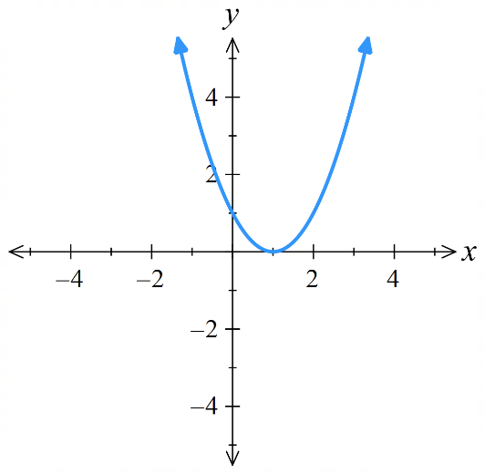 | $$y=-{\left(x-1\right)}^{2}$$  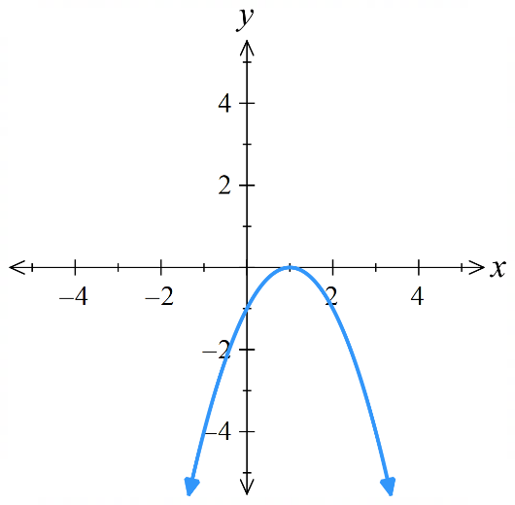  $-f\left(x\right)$, reflection across $x$ | $$y={\left(x+1\right)}^{2}$$  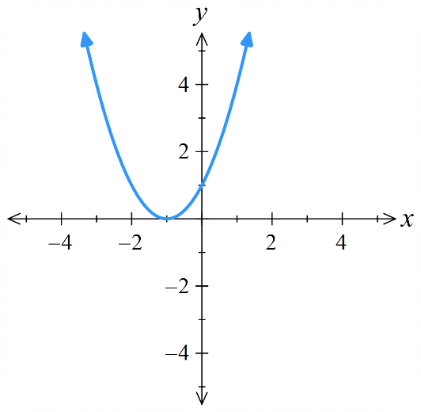  $f\left(-x\right)$, reflection across $y$ | $$y=-{\left(x+1\right)}^{2}$$  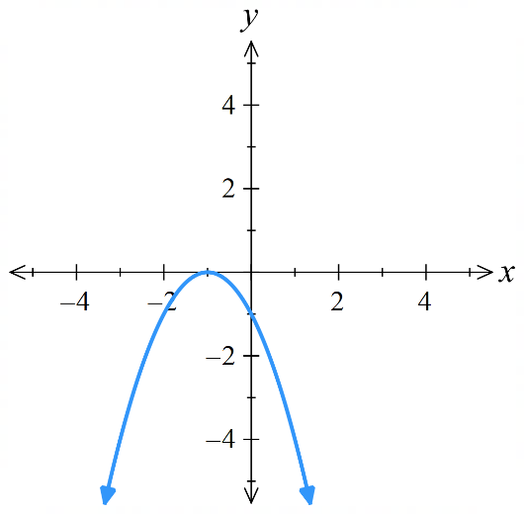  $-f\left(-x\right)$, 180 deg rotation
- $y=4-x$  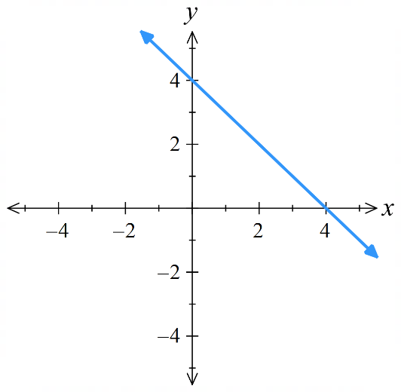 | $$y=x-4$$  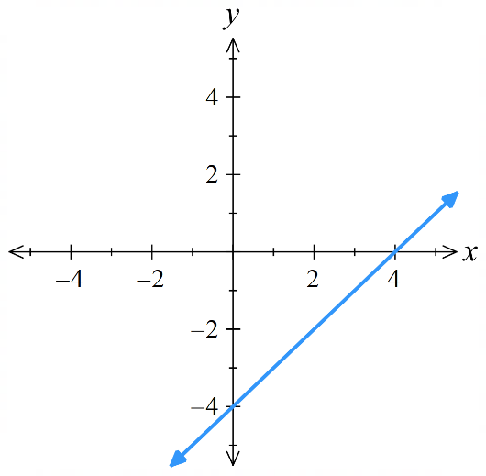  $-f\left(x\right)$, reflection across $x$ | $$y=x+4$$  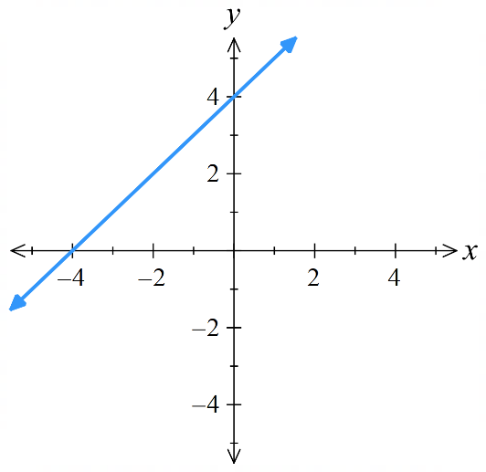  $f\left(-x\right),$ reflection across $y$ | $$y=-x-4$$  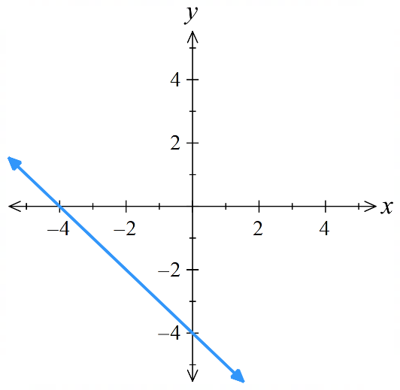  $-f\left(-x\right)$, 180 deg rotation
- $y=$ $1+\frac{1}{x-1}$  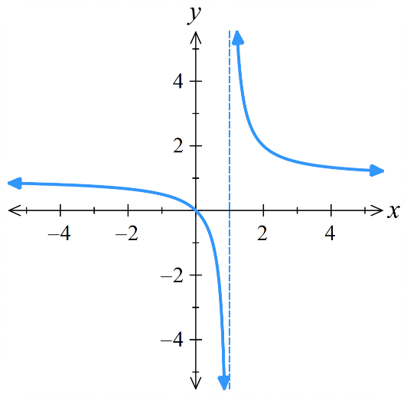 | $$y=1-\frac{1}{x+1}$$  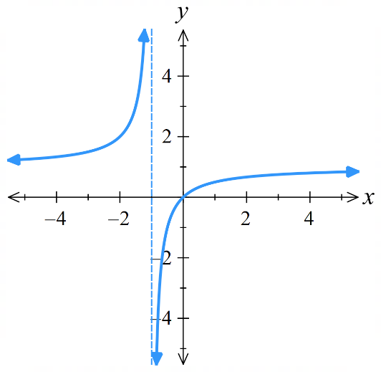  $f\left(-x\right)$, reflection across $y$ | $$y=-1+\frac{1}{x+1}$$  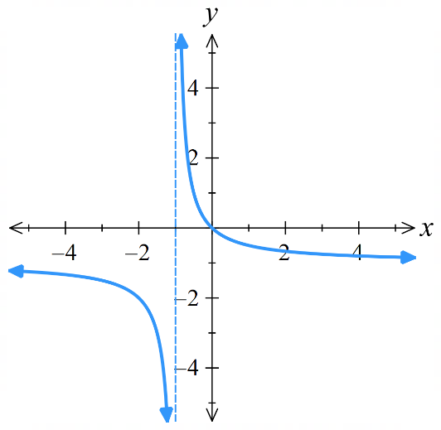  $-f\left(-x\right)$, 180 deg rotation | $$y=-1+\frac{1}{1-x}$$  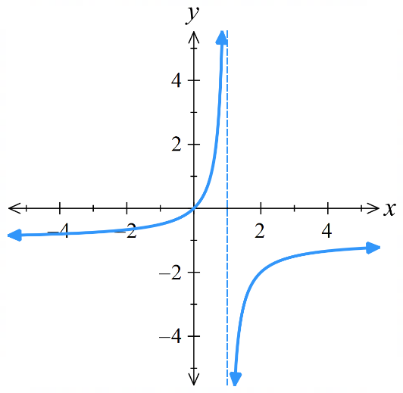  $-f\left(x\right)$, reflection across $x$
- $f\left(x\right)=x^{3}-7x^{2}+12x$. Sketch the graph of $y=f\left(x\right),$ $y=-f(x)$, $y=f(-x)$ and $y=-f(-x)$.
Note: you do not need to find the coordinates of the turning point.

$$y=f(x)$$  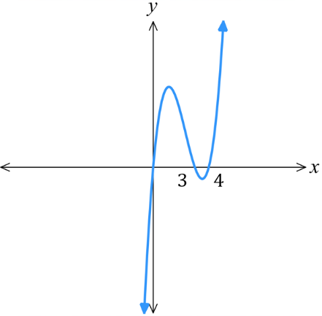  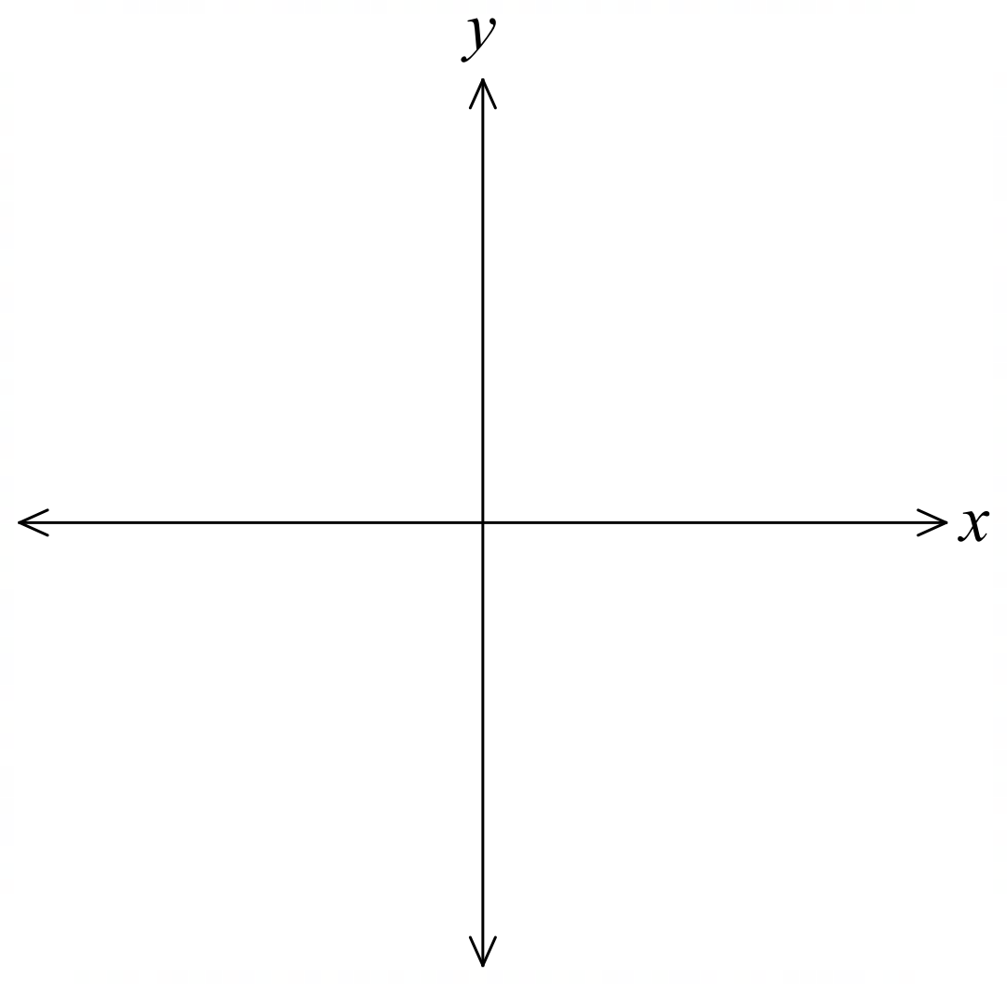 | $$y=-f(x)$$  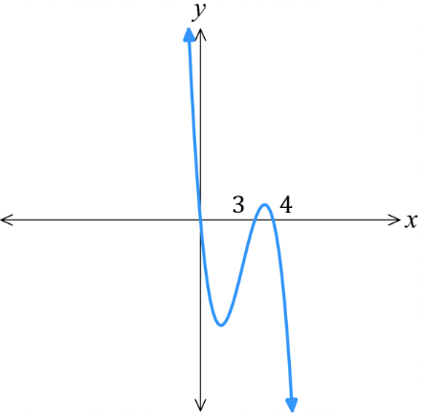
$$y=f(-x)$$  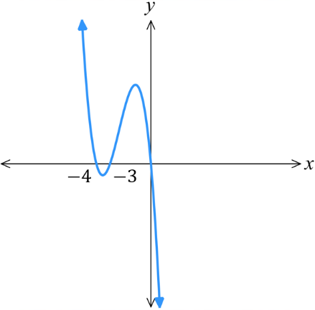 | $$y=-f(-x)$$  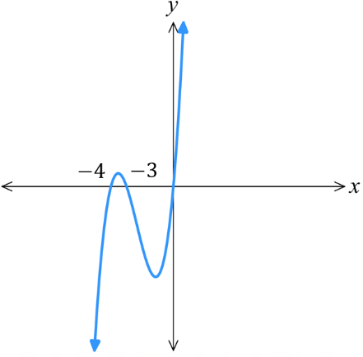

- Which of the following equations is the rotation of $y=\left(x-1\right){\left(x+1\right)}^{2}$ by $180°$?
$y=\left(x^{2}-1\right)\left(x+1\right)$ $y=\left(x^{2}-1\right)\left(x-1\right)$ $y=\left(x^{2}-1\right)\left(1-x\right)$

Let $f\left(x\right)=\left(x-1\right){\left(x+1\right)}^{2}$
$f\left(-x\right)=\left(-x-1\right){\left(-x+1\right)}^{2}$
$-f\left(-x\right)=-\left(-x-1\right){\left(1-x\right)}^{2}$
$=\left(x+1\right){\left(1-x\right)}^{2}$
$=\left(x+1\right)\left(1-x\right)\left(1-x\right)$
$=\left(1-x^{2}\right)\left(1-x\right)$
$=-\left(x^{2}-1\right)×-\left(x-1\right)$
$=\left(x^{2}-1\right)\left(x-1\right)$

Dilations

- Dilation
A dilation enlarges or reduces the size and shape on an object by multiplying lengths by a scale factor, $k$.
$$k=1$$  the object stays identical | $$k>1$$  the object is larger  $$k=1.5$$ | $$0<k<1$$  the object is smaller  $$k=0.5$$
We can apply horizontal and vertical dilations independently.

- Investigation Replacing $x$ with $\frac{x}{a}$
Compare the graphs of $y=x\left(x-4\right)$and $y=\frac{x}{2}\left(\frac{x}{2}-4\right).$
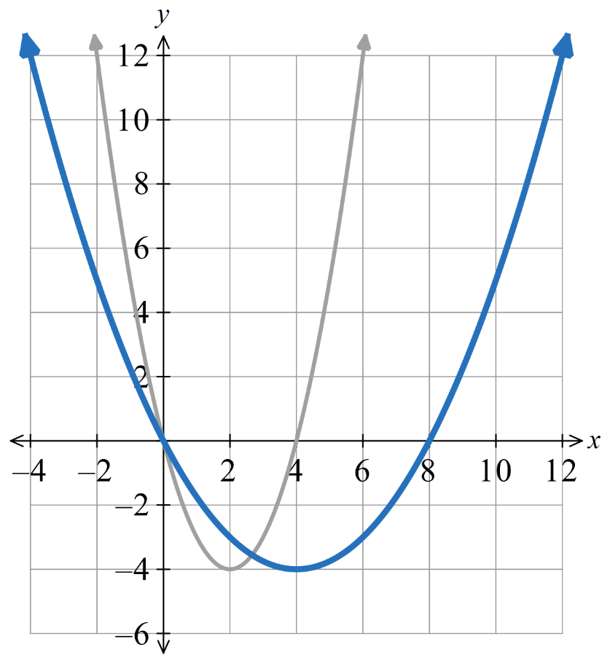
The graph of $y=\frac{x}{2}\left(\frac{x}{2}-4\right)$ is the graph of $y=x\left(x-4\right)$ dilated …………………
Since we are replacing all $x$ values with $\frac{x}{2}$, the input must be ……………… by 2 to get the same output.
Therefore, replacing $x$ with $\frac{x}{2}$ is a horizontal dilation of factor ……

- Horizontal Dilations
Horizontal dilations are stretches or compressions in the $y$-axis, parallel to the $x$-axis.
Let $a$ be a positive number.
To dilate by factor $a$: $x↦$ $\frac{x}{a}$  This multiplies all $x$ coordinates by $a$.  $$y=f\left(\frac{x}{a}\right)$$  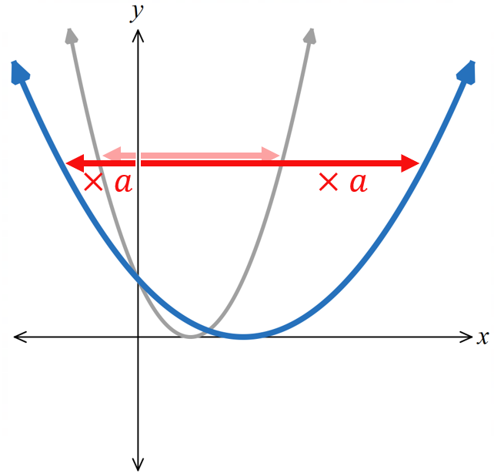 | To dilate by factor $\frac{1}{a}$ $:x↦$ $ax$  This multiplies all $x$ coordinates by $\frac{1}{a} (or ÷a)$  $$y=f\left(ax\right)$$  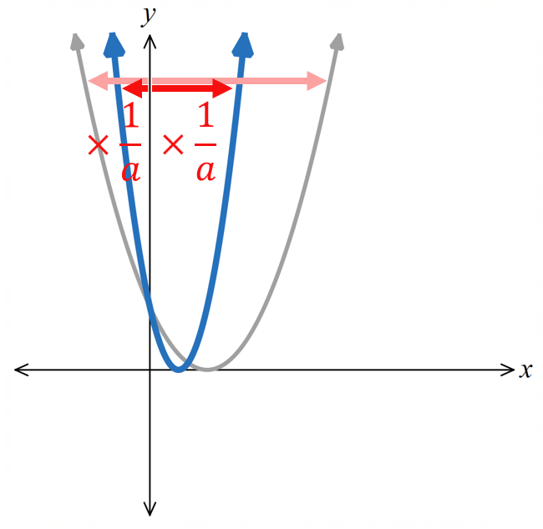

- Interpret Horizontal dilations
$y=f\left(x\right)$ is given. Sketch:
- $y=f\left(3x\right)$  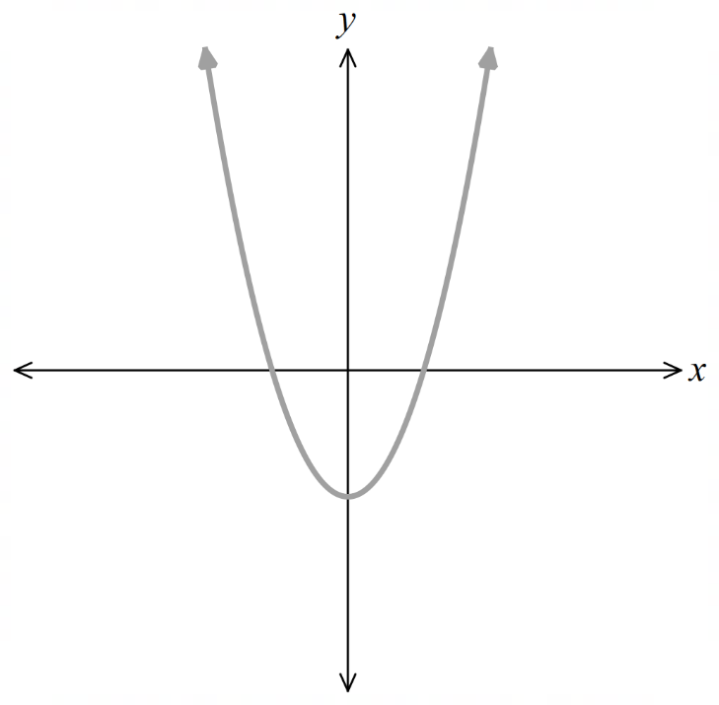 | - $y=f\left(\frac{x}{2}\right)$  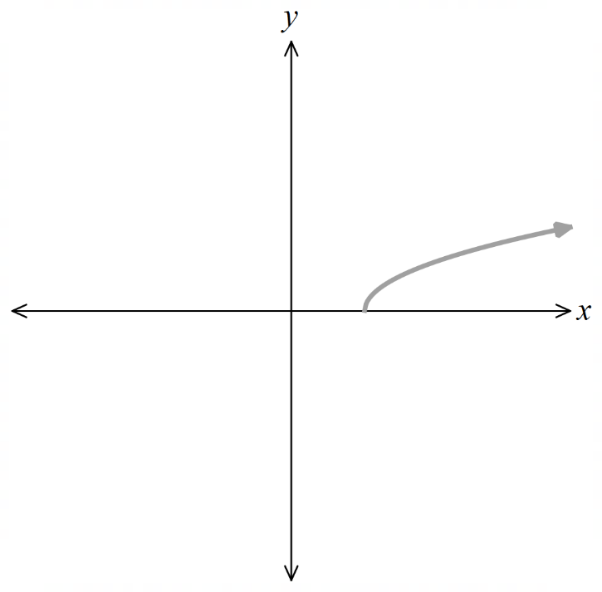 | - $y=f\left(\frac{3x}{2}\right)$  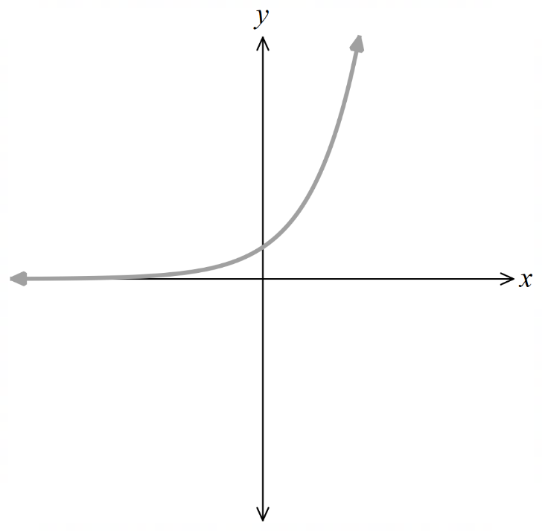
$f\left(x\right)$ and its transformation is shown, identify the new function in function notation.
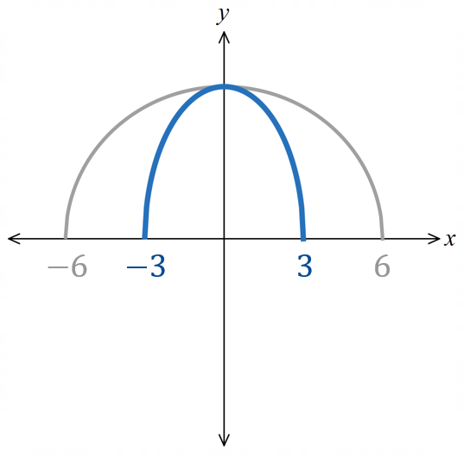 | 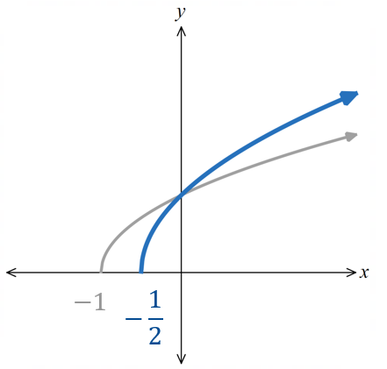 | 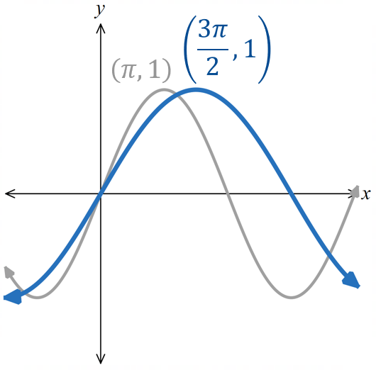
- Investigation Replacing $y$ with $\frac{y}{k}$
Compare the graphs of $y=x\left(x-4\right)$and $\frac{y}{2}=x\left(x-4\right).$
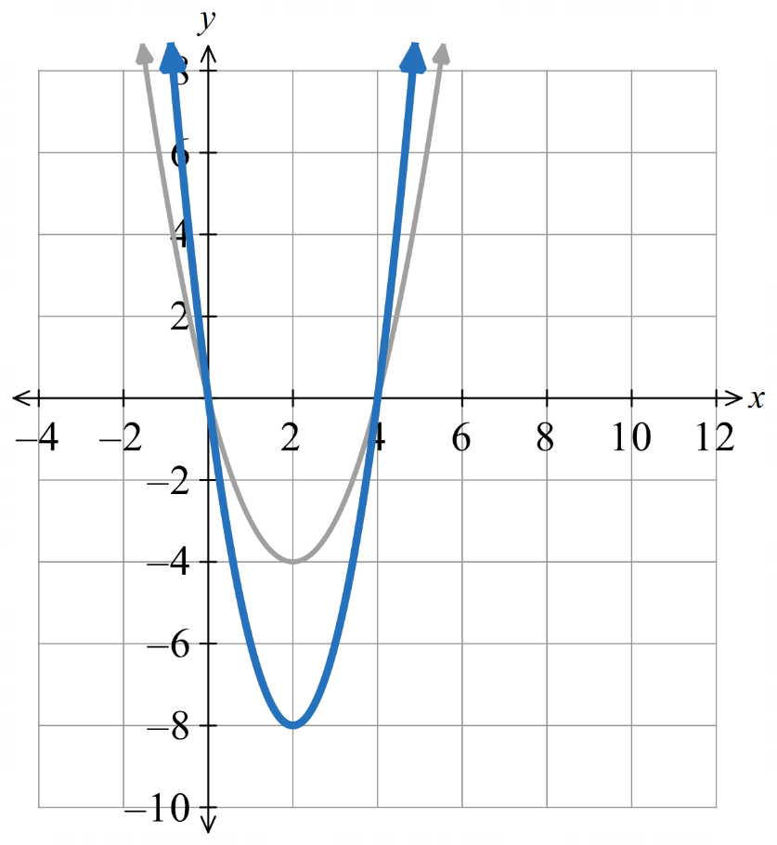
The graph of $\frac{y}{2}=x\left(x-4\right)$ is the graph of $y=x\left(x-4\right)$ dilated ……………………
Therefore, replacing $y$ with $\frac{y}{2}$ is a vertical dilation of factor ……
In function notation: $\frac{y}{2}$ $=f\left(x\right)$
$y=2f\left(x\right)$

- Vertical Dilations
Vertical dilations are stretches or compressions in the $x$-axis, parallel to the $y$-axis.
Let $k$ be a positive number.
To dilate by factor $k$: $y↦$ $\frac{y}{k}$  This multiplies all $y$ coordinates by $k$.  $$\frac{y}{k}=f\left(x\right) \\ y=kf\left(x\right)$$  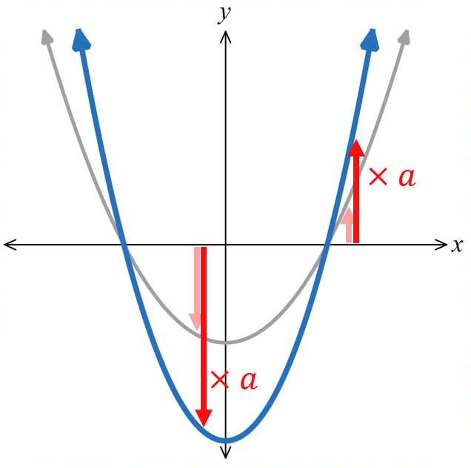 | To dilate by factor $\frac{1}{k}$ $:y↦$ $ky$  This multiplies all $y$ coordinates by $\frac{1}{k} (or ÷k)$  $$ky=f\left(x\right) \\ y=\frac{f\left(x\right)}{k}$$  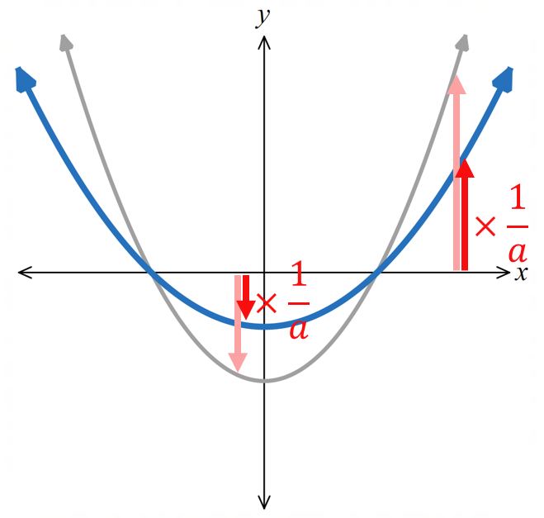

- Interpret Vertical dilations
$y=f\left(x\right)$ is given. Sketch:
- $y=2f(x)$  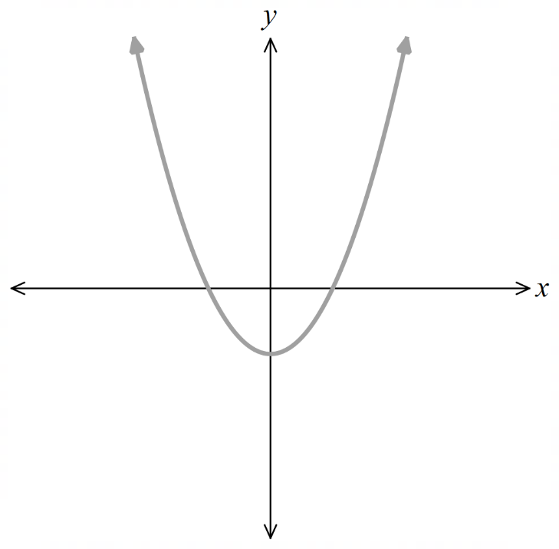 | - $y=\frac{f\left(x\right)}{2}$  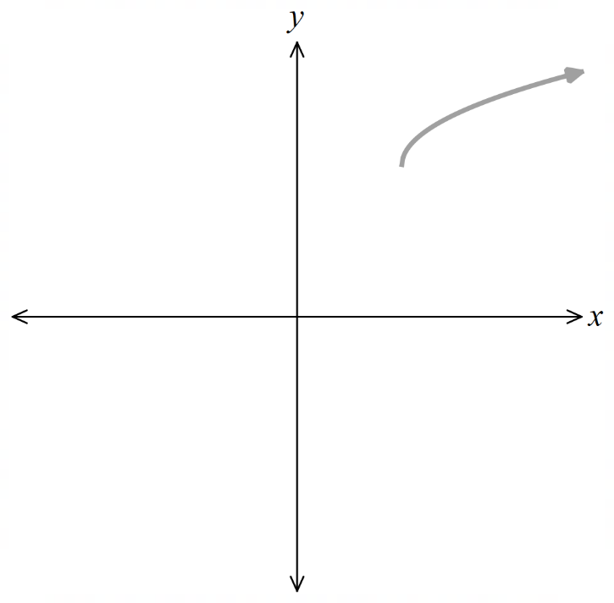 |  | - $\frac{2}{3}y=f\left(x\right)$  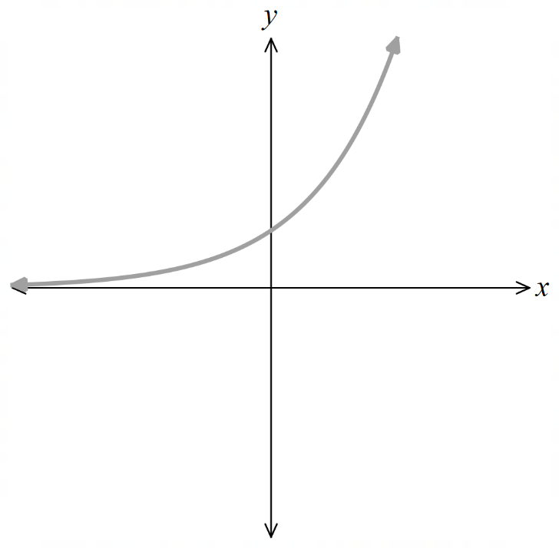
$f\left(x\right)$ and its transformation is shown, identify the new function in function notation.
 | 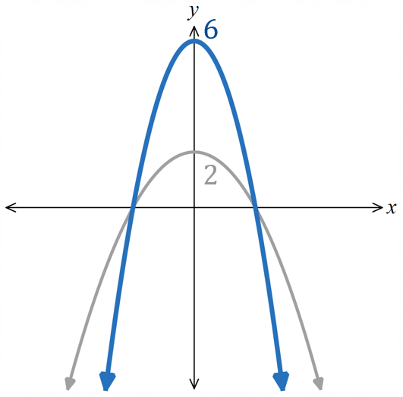 |  | 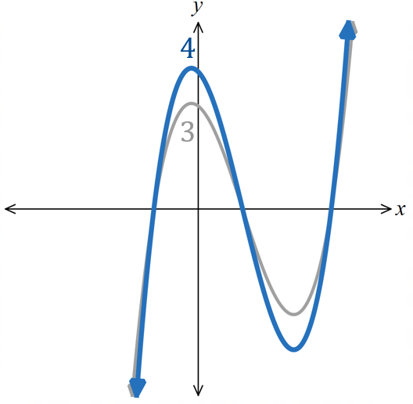  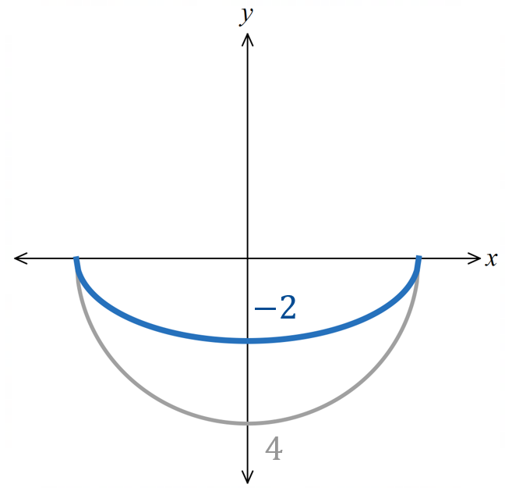
- Example Dilate using the equation.
$y=\sqrt{3x+1}$ is dilated horizontally by a factor of $\frac{1}{2}$. Find the new equation.  $$y=\sqrt{3\left(\frac{x}{\left(\frac{1}{2}\right)}\right)+1} \\ =\sqrt{3\left(2x\right)+1} \\ =\sqrt{6x+1}$$ |  | $x^{2}+y^{2}=4$ is dilated vertically by a factor of 3. Find the new equation.  $$x^{2}+{\left(\frac{y}{3}\right)}^{2}=4 \\ x^{2}+\frac{y^{2}}{9}=4$$

- Guided Practice
Find the equation of the new curve if:
- $y=3x^{2}$ is dilated vertically by factor $2$.  $$y =6x^{2}$$ | - $y=3x^{2}$ is dilated horizontally by factor $2$  $$y =\frac{3}{4}x²$$
- The parabola $y=\left(x-3\right)\left(x-5\right)$ is dilated horizontally with factor $-\frac{1}{3}$  $$y = 9\left(x + 1\right)\left(x +\frac{5}{3}\right)$$ | - ${\left(x+1\right)}^{2}+{\left(y-1\right)}^{2}=1$ is dilated by a factor of 3 horizontally and vertically.  $${\left(x + 3\right)}^{2}+ {\left(y - 3\right)}^{2}= 9$$

- Identifying Dilations
If you are given two equations and asked to determine the translations,
- Replace $x$ and/or $y$ in the original equation with $\frac{x}{a}$ and $\frac{y}{k}$ and
set it equal to the new equation,
- Solve to find $a$ or $k,$ equating coefficients if necessary.

- Example Identifying the translation from an equation.
The function $y=$ $\frac{5x+1}{x-2}$ is dilated horizontally to $y=$ $\frac{5x+2}{x-4}$. Find the dilation factor.
$$\frac{\frac{5x}{a}+1}{\frac{x}{a}-2}=\frac{5x+2}{x-4} \\ \frac{5x+a}{x-2a}=\frac{5x+2}{x-4} \\ ∴a=2$$
Dilation factor is 2

- Guided Practice
Find the dilation factor.
- $y=x\left(x+2\right)$ is dilated horizontally to $5x\left(5x+2\right)$.  $$\frac{1}{5}$$ | - $x^{2}+y^{2}=1$ is dilated vertically to  $$x^{2}+\frac{y^{2}}{9}=1$$  $$3$$
- $y=x^{2}$ dilated vertically to $y=3x^{2}$  $$3$$ | - $y=x^{2}$ dilated horizontally to $y=3x^{2}$  $$\frac{1}{\sqrt{3}}$$

Foundation
- Consider the graph of $f(x)=x^{2}$.
- The graph has been dilated horizontally.  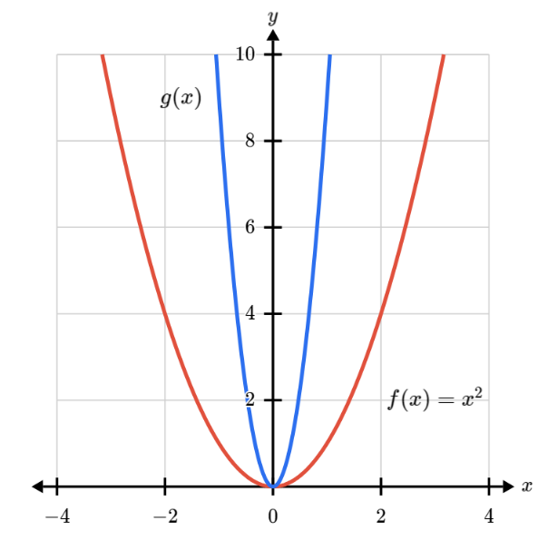  What would the equation of $g(x)$ be?  - $g\left(x\right)={\left(\frac{1}{3}x\right)}^{2}$  - $g\left(x\right)=\frac{1}{3}x^{2}$  - $g\left(x\right)={3x}^{2}$  - $g\left(x\right)={\left(3x\right)}^{2}$  D | - The graph has been dilated vertically.  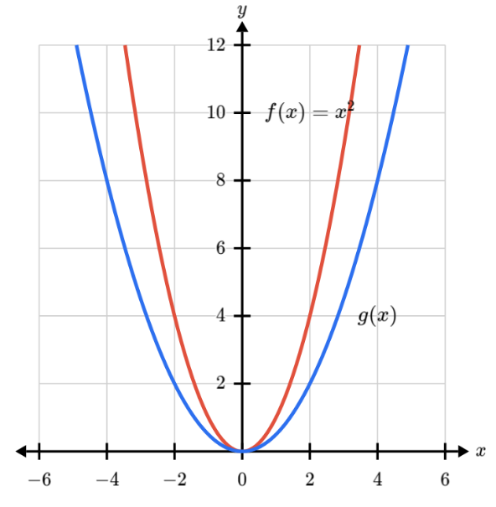  What would the equation of $g(x)$ be?  - $g\left(x\right)=2x^{2}$  - $g\left(x\right)=\frac{1}{2}x^{2}$  - $g\left(x\right)={\left(2x\right)}^{2}$  - $g\left(x\right)={\left(\frac{x}{2}\right)}^{2}$  B

- Consider the graph of $f(x)=\sqrt{x}$.
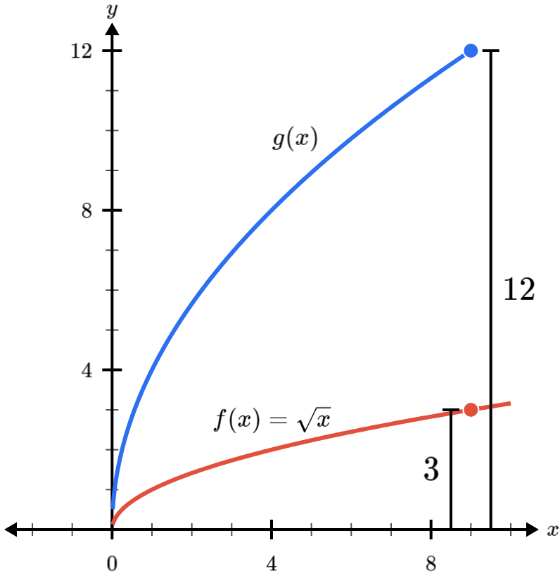  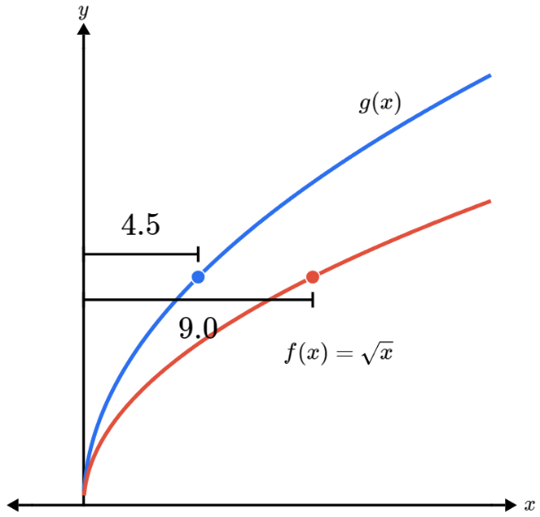  What would the equation of $g(x)$ be?  - $g\left(x\right)=2\sqrt{x}$  - $g\left(x\right)=\sqrt{2x}$  - $g\left(x\right)=\sqrt{4.5x}$  - $g\left(x\right)=4.5\sqrt{x}$  B | What would the equation of $g(x)$ be?  - $g\left(x\right)=3\sqrt{x}$  - $g\left(x\right)=4\sqrt{x}$  - $g\left(x\right)=\sqrt{3x}$  - $g\left(x\right)=\sqrt{4x}$  B
- Determine the dilation factor if the original graph is $y=f\left(x\right)$.
- $y=$ $f\left(2x\right)$  Horizontal by factor $\frac{1}{2}$ | - $y=$ $f\left(3x\right)$  Horizontal by factor $\frac{1}{3}$ | - $y=$ $f\left(\frac{x}{2}\right)$  Horizontal by factor 2
- $y=$ $f\left(\frac{x}{3}\right)$  Horizontal by factor 3 | - $y=$ $f\left(\frac{2x}{3}\right)$  Horizontal by factor $\frac{3}{2}$ | - $y=$ $f\left(\frac{3x}{2}\right)$  Horizontal by factor $\frac{2}{3}$
- $y=2f\left(x\right)$  Vertical by factor 2 | - $y=3f\left(x\right)$  Vertical by factor 3 | - $3y=f\left(x\right)$  Vertical by factor $\frac{1}{3}$
- $3y=$ $2f\left(x\right)$  Vertical by factor $\frac{2}{3}$ | - $y=$ $\frac{f\left(x\right)}{3}$  Vertical by factor $\frac{1}{3}$ | - $\frac{y}{2}=$ $3f\left(x\right)$  Vertical by factor 6

- Write the new equation for each relation after the given dilation has been applied.
Sketch the graph of the transformed relation.
- $y=x^{2}$  horizontally by $\frac{1}{2}$  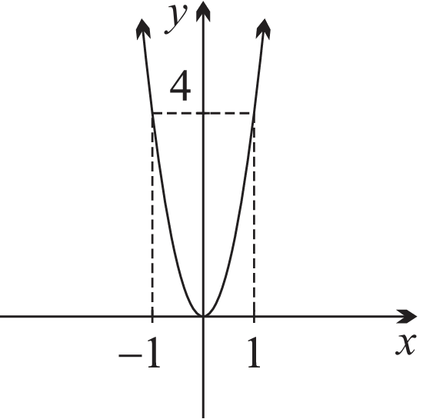  $$y=4x^{2}$$ | - $y=2^{x}$  vertically by 2  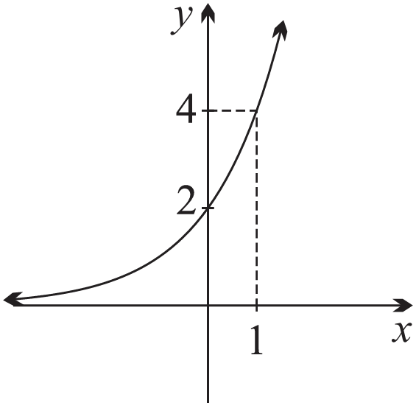  $$y=2×2^{x}=2^{x+1}$$ | - $y=x^{2}-1$  vertically by $-1$  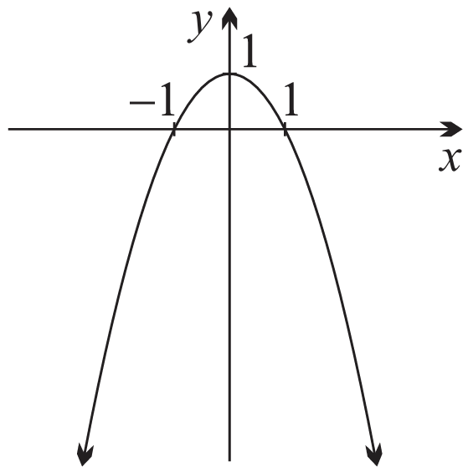  $$y=1-x^{2}$$
- $y=\frac{1}{x}$  horizontally by 2  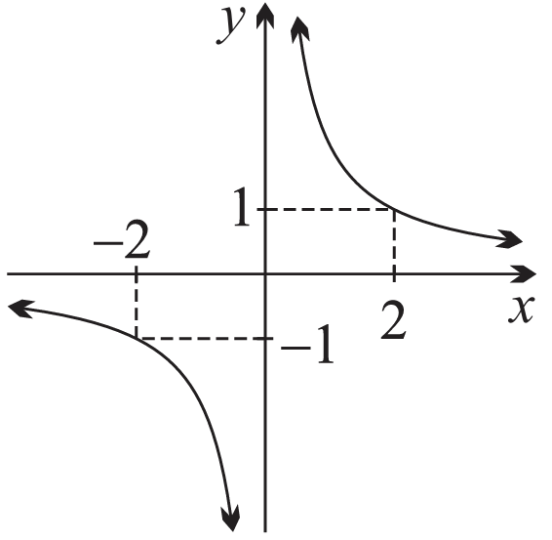  $$y=\frac{2}{x}$$ | - $x^{2}+y^{2}=4$  vertically by $\frac{1}{3}$  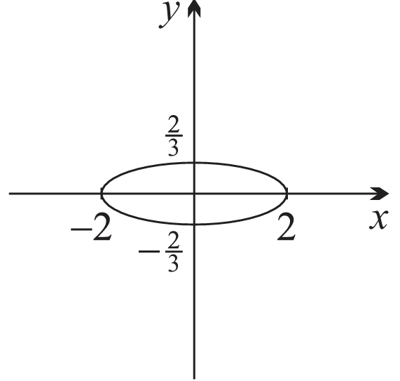  $$x^{2}+9y^{2}=4$$ | - $y=\sqrt{4-x^{2}}$  horizontally by $\frac{1}{2}$  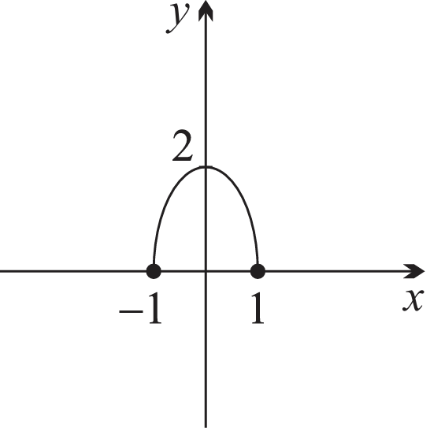  $$y=2\sqrt{1-x^{2}}$$
- In each case, $y=f\left(x\right)$ has been drawn. Draw the specified function transformations.
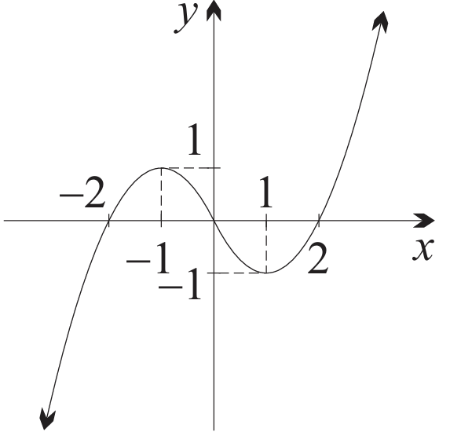 | $$y=f\left(2x\right)$$  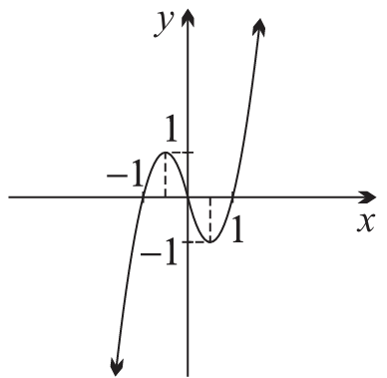 | $$y=2f\left(x\right)$$  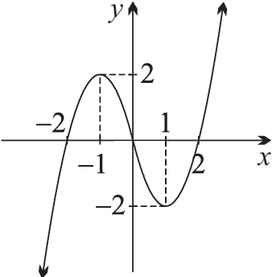
 | $$y=f\left(\frac{x}{2}\right)$$  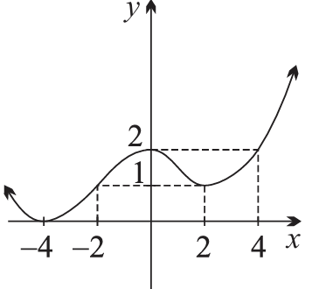 | $$y=\frac{f\left(x\right)}{2}$$  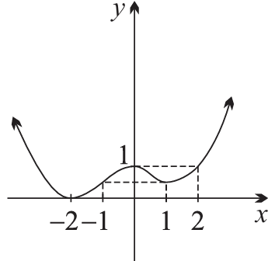
 | $$\frac{y}{2}=f\left(x\right)$$  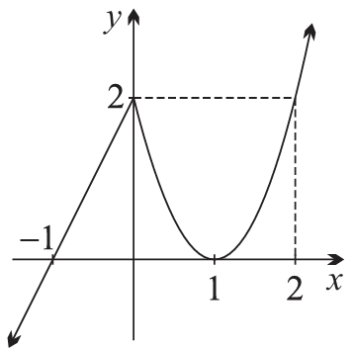 | $$y=f\left(\frac{x}{2}\right)$$  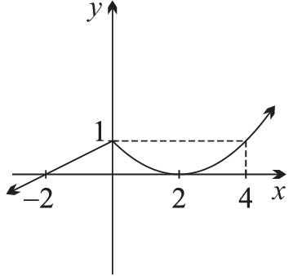
 | $$2y=f\left(x\right)$$  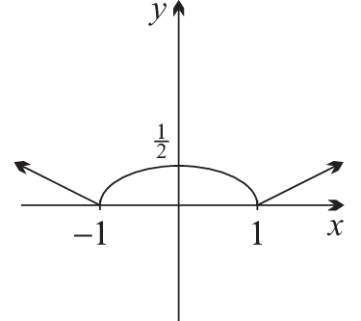 | $$y=f\left(2x\right)$$  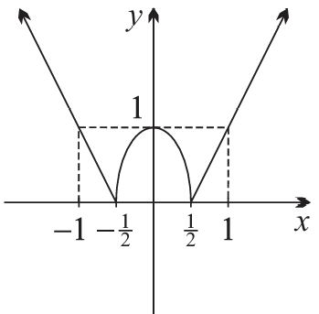

- Based on the previous question, complete these sentences:
The $x$-intercepts of a function, $f\left(x\right)=0$, is unchanged by a ……………… dilation.
vertical
The $y$-intercept, $f\left(0\right)$, of a function is unchanged by a ……………… dilation.
horizontal

Development
- In each case, identify which graph is which.
- $y=x\left(4+x\right)$  $$y=2x\left(4+x\right)$$  $$y=\frac{x}{2}\left(4+\frac{x}{2}\right)$$  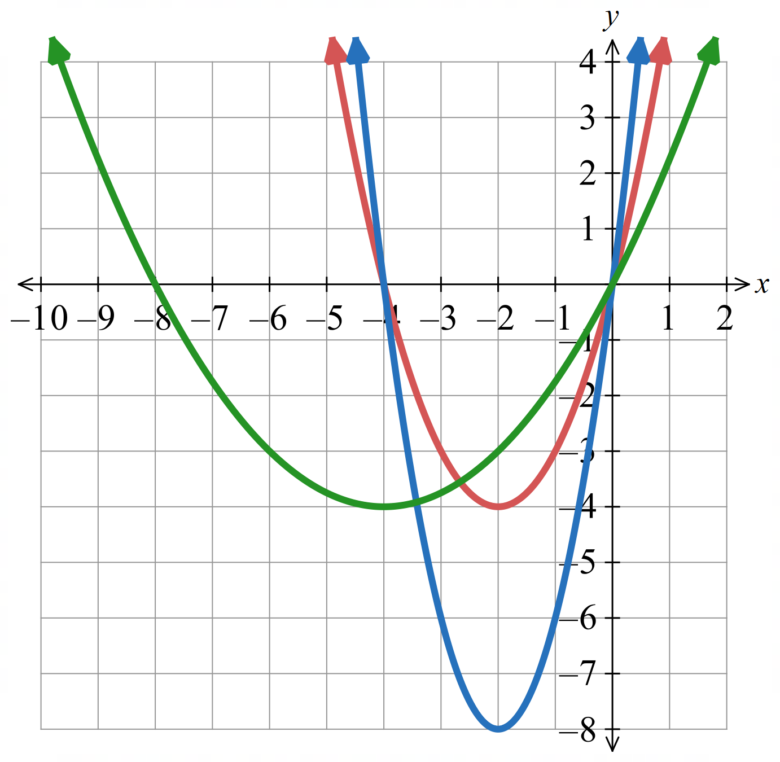  Red: $y=x\left(4+x\right)$  Blue: $y=2x\left(4+x\right)$  Green: $y=$ $\frac{x}{2}\left(4+\frac{x}{2}\right)$ | - $x^{2}+y^{2}=36$  $${\left(\frac{x}{2}\right)}^{2}+{\left(\frac{y}{3}\right)}^{2}=36$$  $${\left(2x\right)}^{2}+\left(3y^{2}\right)=36$$  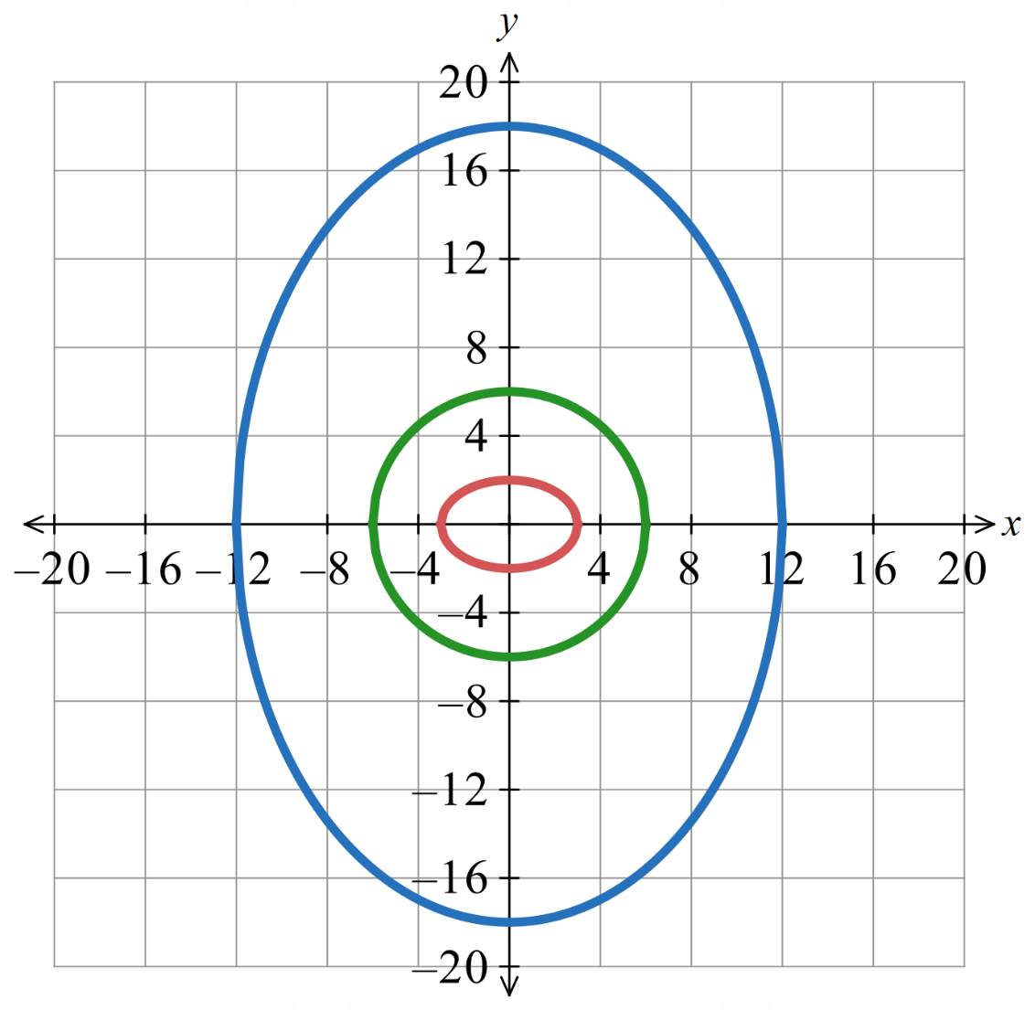  Green: $x^{2}+y^{2}=36$  Blue: ${\left(\frac{x}{2}\right)}^{2}+{\left(\frac{y}{3}\right)}^{2}$ $=36$  Red: ${\left(2x\right)}^{2}+\left(3y^{2}\right)=36$

  - Consider the function $y = x(x + 2)$
    - The graph in part a is stretched horizontally by a factor of 2.
Write down the equation of this new function.
$$y=\frac{1}{4}x\left(x+4\right)$$
    - This graph is then stretched vertically by a factor of 3.
Write down the equation of this new function.
$$y=\frac{3}{4}x\left(x+4\right)$$
  - Consider again $y = x(x + 2)$
    - The graph in part b is stretched vertically by a factor of 3.
Write down the equation of this new function.
$$y=3x\left(x+2\right)$$
    - This graph is then stretched horizontally by a factor of 2.
Write down the equation of this new function.
$$y=\frac{3}{4}x\left(x+4\right)$$
  - Compare your equations in parts a ii and b ii.
Did the order of the two dilations change the final results?
No.

    - Show that $y=x³-x$is an odd function.
Let $f\left(x\right)=x^{3}-x$
$$f\left(-x\right)=(-{x)}^{3}-\left(-x\right)$$
$$=-x^{3}+x$$
$$=-f\left(x\right)$$
    - This function is stretched horizontally by a factor of 2.
Write down the equation of this new function.
$$y=\frac{1}{8}\left(x^{3}-4x\right)$$
    - Is the new function odd?

Yes

    - Show that $y=1-x²$ is an even function.
Let $f\left(x\right)=1-x^{2}$
$$f\left(-x\right)=1-{\left(-x\right)}^{2}$$
$$=1-x^{2}$$
$$=f\left(x\right)$$
    - This function is stretched vertically by a factor of 3.
Write down the equation of this new function.
$$y=3\left(1-x^{2}\right)$$
    - Is the new function even?

Yes
  - What do you conclude about dilations and symmetry from these two examples?

Dilations do not affect symmetry

- In each case identify how the graph of the second equation can be obtained from the graph of the first by a suitable dilation.
- $y=x^{2}-2x$ and $y=3x^{2}-6x$  Vertical factor 3 | - $y=$ $\frac{1}{x-4}$ and $y=$ $\frac{1}{2x-4}$  Horizontal factor $\frac{1}{2}$
- $y=3^{x}$ and $y=3^{\frac{x}{4}}$  Horizontal factor 4 | - $y=$ $\frac{1}{x+1}$ and $y=$ $\frac{2}{x+1}$  Vertical factor 2

- Consider the parabola $y=x^{2}$
  - Write the equation of $g\left(x\right)=4f(x)$. What dilation is this?
$y=4x^{2}$ Vertical dilation by factor 4.
  - Write the equation of $h\left(x\right)=f(2x)$. What dilation is this?
$y=4x^{2}$ Horizontal dilation by factor $\frac{1}{2}$.
  - What do you notice about the answers to parts a and b?

Both give the same equation $y = 4x².$
For $y = x²,$ a vertical dilation by factor $k²$ is equivalent to a horizontal dilation by factor $\frac{1}{k}.$

- Consider the hyperbola $y=$ $\frac{1}{x}$
  - Write the equation of $g\left(x\right)=2f(x)$. What dilation is this?
$y=$ $\frac{2}{x}$ Vertical dilation by factor 2.
  - Write the equation of $h\left(x\right)=f\left(\frac{x}{2}\right)$. What dilation is this?
$y=$ $\frac{2}{x}$ Horizontal dilation by factor 2.
  - What do you notice about the answers to parts a and b?

Both give the same equation $y =$ $\frac{2}{x}$.
For $y =$ $\frac{1}{x}$, a vertical dilation by factor $k$ is equivalent to a horizontal dilation by factor $k$.
- Show that horizontally translating $y=2^{x}$ is equivalent to dilating it vertically.
Consider a horizontal translation left by $c$:
$$y=2^{x+c}$$
$$y=2^{x}×2^{c}$$
This is a vertical dilation by factor by $2^{c}$
- Describe the gradient-intercept formula $y=mx+c$ in terms of a dilation of the line $y=x+b$

Horizontal dilation by factor $\frac{1}{m}$
- Give a possible equation for each graph below as dilations of the given equation.
- $x^{2}+y^{2}=1$  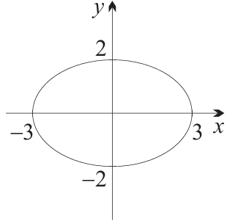  $$\frac{x^{2}}{9}+\frac{y^{2}}{4}=1$$ | - $y=3^{x}$  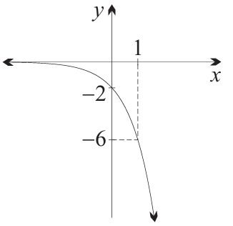  $$y=-2×3^{x}$$ | - $y=x^{2}-4$  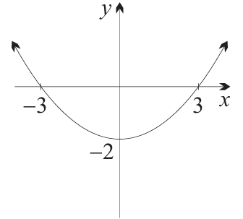  Horizontally by $\frac{3}{2}$ vertically by $\frac{1}{2}$  $$y=\frac{2}{9}\left(x^{2}-9\right)$$

Mixed Practice

- Summary of Transformations
Transformation | By Replacement | By Function Rule
Horizontal translation right $b$ | $x↦x-b$ | $$y=f(x-b)$$
Vertical translation up $c$ | $y↦y-c$ | $$y-c=f\left(x\right) \\ y=f\left(x\right)+c$$
Horizontal reflection | $x↦-x$ | $$y=f\left(-x\right)$$
Vertical reflection | $y↦-y$ | $$-y=f\left(x\right) \\ y=-f\left(x\right)$$
Horizontal dilation factor $a$ | $$x↦\frac{x}{a}$$ | $$y=f\left(\frac{x}{a}\right)$$
Vertical dilation factor $k$ | $$y↦\frac{y}{k}$$ | $$\frac{y}{k}=f\left(x\right)$$  $$y=kf\left(x\right)$$
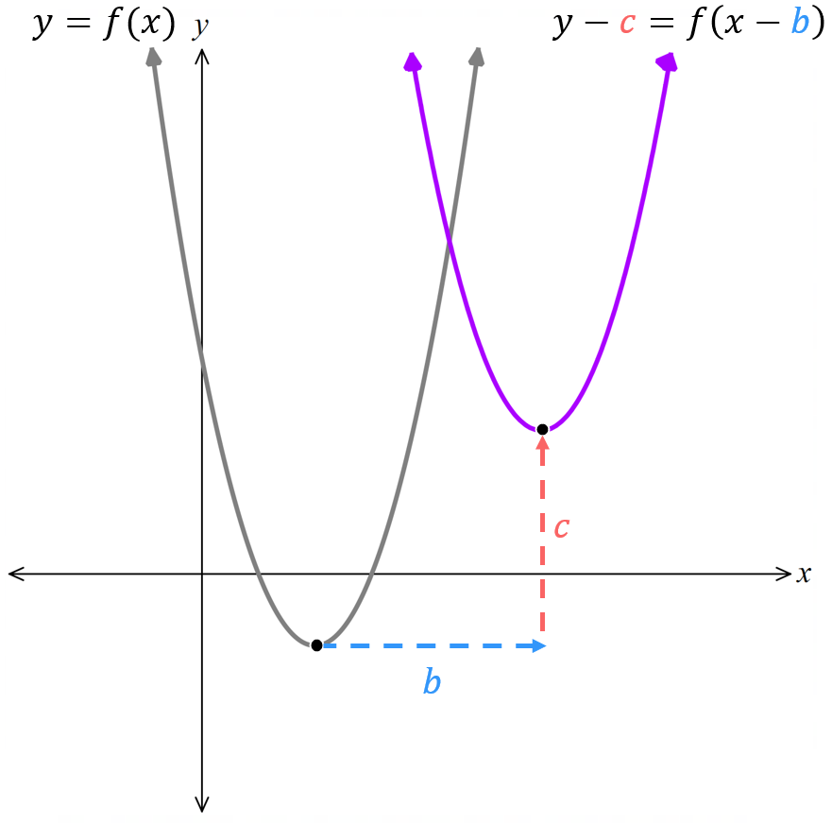
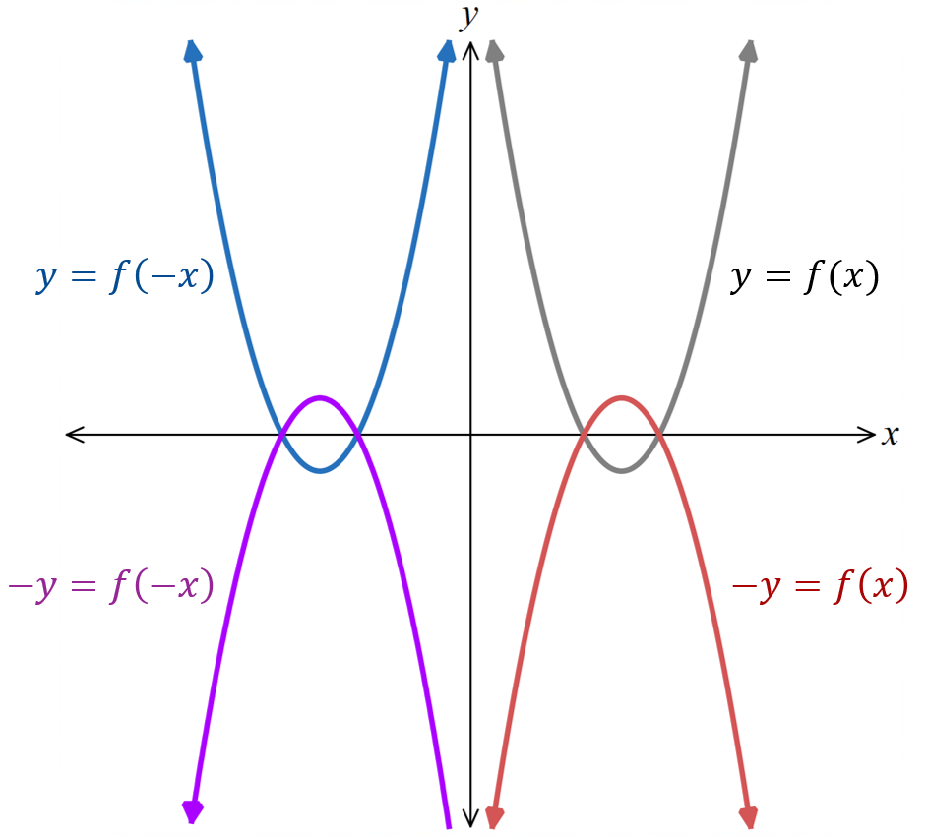

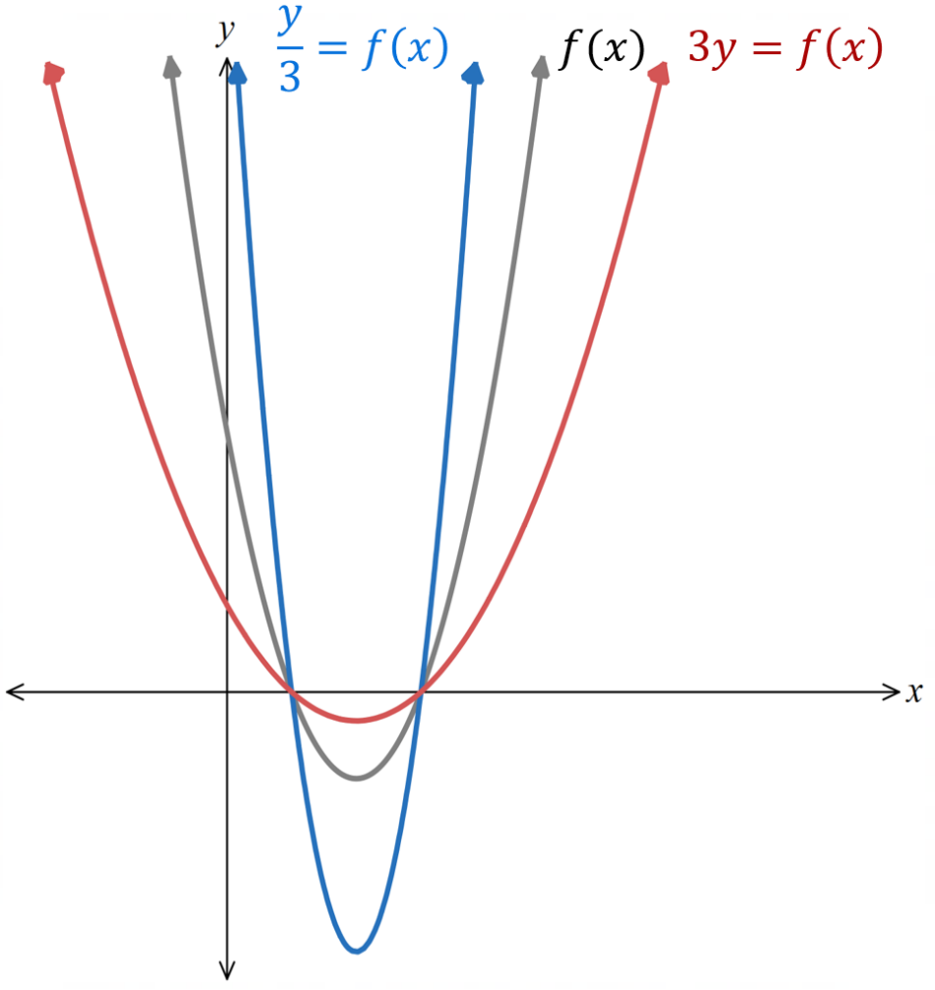
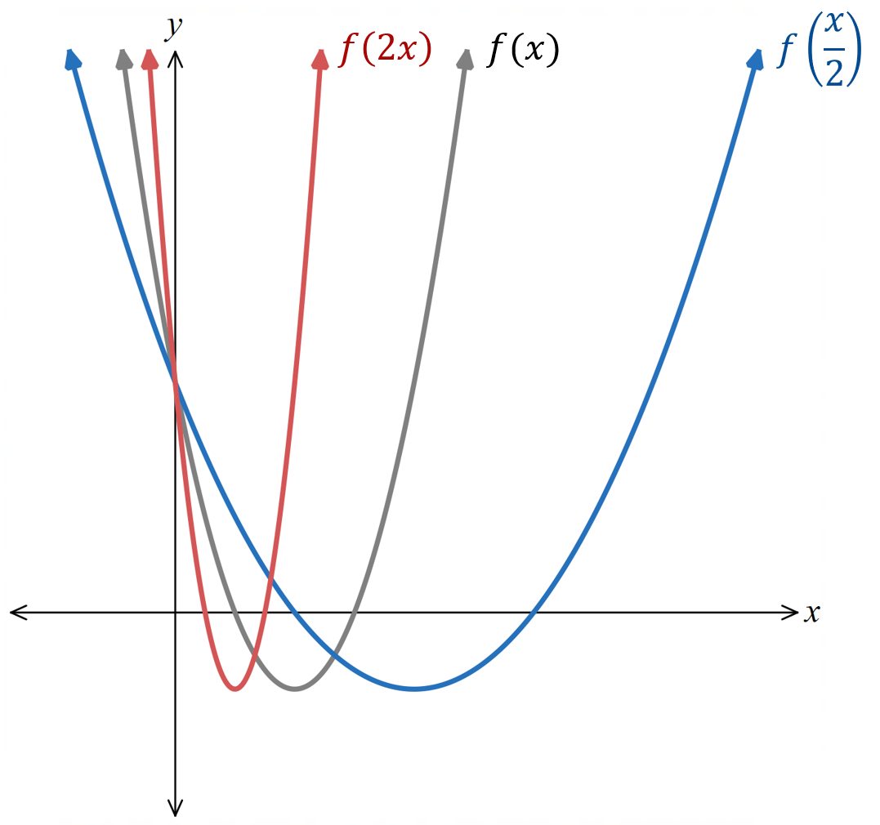

Foundation
- Given the curve $y = x²$, write down the translation that is required to obtain the graphs of the following.
- $y=x^{2}+2$  2 up | - $y=x^{2}-3$  3 down | - $y={\left(x+1\right)}^{2}$  1 left | - $y={\left(x-2\right)}^{2}$  2 right

- Let $f\left(x\right)=x^{2}$. Sketch the graph of the following, labelling intercepts with the coordinate axes.
- $y=f\left(x\right)+1$  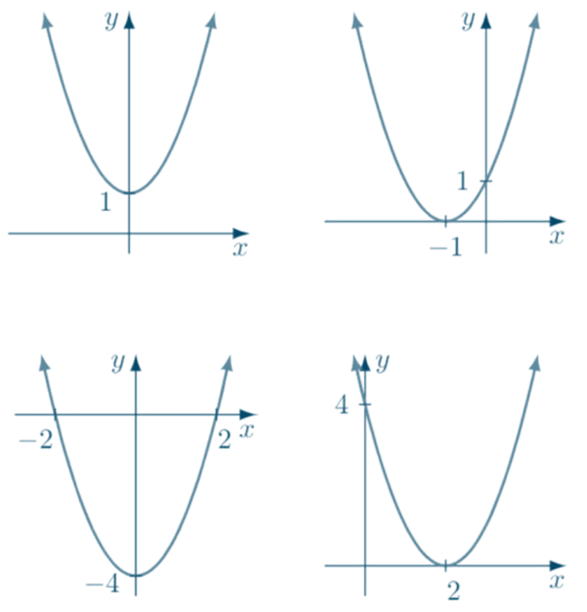 | - $y = f\left(x + 1\right)$ | - $y = f\left(x\right)- 4$ | - $y = f\left(x - 2\right)$

- Given the curve $y = 3^{x}$, write down the translation that is required to obtain the graphs of the following.
- $y=3^{x}-1$  1 down | - $y=3^{x-2}$  2 right | - $y=3^{x}+1$  1 up | - $y=3^{x+1}$  1 left

- Starting with $f(x),$ write down the translation that is required to obtain $g(x)$.
$$f\left(x\right)=\frac{1}{x}, g\left(x\right)=\frac{1}{x - 1}$$  1 right | $$f\left(x\right)=\frac{1}{x}, g\left(x\right)=\frac{1}{x}+ 1$$  1 up
$$f\left(x\right)= \left|x\right|, g(x) = \left|x - 3\right|$$  3 right | $$f\left(x\right)= \left|x\right|, g\left(x\right)= \left|x\right|- 3$$  3 down
$$f\left(x\right)= -x^{3}, g(x) = -{\left(x - 2\right)}^{3}$$  2 right | $$f\left(x\right)= -x^{3}, g\left(x\right)= -x^{3}- 3$$  3 down

- Write down the new equation obtained when the following translation is applied to $f(x).$
- $f(x) = 2x,$ translate left 2 units  $$y=2x+4$$ | - $f(x) = 2x,$ translate down 3 units  $$y=2x-3$$
- $f\left(x\right)=$ $\frac{1}{x - 1}$ translate left 2 units  $$y=\frac{1}{x+1}$$ | - $f\left(x\right)=$ $\frac{1}{x - 1}$ translate down 3 units  $$y=\frac{1}{x-1}-3$$
- $f(x) = 2x²,$ translate right 4 units  $$y=2{\left(x-4\right)}^{2}$$ | - $f(x) = 2x²$, translate up 2 units  $$y=2x^{2}+2$$
- $f(x) = 3 - 2x$, translate up 2 units  $$y=5-2x$$ | - $f(x) = 3 - 2x,$translate left 3 units  $$y=-2x-3$$

- Write down the new equation obtained when the following translation is applied to the graph.
- $2x + 3y + 1 = 0,$  translated right by 2 units.  $$2x+3y-3=0$$ | - $x^{2}+y^{2}=4,$  translated left by 4 units.  $${\left(x+4\right)}^{2}+y^{2}=4$$
- $xy = 1$, translated right by 3 units.  $$y=\frac{1}{x-3}$$ | - $x² + xy = 1$, translated left by 1 unit.  $$y=\frac{1}{x+1}-\left(x+1\right)$$

- The points $P\left(0,-2\right)$ and $Q\left(-4,-6\right)$ lie on the graph of $y=f\left(x\right)$.
The graph of $y=f\left(x+2\right)+3$ is then drawn. State the new locations of $P$ and $Q$.
Left 2, up 3
Subtract 2 from $x$ coordinates and add $3$ to $y$ coordinates
$P\left(-2,1\right)$ and $Q\left(-6,-3\right)$
- $y=-x^{2}+bx+c$ has $x$ intercepts $-1$ and 4.
  - Find the values of $b$ and $c$.
$$x intercepts at x = -1 and x = 4$$
$$∴ y = -(x + 1)(x - 4) \\ y = -(x² - 3x - 4) \\ y = -x² + 3x + 4$$
$$b=3, c=4$$
  - Find the equation of the resulting function if $y=f\left(x\right)$ is shifted 6 units left.
$$replace x with (x + 6)$$
$$y = -(x + 6)² + 3(x + 6) + 4 \\ y = -(x² + 12x + 36) + 3x + 18 + 4 \\ y = -x² - 12x - 36 + 3x + 22 \\ y = -x² - 9x - 14$$

Development
- For each pair of graphs, find the equation of $y=g\left(x\right)$ in terms of $f\left(x\right)$.
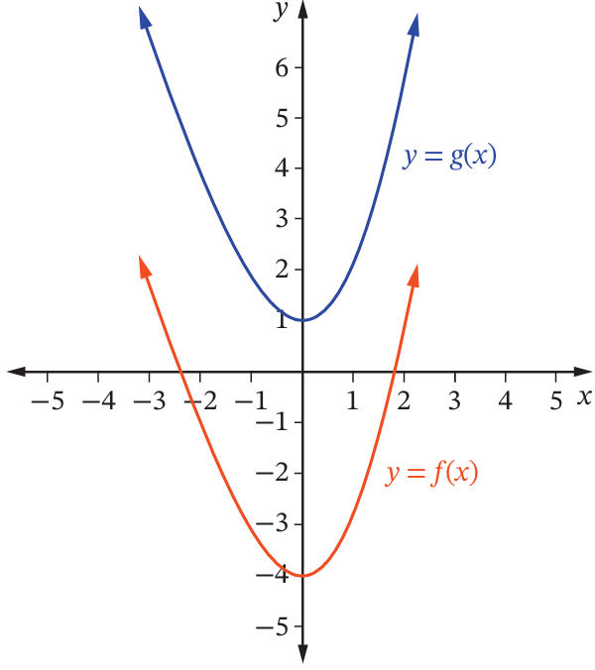  $$g\left(x\right)=f\left(x\right)+5$$ | 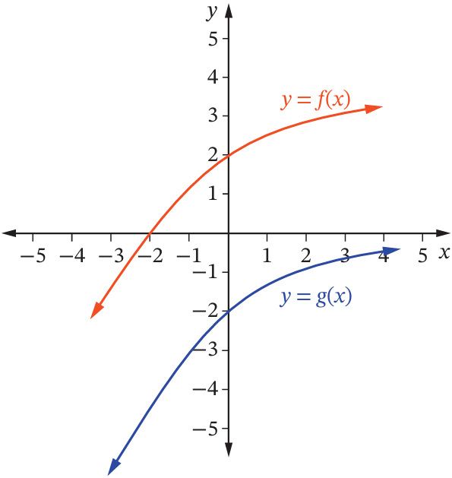  $$g\left(x\right)=f\left(x\right)-4$$ | 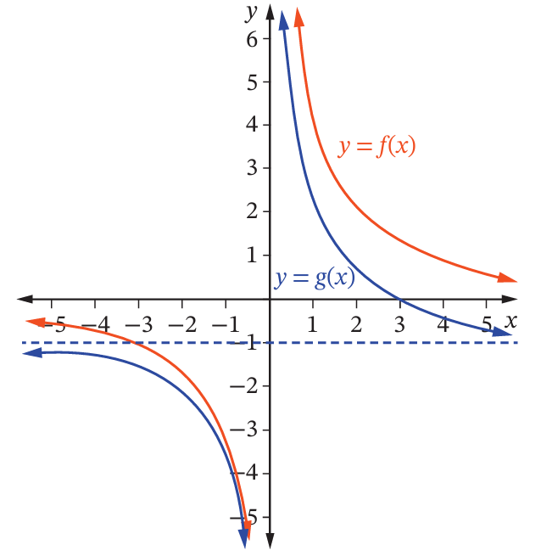  $$g\left(x\right)=f\left(x\right)-1$$
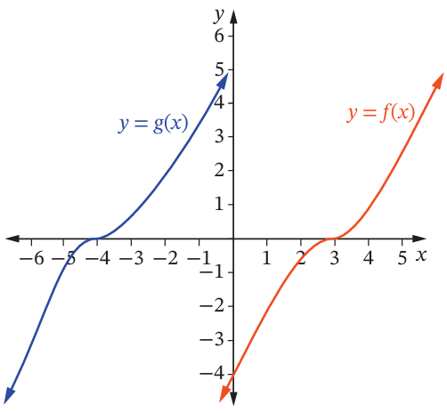  $$g\left(x\right)=f\left(x+7\right)$$ | 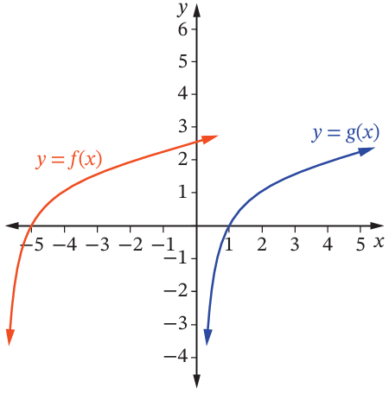  $$g\left(x\right)=f\left(x-6\right)$$

  - Show that $\frac{3x+1}{x}=\frac{1}{x}$ $+3$ for $x≠0$.
$$\frac{3x + 1}{x}=\frac{3x}{x}+\frac{1}{x} \\ = 3 +\frac{1}{x}$$
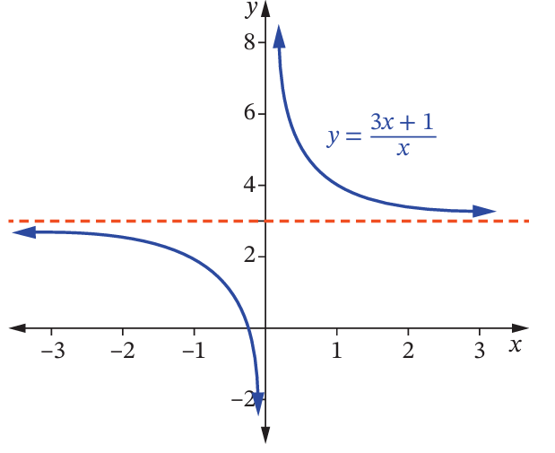
  - Hence sketch $y=$ $\frac{3x+1}{x}$

- The graphs of $y=f\left(x\right)$ are given.
Describe the transformation, write the new equation, then sketch the new curve.
- $f\left(x\right)={\left(x-2\right)}^{3}+1$  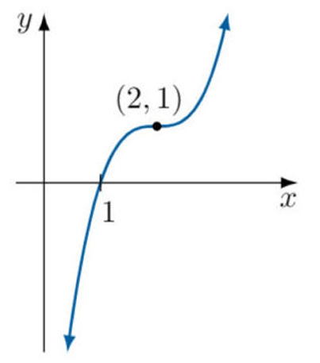 | $y=f\left(x+1\right)$  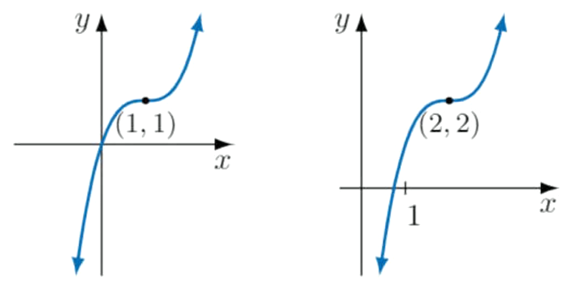  $$y={\left(x-1\right)}^{3}+1$$ | $$y=f\left(x\right)+1$$  $$y={\left(x-2\right)}^{3}+2$$
- $f\left(x\right)=\left(3-x\right)\left(3+x\right)$ | $y=f\left(x-1\right)$  $$y=\left(4-x\right)\left(x+2\right)$$ | $$y=f\left(x\right)-1$$  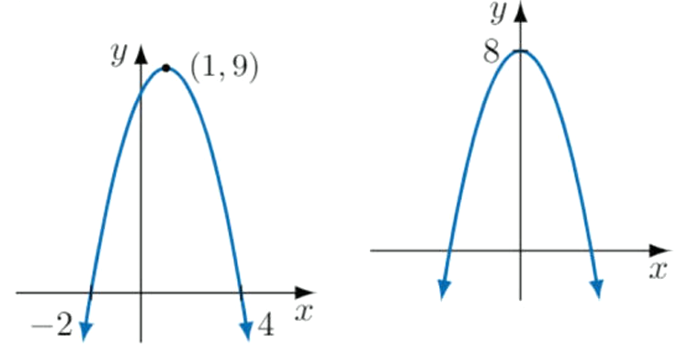  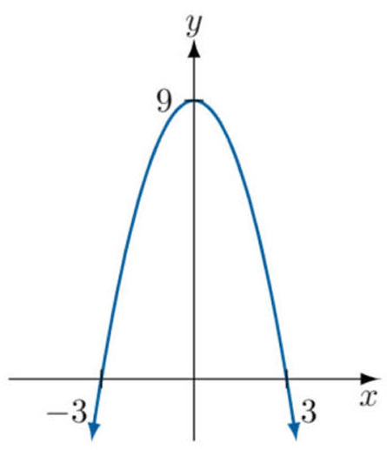  $$y=8-x^{2}$$
- $f\left(x\right)=-2^{-x}$  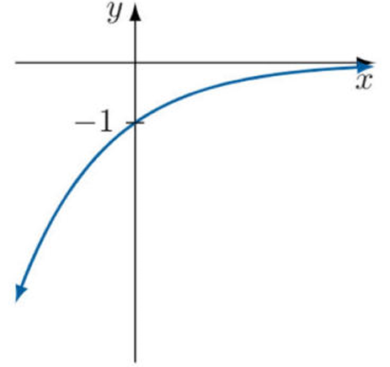  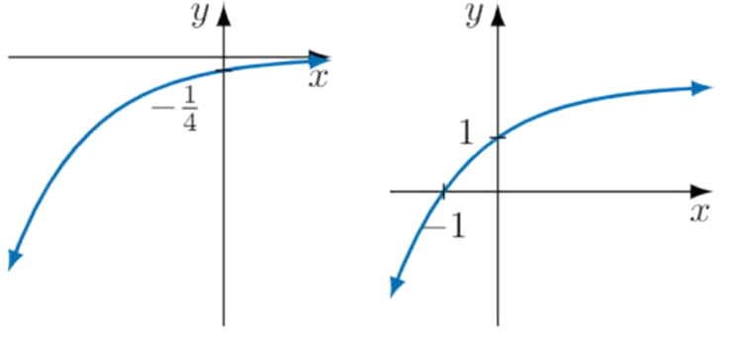 | $y=f\left(x+2\right)$  $$y=-2^{-x-2}$$ | $$y=f\left(x\right)+2$$  $$y=2-2^{-x}$$
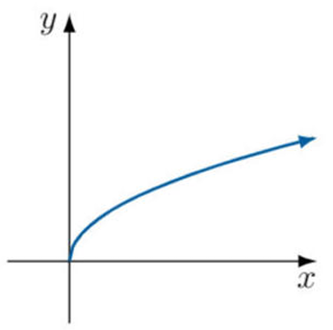
- The graph of $y=\sqrt{x}$ is given.

Sketch the following:
- $y=\sqrt{x}+2$  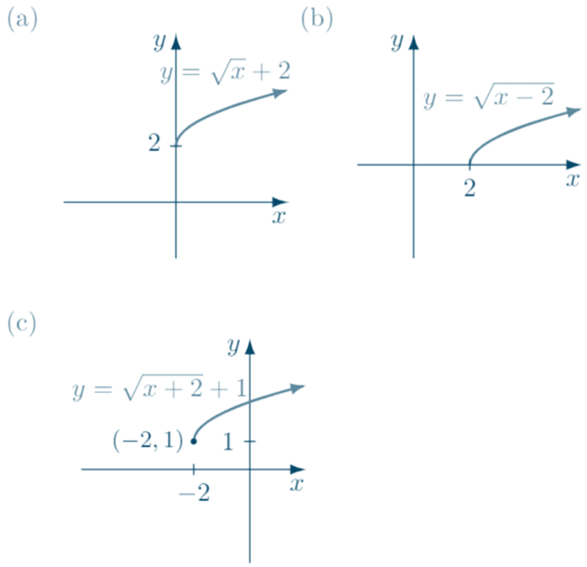 | - $y=\sqrt{x-2}$ | - $y=\sqrt{x+2}+1$
- By considering an appropriate ‘original’ and translating it, draw a sketch of these equations.
- $y=\left|x-1\right|$  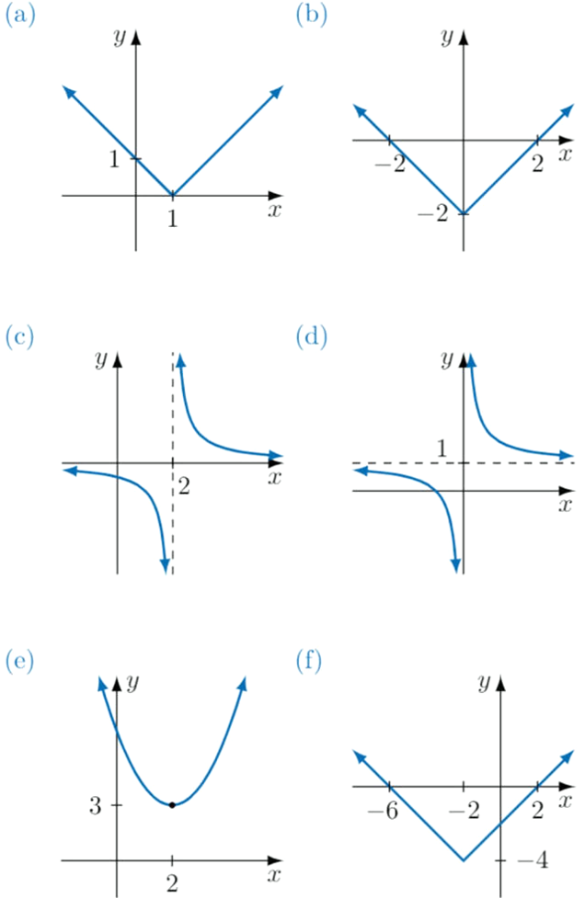 | - $y=\left|x\right|-2$ | - $y=$ $\frac{1}{x-2}$
- $y=$ $\frac{1}{x}$ $+1$ | - $y={\left(x-2\right)}^{2}+3$ | - $y=\left|x+2\right|-4$

- Sketch the following graphs by applying a translation to $y=2^{x}$. The original curve is given.
- $y=2^{x-2}$  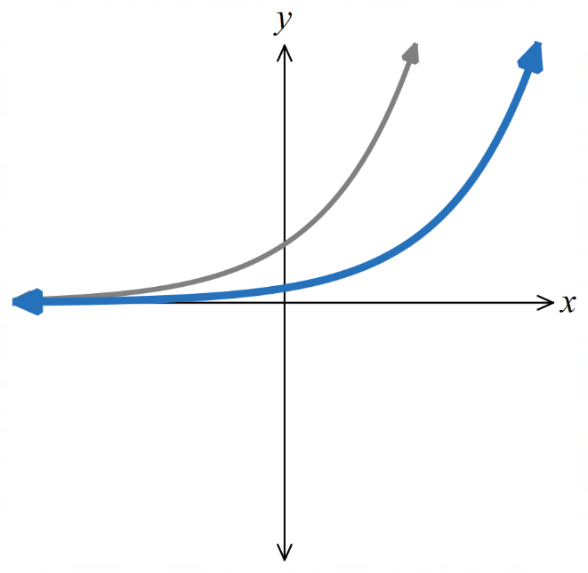  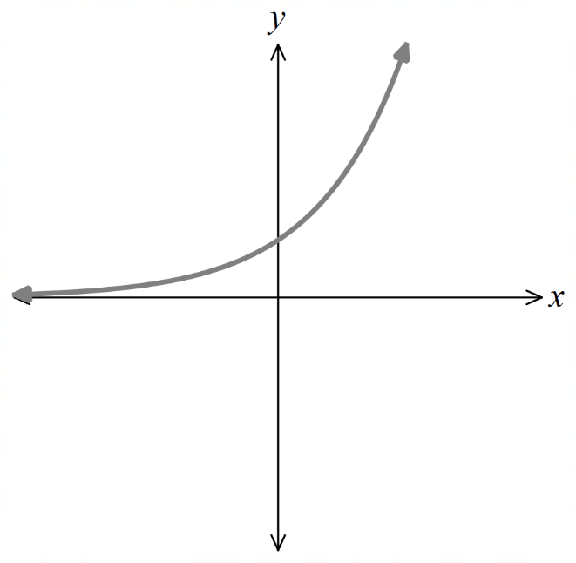 | - $y=2^{x}+1$  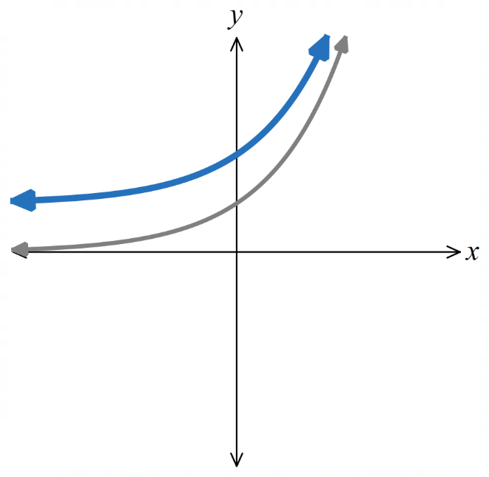 | - $y=-2^{x+2}$  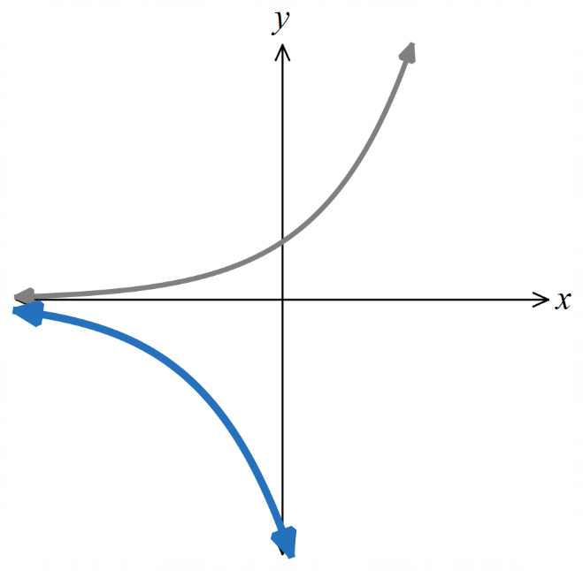
- $y=-2^{x}+3$  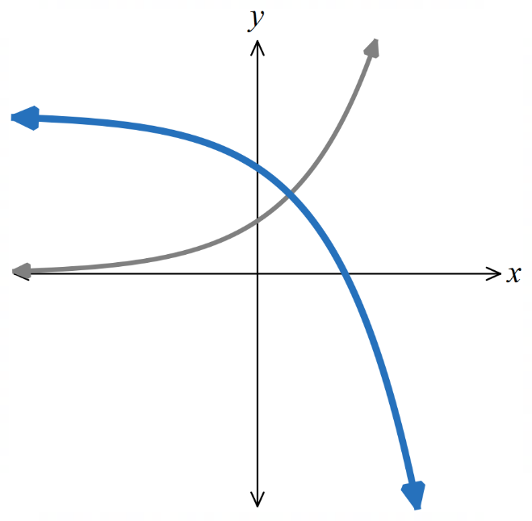 | - $y=-2^{-x}+1$  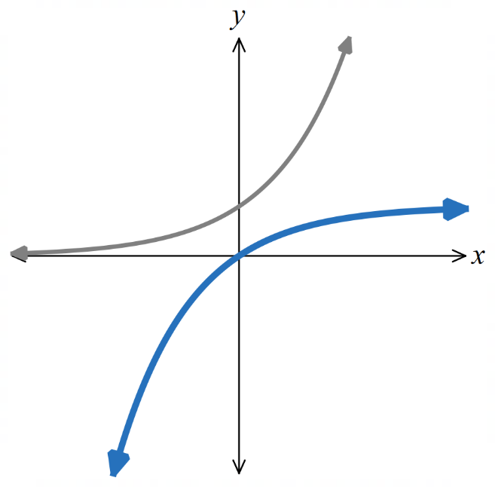 | - $y-1=-2^{x+1}$  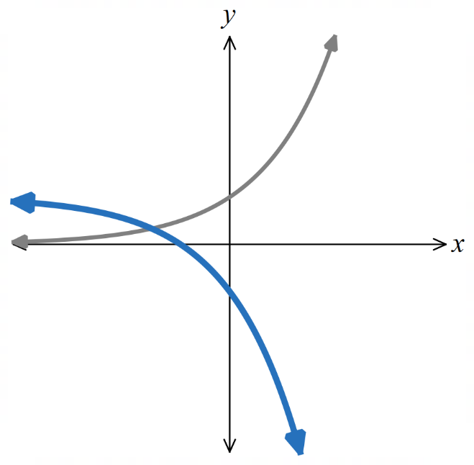

- In each part, describe how each subsequent equation is a transformation of the first graph.
- $y=x^{2}$ | $$y={\left(x+1\right)}^{2}$$  1 left | $$y=-{\left(x+1\right)}^{2}$$  1 left, vertical reflection | $$y={\left(x+1\right)}^{2}-1$$  1 left, 1 down
- $y=\sqrt{x}$ | $$y=\sqrt{x+4}$$  4 left | $$y=\sqrt{-x}$$  Horizontal reflection | $$y=-\sqrt{x+4}$$  4 left, vertical reflection
- $y=$ $\frac{2}{x}$ | $$y=\frac{2}{x}-1$$  1 down | $$y=\frac{2}{x-2}-1$$  2 right, 1 down | $$y=-\frac{2}{x}$$  Vertical or horizontal reflection
- $y=\sin{x}$ | $$y=\sin{x}-1$$  1 down | $$y=\sin\left(x-π\right)-1$$  $π$ right, 1 down | $$y=-\sin{x}$$  Vertical reflection or horizontal reflection (as $\sin\left(-x\right)=-\sin{x})$

- Explain why, for an odd function, a vertical reflection is the same as a horizontal reflection.

Since $f\left(-x\right)=-f\left(x\right)$
a vertical reflection is the same as a horizontal reflection

- Complete the square to determine the centre and radius of each circle.
- $x^{2}+4x+y^{2}-8y=0$  $${\left(x+2\right)}^{2}+{\left(y-4\right)}^{2}=20$$  Centre $\left(-2,4\right)$, radius $2\sqrt{5}$ | - $x^{2}-2x+y^{2}+4y=-1$  $${\left(x-1\right)}^{2}+{\left(y+2\right)}^{2}=4$$  Centre $\left(1,-2\right),$ radius 2

- For each pair of curves, suggest two transformations by which the second equation may be obtained from the first.
- $y=2^{x}$ and $y=2^{x+1}$  Vertical dilation factor 2 or  Horizontal translation left 1 | - $y=2x^{2}$ and $y=$ $8x^{2}$  Vertical dilation by factor 4 or  horizontal dilation by factor $\frac{1}{2}$ | - $x^{2}+{\left(y-2\right)}^{2}=1$ and  $$x^{2}+{\left(y+2\right)}^{2}=1$$  Vertical reflection or  vertical translation down 4

- Write down the new equations if these curves are translated to the right by 2 units.
Be careful with negatives!
- $f\left(x\right)=3-2x$  $$f\left(x\right)=7-2x$$ | - $f\left(x\right)=3-4x-x^{2}$  $$f\left(x\right)=7-x^{2}$$ | - $f\left(x\right)=2^{-2x}$  $$2^{-2x+4}$$

- Sketch the following graphs by applying a translation to $y=\ln{x}$. The original curve is given.
- $y=\ln\left(x-1\right)$  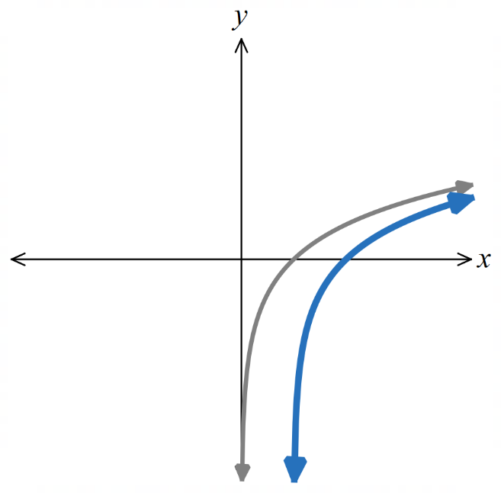  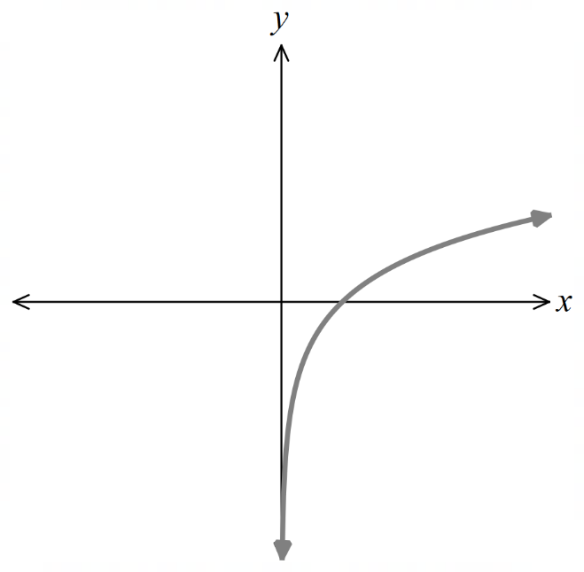 | - $y=\ln\left(x+2\right)$  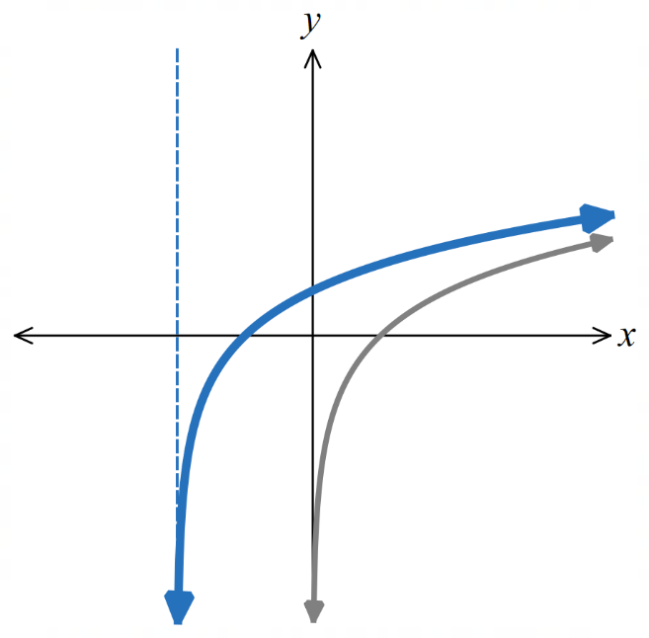 | - $y=\ln\left(x+1\right)+2$  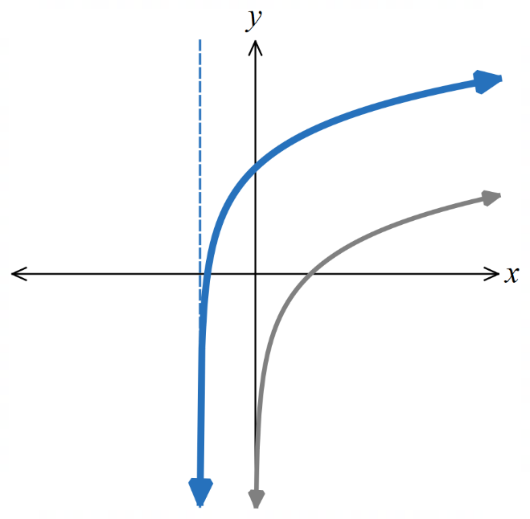

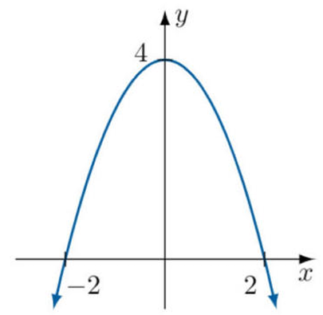
- The diagram shows the graph of $y=f\left(x\right)$.

Describe the transformation and
sketch the graph of the following:
- $y=2f\left(x\right)$  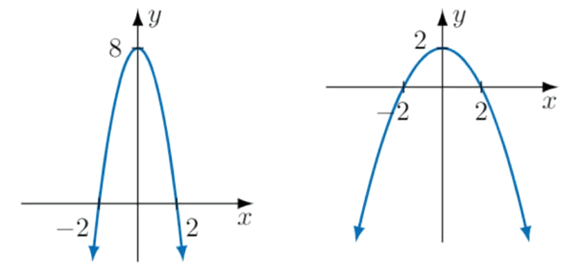  Vertical dilation factor 2 | - $y=$ $\frac{f\left(x\right)}{2}$  Vertical dilation factor $\frac{1}{2}$
- $y=f\left(2x\right)$  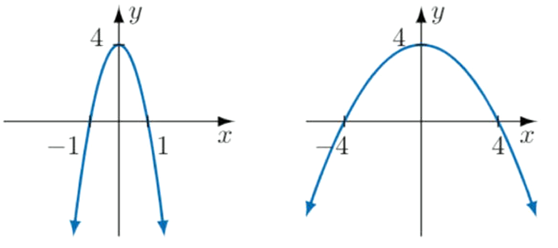  Horizontal dilation factor $\frac{1}{2}$ | - $y=$ $f\left(\frac{x}{2}\right)$  Horizontal dilation factor $2$
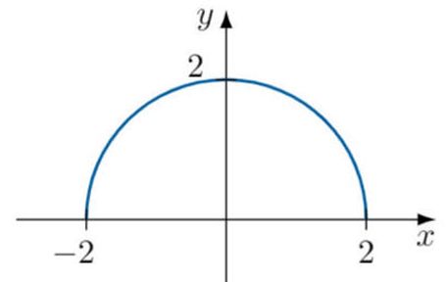
- The diagram shows the graph of $y=f\left(x\right)$.

Describe the transformation and sketch the graph of the following:
- $y=2f\left(2x\right)$  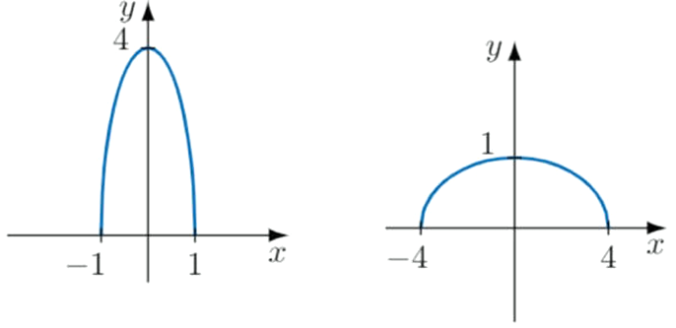  Vertical dilation factor 2,  horizontal dilation factor $\frac{1}{2}$ | - $y=$ $\frac{1}{2}f\left(\frac{x}{2}\right)$  Vertical dilation factor $\frac{1}{2}$,  horizontal dilation factor 2
- $y=\frac{1}{2}f\left(2x\right)$  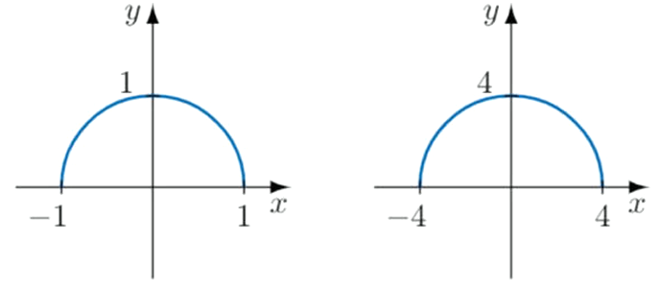  Vertical dilation factor $\frac{1}{2}$,  horizontal dilation factor $\frac{1}{2}$ | - $\frac{y}{2}$ $=$ $f\left(\frac{x}{2}\right)$  Vertical dilation factor 2,  horizontal dilation factor 2

- The graph shows $y=\sin{x}$ in the domain $x∈\left[-π, π\right]$.
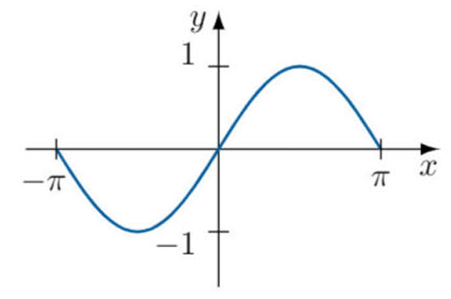

Sketch the following:
- $y=2\sin{x}$  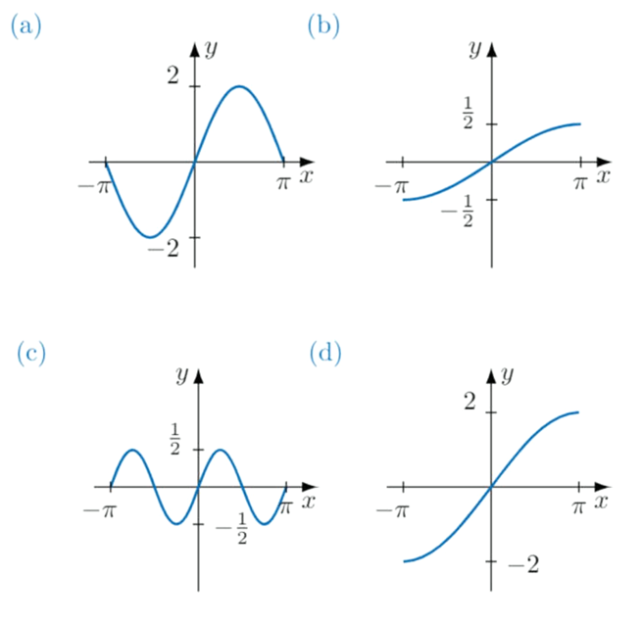 | - $y=$ $\frac{1}{2}\sin\left(\frac{x}{2}\right)$ | - $y=$ $\frac{1}{2}$ $\sin{2x}$ | - $y=2\sin\left(\frac{x}{2}\right)$

Combining Transformations

- Investigation Order of transformations
We have learned three types of graph transformations:
1. Translations
2. Reflections (dilation of factor $-1$)
3. Dilations
We will investigate which transformations are commutative, i.e. the order doesn’t matter.

Consider an arbitrary function $y=f\left(x\right)$.
Horizontal and Vertical Transformations
Dilate horizontally by factor $2,$  then translate downwards by $3$.  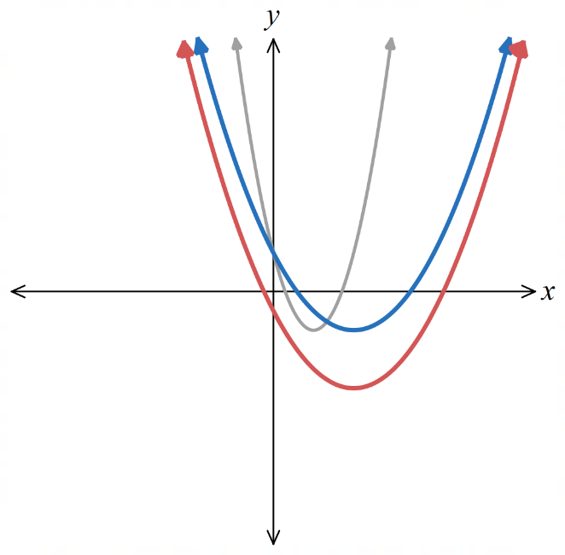  $y=f\left(x\right)$  $$y=f\left(\frac{x}{2}\right)$$  $$y+3=f\left(\frac{x}{2}\right)$$ | 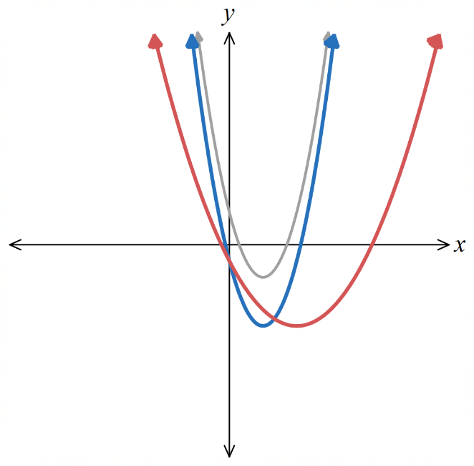  Translate downwards by $3$,  then dilate horizontally by factor $2.$  $$y=f\left(x\right)$$  $$y+3=f\left(x\right)$$  $$y+3=f\left(\frac{x}{2}\right)$$
The $x$ and $y$ coordinates are independent of each other.
We can apply vertical transformations first, or horizontal first.
The result is the same. Vertical and horizontal transformations are commutative.

Two Dilations
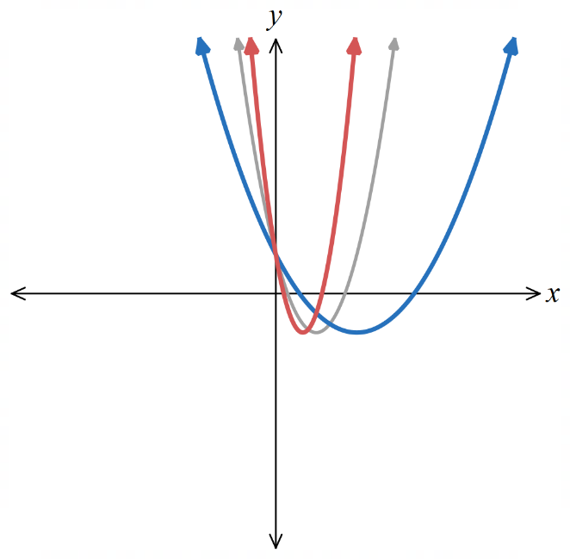  Dilate horizontally by factor $2,$  then dilate horizontally by factor $\frac{1}{3}$.  $$y=f\left(x\right)$$  $$y=f\left(\frac{x}{2}\right)$$  $$y=f\left(\frac{3x}{2}\right)$$ | 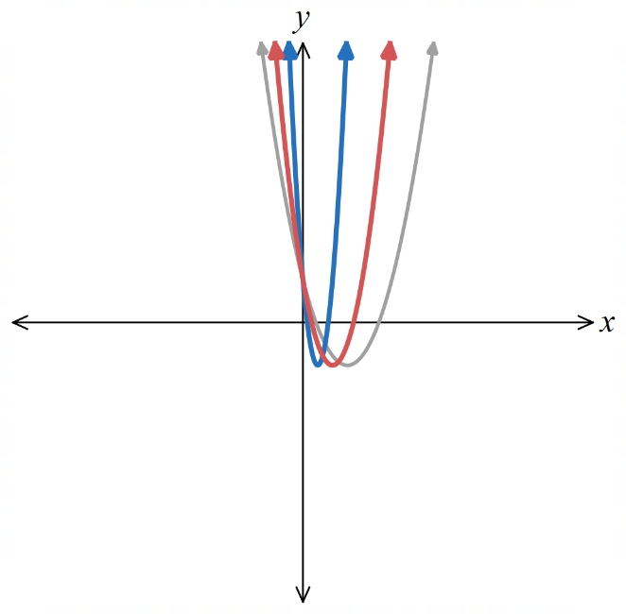  Dilate horizontally by factor $\frac{1}{3}$,then dilate horizontally by factor $2$.  $$y=f\left(x\right)$$  $$y=f\left(3x\right)$$  $$y=f\left(\frac{3x}{2}\right)$$
Two dilations can be applied in any order.

- Investigation Order of transformations
Dilations and Reflections
Dilate horizontally by factor $2,$  then reflect horizontally.  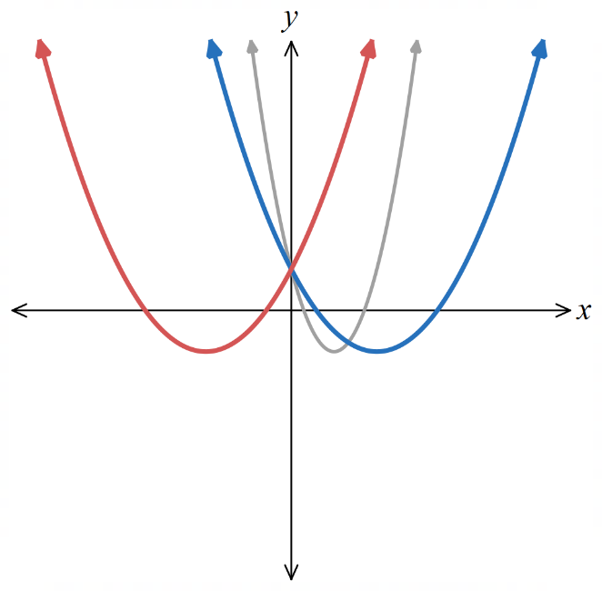  $y=f\left(x\right)$  $$y=f\left(\frac{x}{2}\right)$$  $$y=f\left(-\frac{x}{2}\right)$$ | 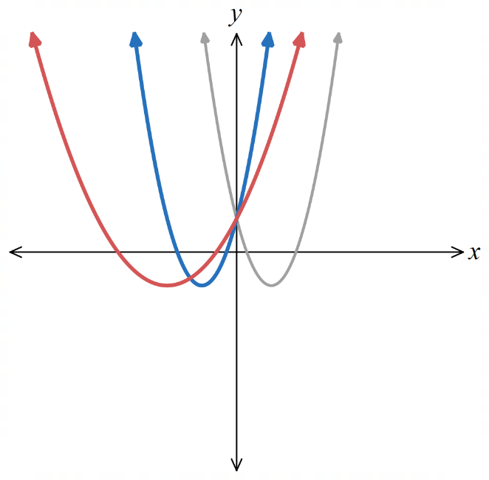  Reflect horizontally,  then dilate horizontally by factor $2$.  $$y=f\left(x\right)$$  $$y=f\left(-x\right)$$  $$y=f\left(-\frac{x}{2}\right)$$
Since reflections are just a dilation of factor $-1$, this is the same as two dilations.
They can be applied in any order.

Two Translations
Translate left by $2$,  then right by $5$.  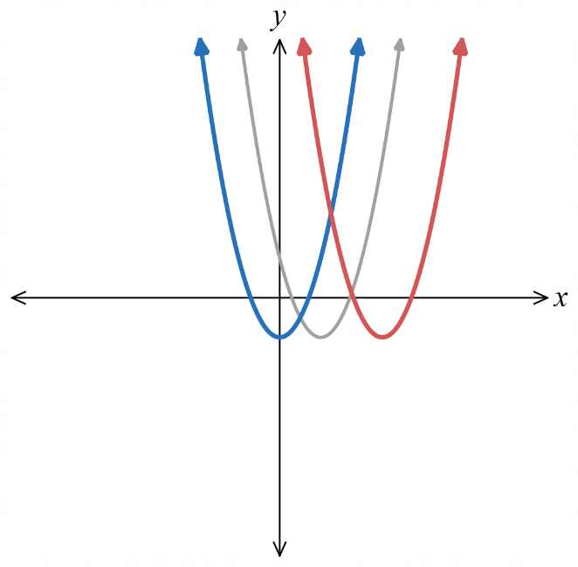  $y=f\left(x\right)$  $$y=f\left(x+2\right)$$  $$y=f\left(x-5+2\right)$$ | 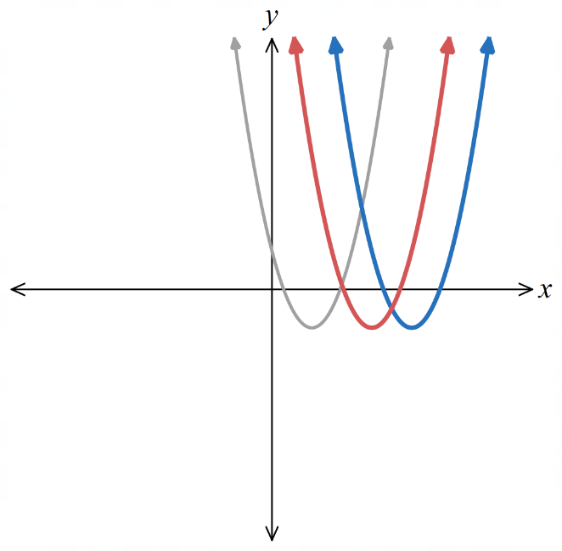  Translate right by $5,$  then left by $2$.  $$y=f\left(x\right)$$  $$y=f\left(x-5\right)$$  $$y=f\left(x+2-5\right)$$
Two translations can be applied in any order.

- Key Ideas
- Two transformations are commutative if they can be applied in any ………………
- Two transformations are always commutative if one is h……………… and the other v………………
- Transformations are commutative if they are the same ‘type’, e.g. two t……………………, two d………………, or a d………………and a r………………, which is the same as two dilations.

- Investigation Order of transformations
We will now see transformations where order matters.
Reflect vertically,  then translate 3 units up.  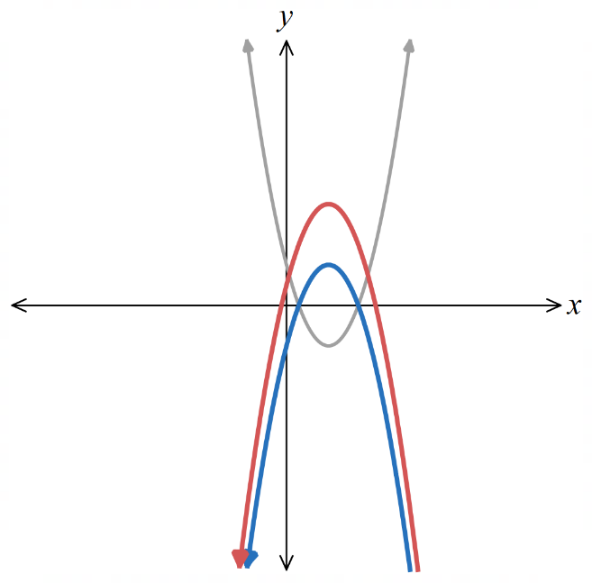  $y=f\left(x\right)$  $$-y=f\left(x\right)$$  $$-(y-3)=f\left(x\right)$$ | 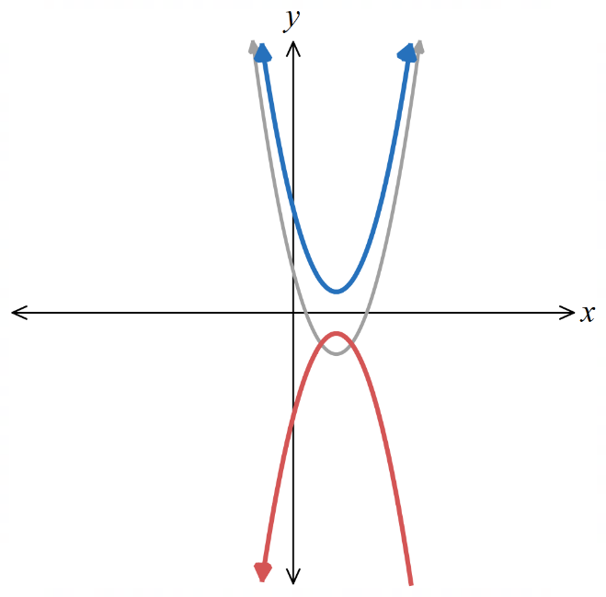  Translate 3 units up,  then reflect vertically.  $$y=f\left(x\right)$$  $$y-3=f\left(x\right)$$  $$-y-3=f\left(x\right)$$
A dilation and a translation does not commute.
When you translate first, then dilate, the translation distance is scaled by the dilation factor.

Order matters when using a $10 off coupon and a 50% off coupon!

Dilate horizontally by factor $2$,  then translate 6 units left.  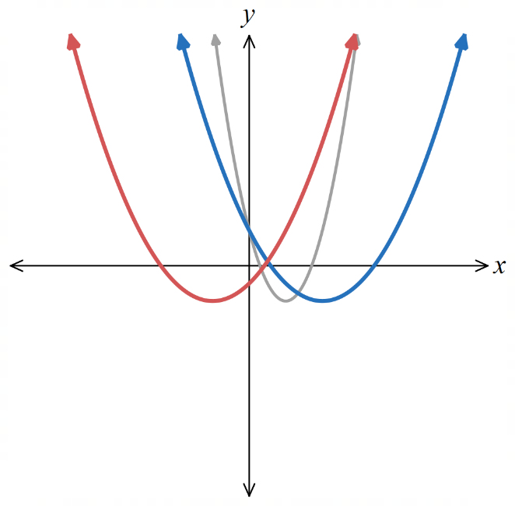  $y=f\left(x\right)$  $$y=f\left(\frac{x}{2}\right)$$  $$y=f\left(\frac{x+6}{2}\right)$$ | 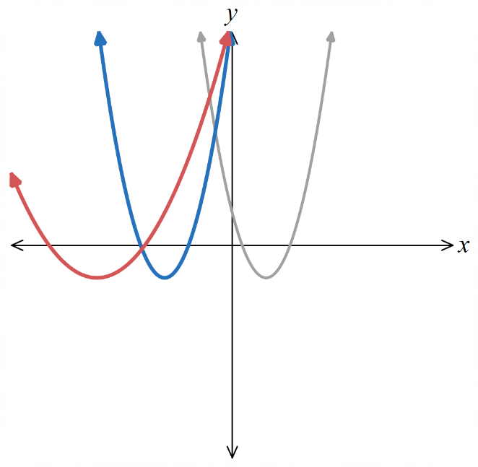  Translate 6 units left,  then dilate horizontally by factor $2$,  $$y=f\left(x\right)$$  $$y=f\left(x+6\right)$$  $$y=f\left(\frac{x}{2}+6\right)$$
A reflection is a type of dilation, so a reflection and translation does not commute.

Adding 5, then making the result negative is different to making a number negative, then adding 5.

- Key Ideas
- A dilation/reflection and a translation do not commute, if they are both horizontal or both vertical.

- Example Find the equation given a combination of transformations
The curve $y=\sqrt{2x+3}$ is dilated horizontally by a factor of 3 then translated to the right by 4.
Find the equation of the transformed graph.
$$x↦\frac{x}{3}$$
$$y=\sqrt{\frac{2x}{3}+3}$$
$$x↦x-4$$
$$y=\sqrt{\frac{2\left(x-4\right)}{3}+3} \\ =\sqrt{\frac{2x-8+9}{3}} \\ =\sqrt{\frac{2x+1}{3}}$$

- Guided Practice
The curve $y={\left(2x+1\right)}^{2}$ is horizontally dilated by factor $\frac{1}{3}$ and translated 2 units right.
Find the equation of the transformed graph.

$$y = {\left(6x - 11\right)}^{2}$$
The curve $y=$ $\frac{x^{2}}{5}$ is translated 3 units up and vertically dilated by factor 4.
Find the equation of the transformed graph.

$$y =\frac{4x^{2}}{5}+ 12$$

- Identifying the Transformations from the Equation
- Write the function in the form
$$\frac{y-c}{k}=f\left(a\left(x-b\right)\right)$$
- Identify the transformations:
  - The vertical transformations are in this order:
Dilate by factor $k$
Translate right by $c$

  - The horizontal transformations are in this order:
Dilate by factor $\frac{1}{a}$
Translate right by $b$

- Remember that a negative dilation factor means a reflection.
- You can do all vertical transformations first, or all horizontal transformations first, since they are independent.
- There is always more than one correct sequence.
To avoid making mistakes, always follow this method to find a valid sequence.

- Example Find the transformations, given the equation
Describe a sequence of transformations that transforms $y=f\left(x\right)$ to $y=f\left(2x+6\right)$.
1. Rewrite
$$y=f\left(2\left(x+3\right)\right)$$
2. Identify
Horizontal dilation by factor $\frac{1}{2}$, then translate left by $3$

- Guided Practice
Describe a sequence of transformations that transforms $y=f\left(x\right)$ to:
- $y=f\left(3x-5\right)$  Horizontal dilation by factor 1/3, then translation 5/3 units right | - $y=f\left(3-x\right)$  Reflection in y-axis, then translation 3 units right
- $y=f\left(\frac{x-2}{3}\right)+5$  Horizontal dilation by factor 3, translation 2 units right, translation 5 units up | - $y=7f\left(\frac{3-2x}{3}\right)+1$  Horizontal dilation by factor 3/2, reflection in y-axis, translation 9/2 units right, vertical dilation by factor 7, translation 1 unit up
- Sketching the Transformation from a Graph
- Write the function in the form
$$\frac{y-c}{k}=f\left(a\left(x-b\right)\right)$$
- Identify the transformations:
  - The vertical transformations are in this order:
Dilate by factor $k$
Translate right by $c$

  - The horizontal transformations are in this order:
Dilate by factor $\frac{1}{a}$
Translate right by $b$

- Sketch the new graph, applying the transformations to key coordinates.

- Example Sketch the transformation, given the graph
Given $y=f\left(x\right),$sketch $y=f\left(2x-6\right)$.
$$y=f\left(2\left(x-3\right)\right)$$
Horizontal dilation by factor $\frac{1}{2}$, then translate right by $3$
$y=f\left(x\right)$ $y=f\left(2x\right)$ $y=f\left(2(x-3)\right)$
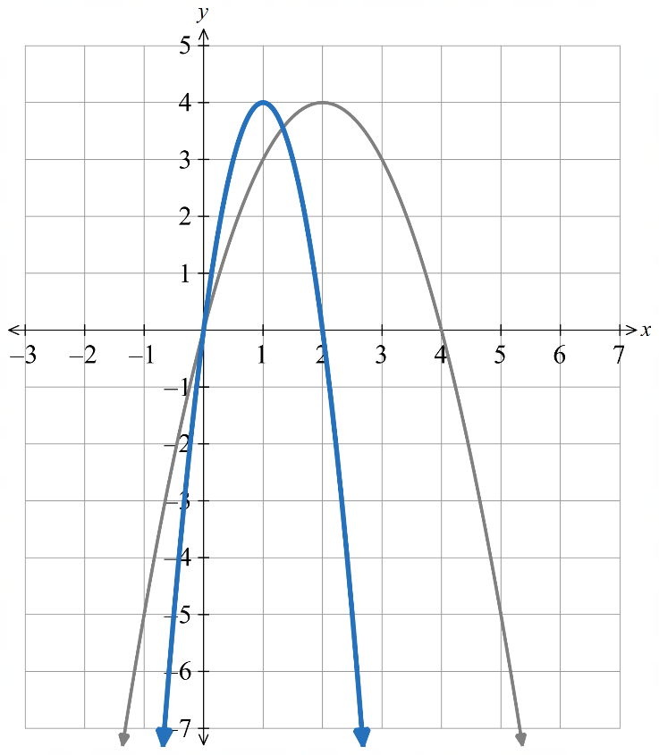
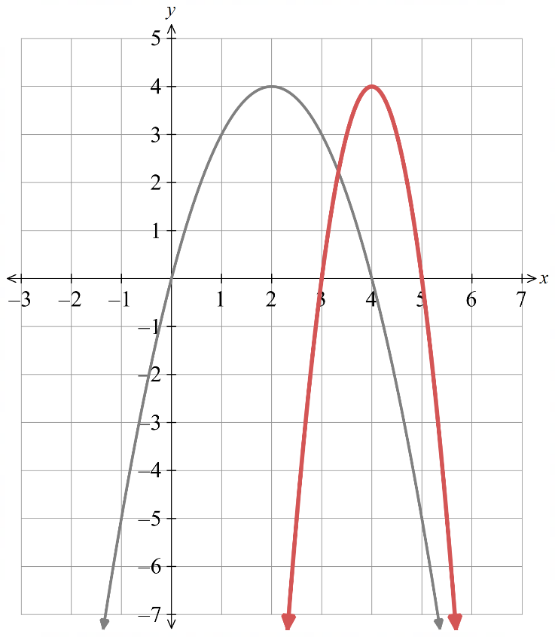
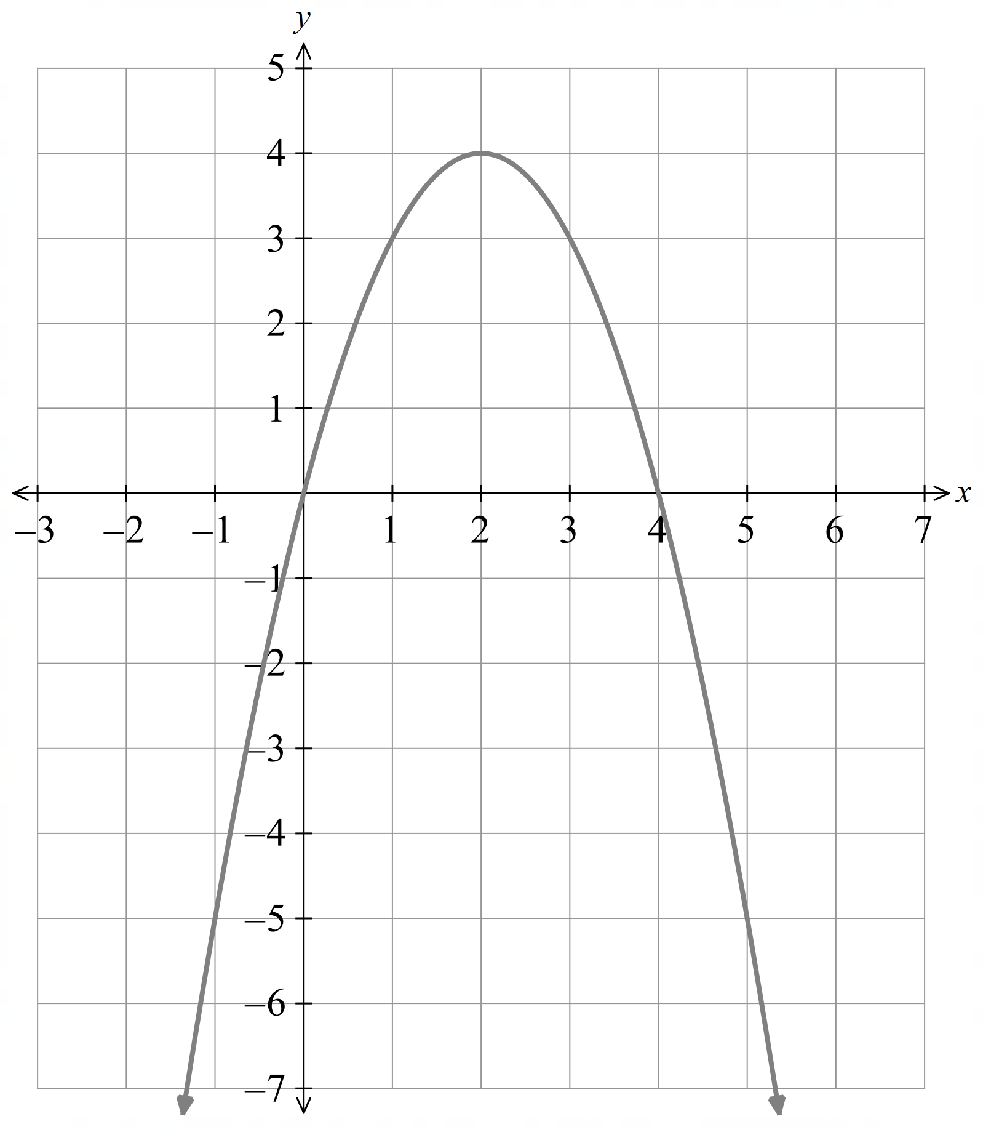

- Guided Practice
Given $y=f\left(x\right),$sketch:
- $y=2f\left(x\right)+1$  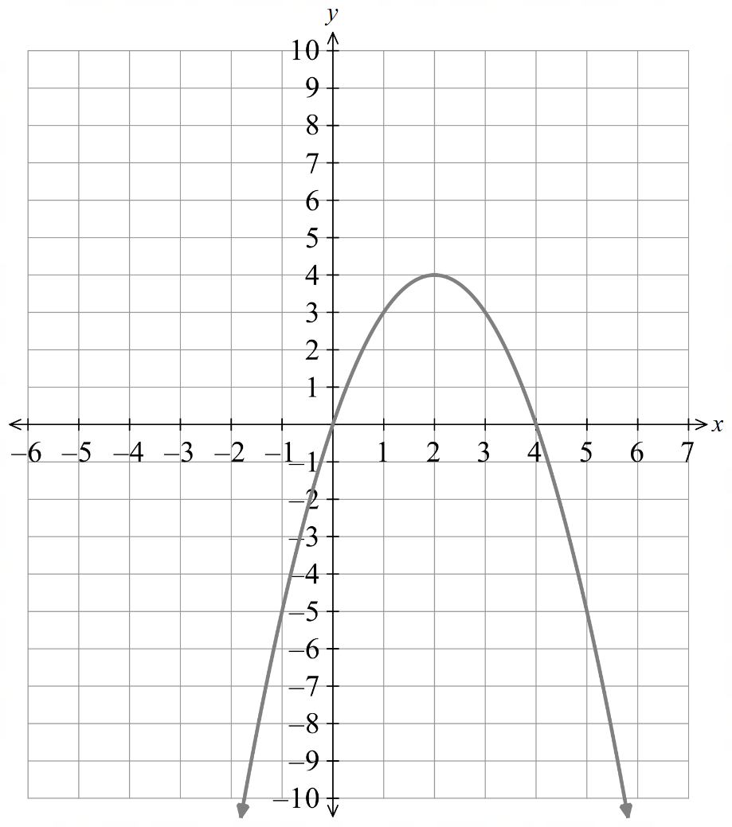 | - $y=f\left(\frac{x}{2}+1\right)$  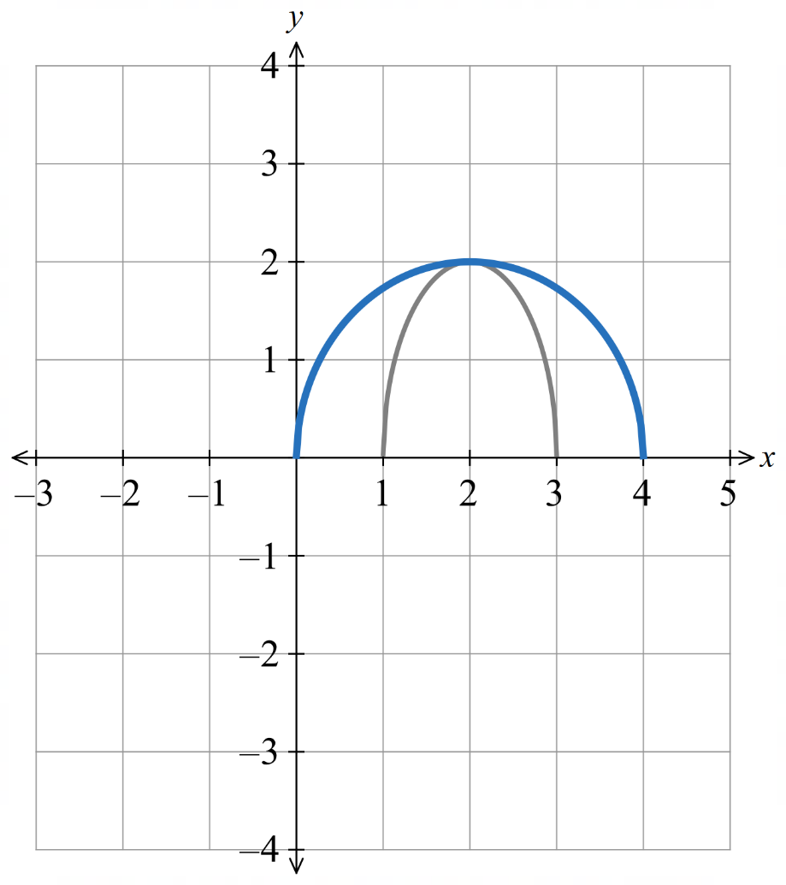  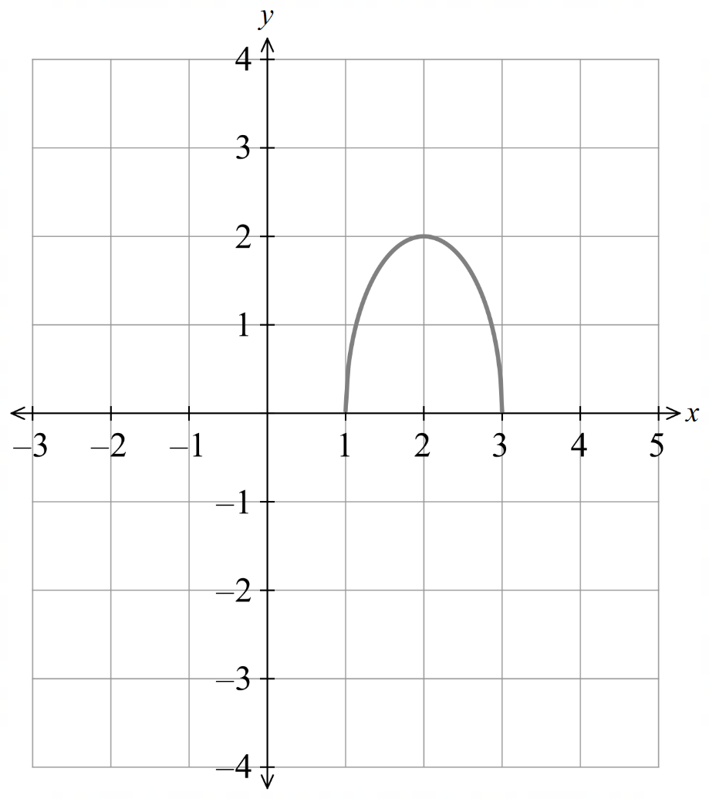  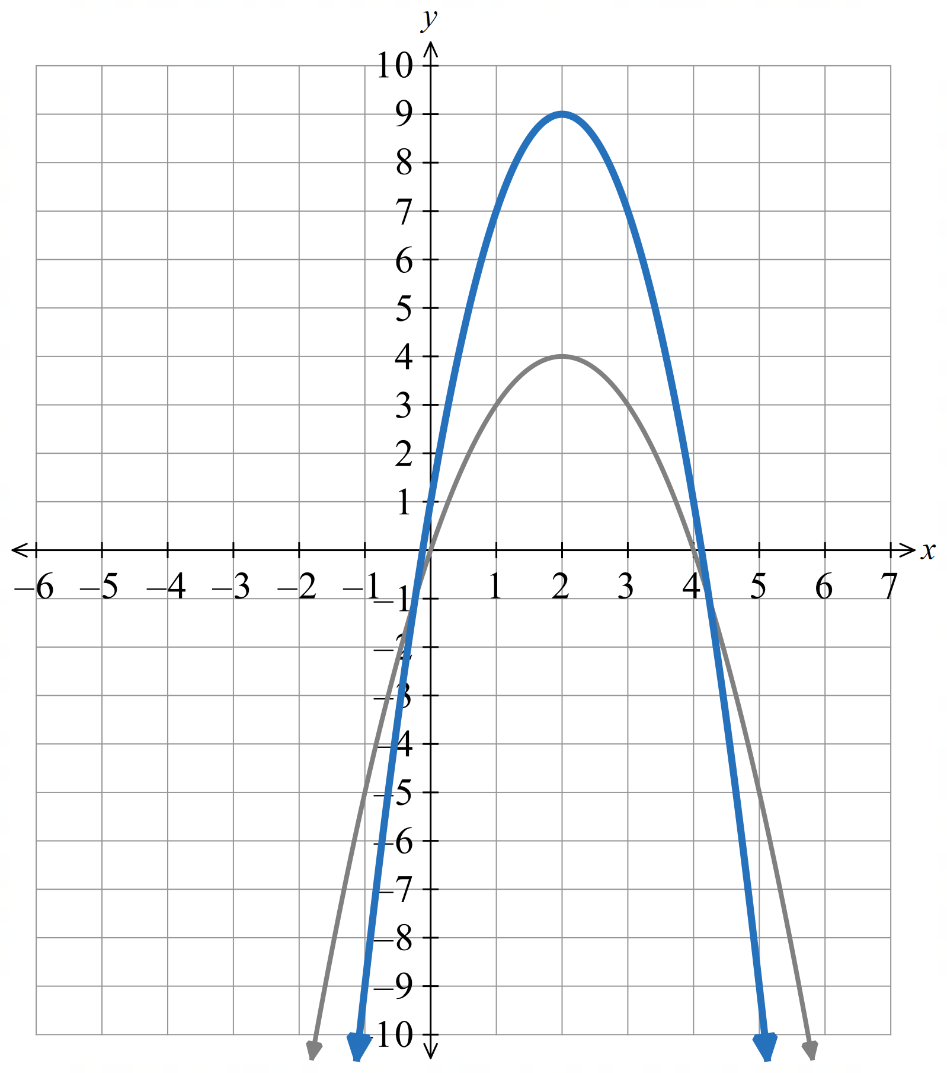
- $y=-f\left(x-2\right)+3$  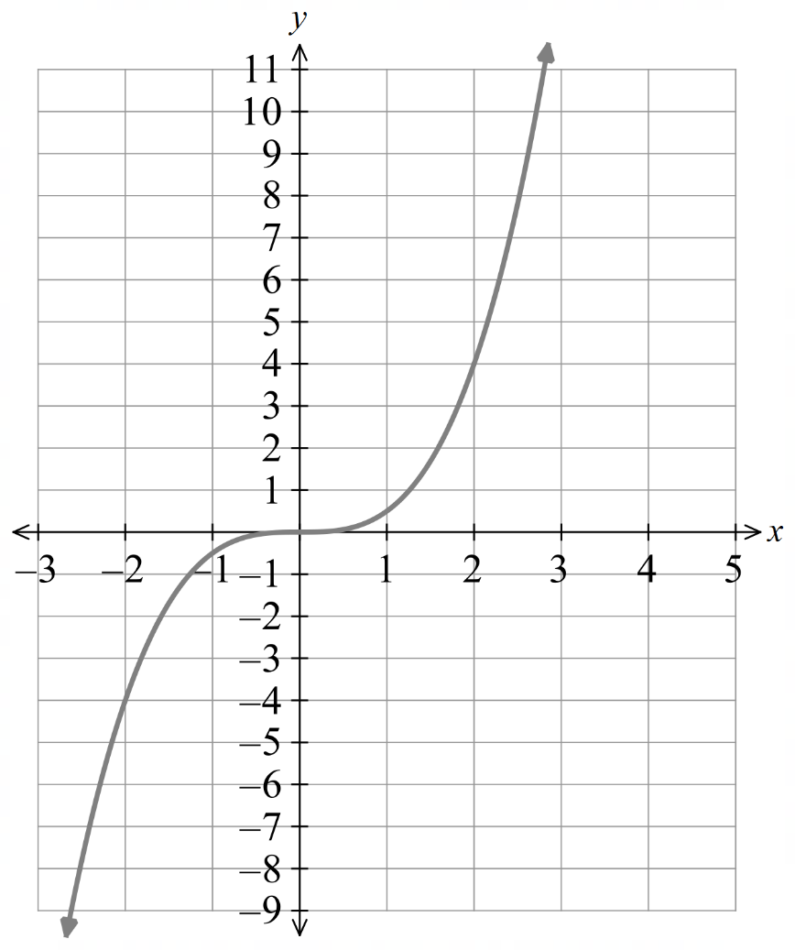  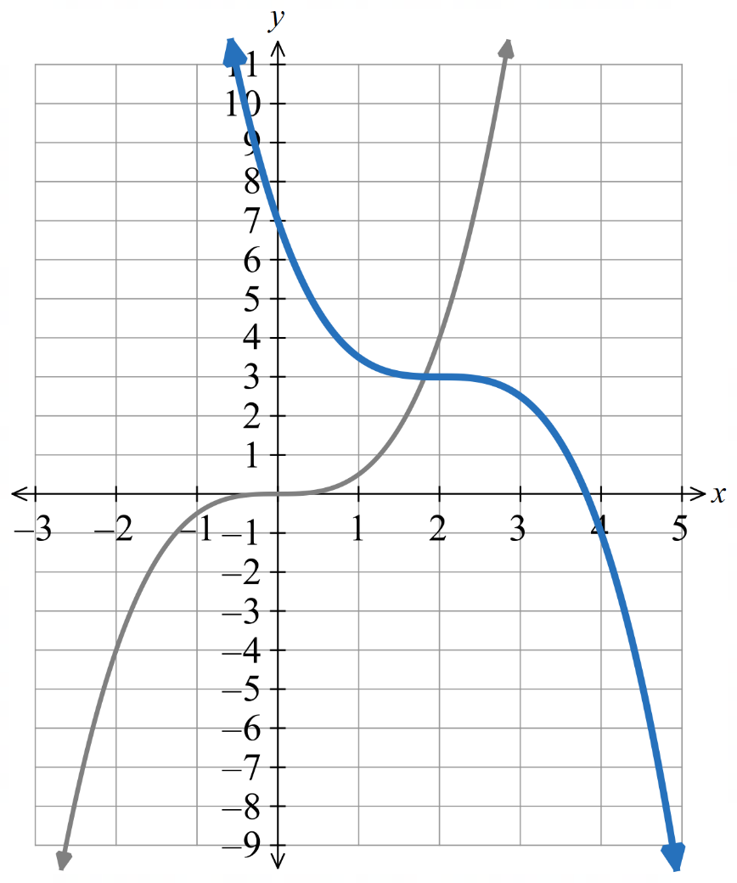 | - $y=3f\left(1-2x\right)$  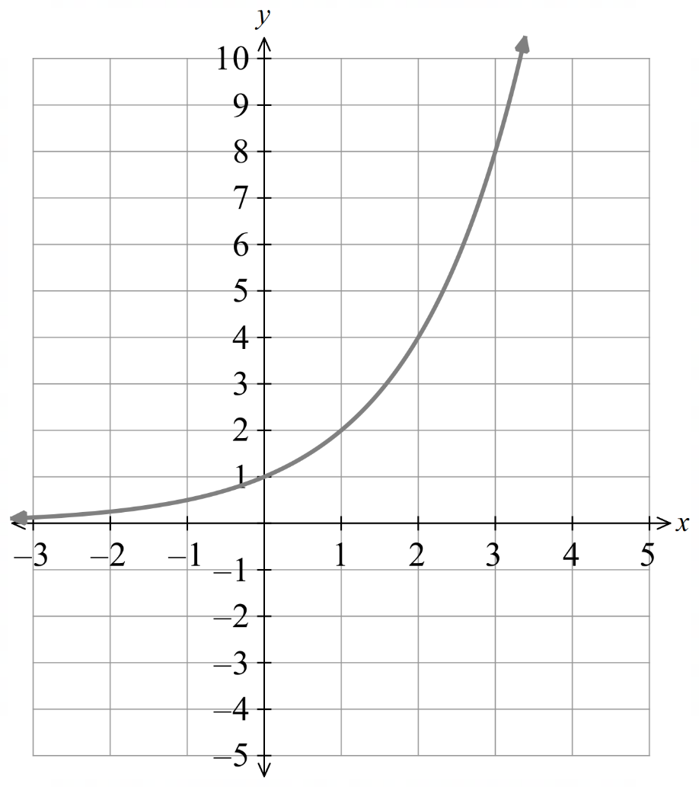  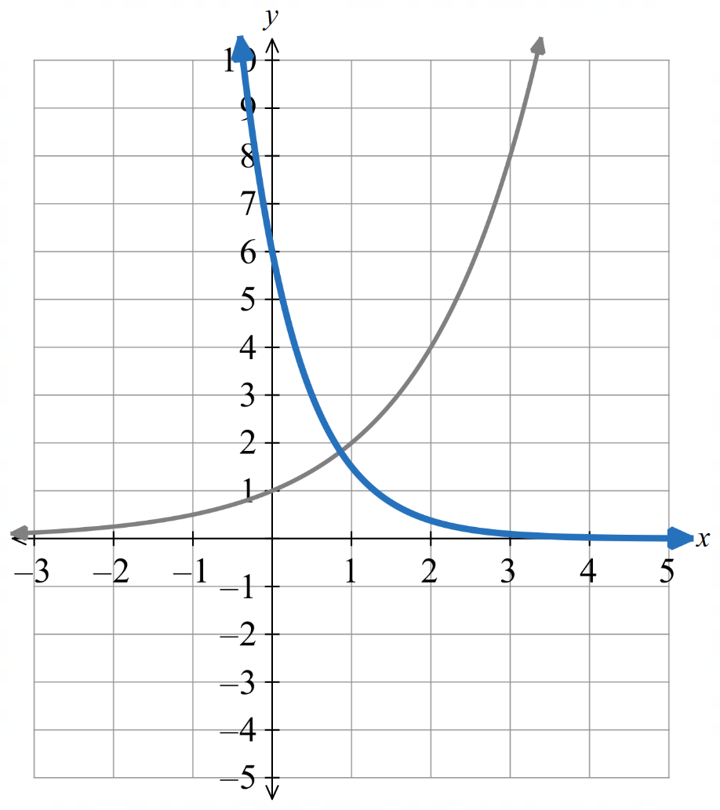

Foundation
- Find the equation of each transformed function.
  - $y=x³$ is translated 3 units down and 4 units to the left
$$y = {\left(x + 4\right)}^{3}- 3$$
  - $y=|x|$ is translated 9 units up and 1 unit to the right
$$y = \left|x - 1\right|+ 9$$
  - $y=x$ is dilated vertically with a factor of 3 and translated down 6 units
$$y = 3x - 6$$
  - $y={10}^{x}$ is reflected in the x-axis and translated up 2 units
$$y = -10ˣ + 2$$
  - $y=x³$ is horizontally dilated by a factor of $\frac{1}{2}$ and translated down 5 units
$$y = {\left(2x\right)}^{3}- 5$$
  - $y=$ $\frac{1}{x}$ is vertically dilated by a factor of 2 and horizontally dilated by a factor of 3
$$y =\frac{2}{\frac{x}{3}}=\frac{6}{x}$$
  - $y=\sqrt{x}$ is reflected in the y-axis, vertically dilated by a factor of 3 and horizontally dilated by a factor of $\frac{1}{2}$
$$y= 3\sqrt{-2x}$$
  - $y=ln x$ is horizontally dilated by a factor of 3 and translated upwards by 2 units
$$y = ln\left(\frac{x}{3}\right)+ 2$$
  - $y=\log_{2}{x}$ is horizontally dilated by a factor of 1/4 and vertically dilated by a factor of 3
$$y = 3 log₂(4x)$$
  - $y=x²$ is horizontally dilated by a factor of 2 and translated down 3 units
$$y = {\left(\frac{x}{2}\right)}^{2}- 3$$

- Write the new equation for each function or relation after the given transformations have been applied. Draw a graph of the image.
- $y = x²:$ right 2 units, then dilate by a factor of $\frac{1}{2}$ horizontally  $$y = 4(x - 1)²$$ | - $y = 2ˣ$: down 1 unit, then reflect across the $y$-axis  $$y = 2⁻ˣ - 1$$
- $y = x² - 1$: down 3 units, then dilate by a factor of −1 vertically  $$y = 4 - x²$$ | - $y =$ $\frac{1}{x}$: right 3 units, then dilate by a factor of 2 vertically  $$y =\frac{2}{x - 3}$$
- $x² + y² = 4$: up 2 units, then dilate by a factor of $\frac{1}{2}$ vertically  $$x^{2}+ 4{\left(y - 1\right)}^{2}= 4$$ | - $y = \sqrt{x}$: up 2 units, then dilate by a factor of −1 horizontally  $$y = \sqrt{-x}+ 2$$

- Which of the following pairs of transformations commute?
  - reflection in the $y$-axis and horizontal translation
  - vertical dilation and vertical translation
  - vertical dilation and reflection in the $x$-axis
  - horizontal translation and vertical translation
  - horizontal dilation and horizontal translation
  - reflection in the $x$-axis and horizontal translation
C, D, F commute
- Consider the graph of $y = x²$.
  - Write down the equation of the graph when it is translated right by 1 unit.
$$y={\left(x-1\right)}^{2}$$
  - Write down the new equation if the graph is then dilated horizontally by a factor of $\frac{1}{2}$.
$$y={\left(2x-1\right)}^{2}$$
  - Complete the following set of steps that were followed in the previous parts.
$x² \overset{→}{Translate} (x -$ …… $)² \overset{→}{Dilate}($…… $- 1)²$
$${\left(x-1\right)}^{2}, {\left(2x-1\right)}^{2}$$
  - Complete the following set of steps if we instead first dilate and then translate.
$x² \overset{→}{Dilate} ($………)² $\overset{→}{Translate}$ (…………)²
$${\left(2x\right)}^{2}, {\left(2x-2\right)}^{2}$$
  - From the above, did the order matter or did you end up with the same curve doing it either way?
The order matters

Development
- Consider the graph of $y =$ $\frac{1}{x}$. Find the equation of the final graph if $y =$ $\frac{1}{x}$ is
  - translated left by 2 units, then dilated horizontally by $\frac{1}{3}$.
$$y=\frac{1}{3x+2}$$
  - dilated horizontally by $\frac{1}{3}$, then translated left by 2 units.
$$y=\frac{1}{3x+6}$$
  - translated right by 5 units, then dilated horizontally by 2.
$$y=\frac{2}{x-10}$$
  - dilated horizontally by 2 units, then translated right by 5.
$$y=\frac{2}{x-5}$$

- Find the equation of the final curve in the form $y=f(ax+b)$ if $y=f(x)$ is
  - translated right by 2 units, then dilated horizontally by a factor of $\frac{1}{3}$.

$$y=f\left(3x-2\right)$$
  - translated left by 3 units, then dilated horizontally by a factor of 2.

$$y=f\left(\frac{x}{2}+3\right)$$
- Find the equation of the final curve in the form $y=f(ax+b)$ if $y=f(x)$ is
  - Dilated horizontally by $\frac{1}{2}$, then translated left by 1 unit.

$$y=f\left(2x+2\right)$$
  - Dilated horizontally by 3, then translated right by 6 units.

$$y=f\left(\frac{x}{3}-2\right)$$
- Consider the graph of $y=\sqrt{x}$. Find the equation of the final graph if $y=\sqrt{x}$ is
  - translated right by 3 units, then reflected across the $y$-axis.
$$y=\sqrt{-x-3}$$
  - reflected across the $y$-axis, then translated right by 3 units.
$$y=\sqrt{3-x}$$
  - translated left by 2 units, then reflected across the $y$-axis.
$$y=\sqrt{-x+2}$$
  - reflected across the $y$-axis, then translated left by 2 units.
$$y=\sqrt{-x-2}$$

- Find the equation of the final graph if $y=f(x)$ is transformed in the following order.
  - Translated right by 1 unit,
dilated horizontally by a factor of 2,
reflected across the $y$-axis.
$$y=f\left(-\frac{1}{2}x-1\right)$$
  - Translated right by 1 unit,
reflected across the $y$-axis,
dilated horizontally by a factor of 2.
$$y=f\left(-\frac{1}{2}x-1\right)$$
  - Reflected across the $y$-axis,
dilated horizontally by a factor of 2,
translated right by 1 unit.
$$y=f\left(-\frac{1}{2}\left(x-1\right)\right)$$
  - Reflected across the y-axis,
translated right by 1 unit,
dilated horizontally by a factor of 2.
$$y=f\left(-\frac{1}{2}x+1\right)$$
  - Dilated horizontally by a factor of 2,
translated right by 1 unit,
reflected across the $y$-axis.
$$y=f\left(-\frac{1}{2}x-\frac{1}{2}\right)$$
  - Dilated horizontally by a factor of 2,
reflected across the $y$-axis,
translated right by 1 unit.
$$y=f\left(-\frac{1}{2}x+\frac{1}{2}\right)$$
- Describe the transformations to y = x³ in the correct order if the transformed function has equation:
- $y=(x-1)³+7$  Horizontal translation 1 unit to the right,  vertical translation 7 units up | - $y=4x³-1$  Vertical dilation factor 4,  vertical translation 1 unit down
- $y=-5x³-3$  Vertical dilation factor 5,  vertical reflection,  vertical translation 3 units down | - $y=2(x+7)³$  Vertical dilation factor 2,  horizontal translation 7 units to the left
- $y=6(2x-4)³+5$  Rewrite as $y = 6[2(x - 2)]³ + 5$.  Horizontal dilation factor $\frac{1}{2}$,  vertical dilation factor 6,  horizontal translation 2 units to the right,  vertical translation 5 units up | - $y=2(3x+9)³-10$  Rewrite as $y = 2[3(x + 3)]³ - 10$.  Horizontal dilation factor $\frac{1}{3}$,  vertical dilation factor 2,  horizontal translation 3 units to the left,  vertical translation 10 units down
- For the following forms, determine two ways that a dilation and translation can be used to obtain the required form.
For example, the form $f(2x - 4)$ can be obtained two ways:
$$f(x) \overset{→}{translate right by 4}f(x-4)\overset{→}{horizontal dilation factor \frac{1}{2} } f(2x - 4)$$
$$f\left(x\right)\overset{→}{horizontal dilation factor \frac{1}{2} }f\left(2x\right)\overset{→}{translate right by 2} f\left(2\left(x-2\right)\right)=f\left(2x-4\right)$$
- $f(2x + 4)$  Translate left by 4 then dilate horizontally by factor $\frac{1}{2}$  Dilate horizontally by factor $\frac{1}{2}$ then translate left 2 | - $f(3x - 2)$  Translate right 2 then dilate horizontally by factor $\frac{1}{3}$  Dilate horizontally by factor $\frac{1}{3}$ then translate right $\frac{2}{3}$
- $f(2x - 1)$  Translate right by 1 then dilate horizontally by factor $\frac{1}{2}$  Dilate horizontally by factor $\frac{1}{2}$ then translate right $\frac{1}{2}$ | - $f(3x + 1)$  Translate left by 1 then dilate horizontally by factor of $\frac{1}{3}$  Dilate horizontally by factor $\frac{1}{3}$ then translate left $\frac{1}{3}$

- Jimmy is given a function $y=f(x)$ and is instructed to transform it into $y=f(1-2x)$.
Describe a possible sequence of transformations so that Jimmy can obtain $y=f(1-2x)$ from $y=f(x)$, if the sequence must begin with a:
  - translation.

Translate left by 1, dilate horizontally by $\frac{1}{2}$, then reflect horizontally
  - reflection.

Reflect horizontally, translate right by 1, dilate horizontally by $\frac{1}{2}$
  - dilation.

dilate horizontally by $\frac{1}{2}$, reflect horizontally, translate right $\frac{1}{2}$

Mastery
- The point $(x, y) = (8, -12)$ lies on the function $y = f(x).$
Find the coordinates of the image point when the function is transformed into:
  - $y=3f\left(x - 1\right)+5$
Horizontal 1 right
Vertical dilation factor 3, 5 up
$$\left(9, -31\right)$$
  - $y=-f\left(2x\right)-7$
Horizontal dilation factor $\frac{1}{2}$
Vertical reflection, 7 down
$$(4, 5)$$
  - $y=2f\left(x+3\right)-1$
Horizontal 3 left
Vertical dilation factor 2, 1 down
$$(5, -25)$$
  - $y=6f\left(-x\right)+5$
Horizontal reflection
Vertical dilation factor 6, 5 up
$$(-8, -67)$$
  - $y=-2f\left[2\left(x-2\right)\right]-3$
$$y=-2f\left[2\left(x-2\right)\right]-3$$
Horizontal dilation factor $\frac{1}{2}$, 2 right
Vertical dilation factor 2, vertical reflection, 3 down
$$(6, 21)$$

- The diagram shows $y=f\left(x\right)$.
First describe the transformations in $y=f\left(2x-1\right)$ and sketch the new curve.
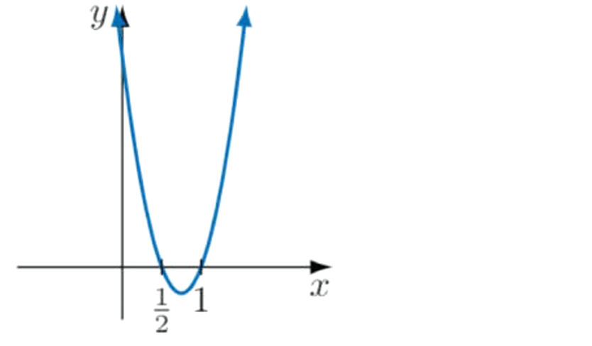
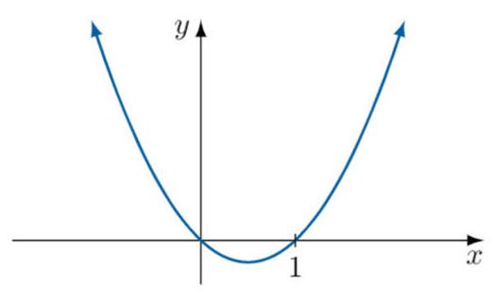

$$y=f\left(2\left(x-\frac{1}{2}\right)\right)$$
Horizontal dilation factor $\frac{1}{2}$, translate right by $\frac{1}{2}$
Alternatively, translate right 1, horizontal dilation factor $\frac{1}{2}$

- The diagram shows $y=f\left(x\right)$.
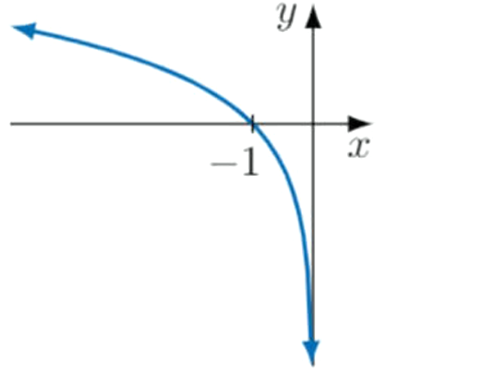
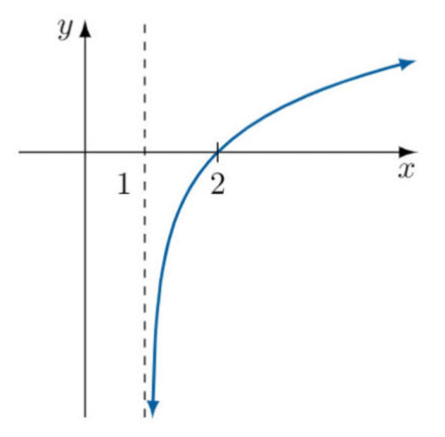
First describe the transformations in $y=f\left(1-x\right)$ and sketch the new curve.

$$y=f\left(-\left(x-1\right)\right)$$
Horizontal reflection, translate 1 right
Alternatively, translate left 1, then horizontal reflection

- The diagram shows $y=f\left(x\right)$.
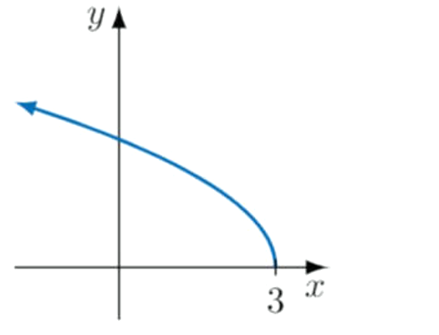
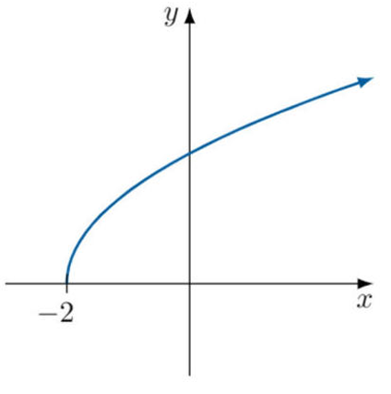
First describe the transformations in $y=f\left(4-2x\right)$ and sketch the new curve.

$$y=f\left(-2\left(x-2\right)\right)$$
Horizontal dilation factor $\frac{1}{2}$, horizontal reflection, translate 2 right
Alternatively, translate 4 left, horizontal reflection, Horizontal dilation factor $\frac{1}{2}$

Exam Questions
- 2025 HSC Advanced Band 3
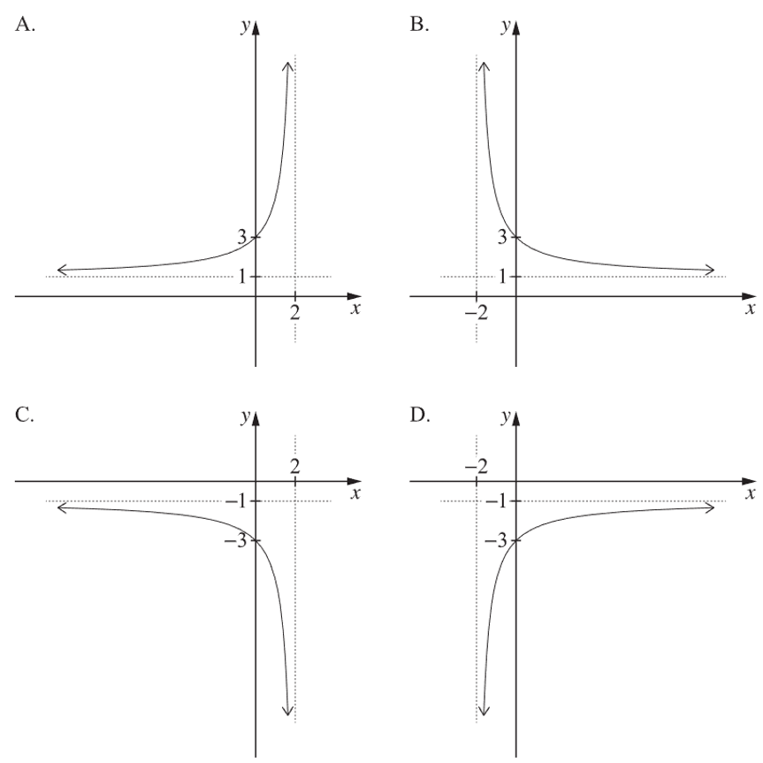
The graph of $y = f(x)$ is shown. Which is the graph of $y=-f\left(-x\right)$?
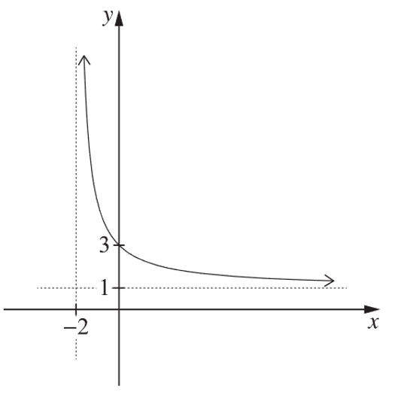

D
- HSC Advanced Sample Question Band 3
The point $P(4, -3)$ lies on the graph of a function $f(x)$. The graph of $f(x)$ is translated four units vertically up and then reflected in the y-axis.
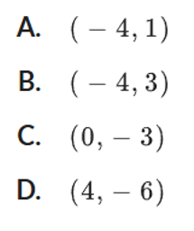
The coordinates of the final image of P are:

A
- HSC Advanced Sample Question Band 4
The graph of a function $f(x)$ is obtained from the graph of the function $g(x) = \sqrt{2x - 5}$ by a reflection in the $x$-axis followed by a dilation from the $y$-axis by a factor of $\frac{1}{2}$.
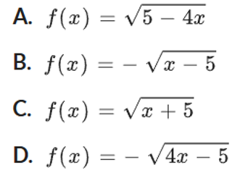
Which one of the following is the function $f(x)?$

$$-f\left(x\right)=\sqrt{2\left(2x\right)-5}$$
D
- HSC Advanced Sample Question Band 4
The graph$y=$ $\frac{2}{x - 2}$ undergoes the following transformations:
- translated 3 units to the left
- dilated vertically by a factor of 2
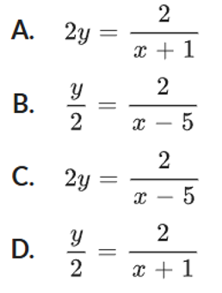
Determine which of the following is the new function.

$$\frac{y}{2}=\frac{2}{\left(x+3\right)-2}$$
- HSC Advanced Sample Question Band 4
The graph of the function $y= 3x^{\frac{5}{2}}$ is reflected in the $x$-axis and then translated 3 units to the right and 4 units down.
The equation of the new graph is:
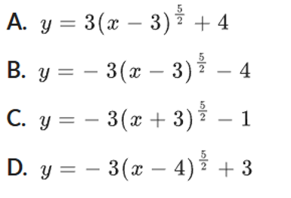

$$-\left(y+4\right)=3{(x-3)}^{\frac{5}{2}}$$
B

- HSC Advanced Sample Question Band 4
$f(x) = \left|x\right|$ is transformed and the equation of the new function is $y = kf\left(x + b\right)+ c.$
The graph of the new function is shown.
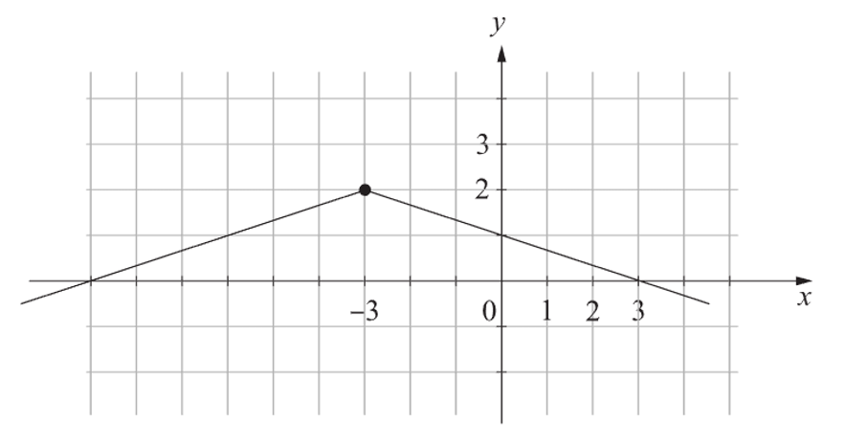
What are the values of $k$, $b$ and $c$?

$$y = \left|x\right|$$
$$Translate 3 units left ⇒ y = \left|x + 3\right|$$
$$Reflect in x axis ⇒ y = -\left|x + 3\right|$$
$$Dilate by\frac{1}{3} from x axis ⇒ y = -\frac{1}{3}\left|x + 3\right|$$
$$Translate 2 units up ⇒ y = -\frac{1}{3}\left|x + 3\right|+ 2$$
$$∴ k = -\frac{1}{3}, b = 3, c = 2$$

- HSC Advanced Sample Question Band 4
List a set of transformations that, when applied in order, would transform $y = x²$ to the graph with equation $y = 1 - 6x - x^{2}$
Complete the square
$$y=-{\left(x+3\right)}^{2}+10$$
Horizontal translation left 3
Vertical reflection, then translation up 10
Other sequences are possible.
E.g. you could translate down 10, then reflect vertically

- HSC Advanced Sample Question Band 4
Let $f(x) = x² - 4$
Let the graph of $g(x)$ be a transformation of the graph of $f(x)$ where the transformations have been applied in the following order:
- dilation by a factor of $\frac{1}{2}$ from the vertical axis (parallel to the horizontal axis)
- translation by two units to the right (in the direction of the positive horizontal axis)
Find $g(x)$ and the coordinates of the horizontal axis intercepts of the graph of $g(x)$.

1st transformation:
$$x↦2x: f\left(2x\right)=4x^{2}-4$$
2nd transformation:
$$x↦x-2:g\left(x\right)=4{\left(x-2\right)}^{2}-4$$

$x$-intercepts: $4{\left(x-2\right)}^{2}-4=0$
$${\left(x-2\right)}^{2}=1$$
$$x-2=±1$$
$$∴x=1,3$$
$\left(1,0\right)$ and $\left(3,0\right)$
- 2024 HSC Advanced Band 5
The parabola $y = (x - 3)² - 2$ is reflected about the $y$-axis.
This is then reflected about the $x$-axis.
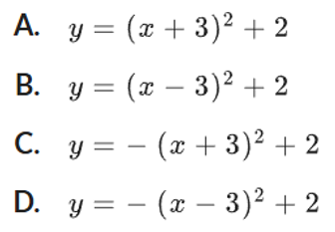
What is the equation of the resulting parabola?

$$-y={\left(-x-3\right)}^{2}-2$$
C

- 2024 HSC Advanced Band 5
The diagram shows the graph $y = f(x)$.
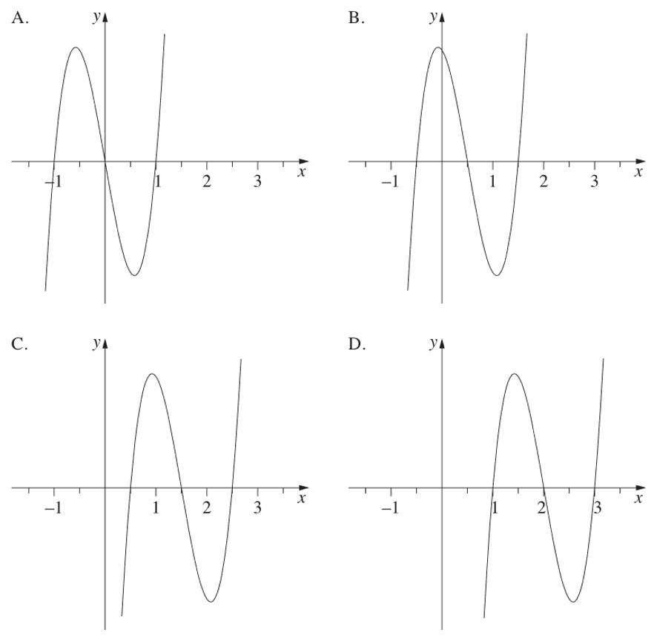
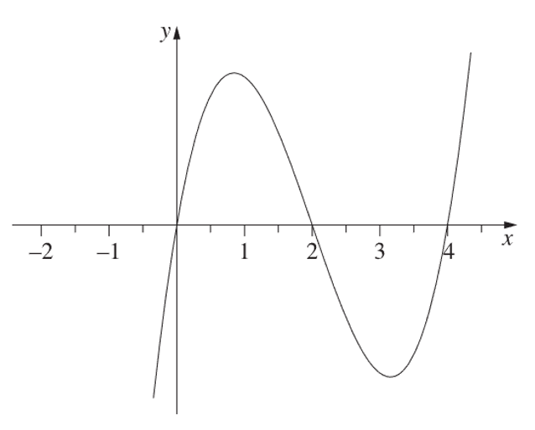
Which of the following best represents the graph $y = f\left(2x - 1\right)$?

Horizontal dilation by factor $\frac{1}{2}$, shift right by $\frac{1}{2}$
C
- HSC Advanced Sample Question Band 5
The transformation that maps the graph of $y=\sqrt{8x^{3}+ 1}$ onto the graph of $y=\sqrt{x^{3}+ 1}$ is a
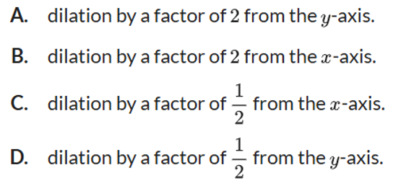

$x$ was replaced by $\frac{x}{2}$
Horizontal dilation by factor 2
A

- HSC Advanced Sample Question Band 5
The curve $y = kx² + c$ is subject to the following transformations
- Translated 2 units in the positive x-direction
- Dilated in the positive y-direction by a factor of 4
- Reflected in the y-axis

The final equation of the curve is $y = 8x² + 32x - 8.$
  - Find the equation of the graph after the dilation.

$$y = kx^{2}+ c$$
Translate 2 units in positive $x$-direction:
$$y = k{\left(x - 2\right)}^{2}+ c$$
Dilate in positive y-direction by factor 4:
$$y = 4k{\left(x - 2\right)}^{2}+ 4c$$
  - Find the values of $k$ and $c$.

$$y = 4k\left(x^{2}- 4x + 4\right)+ 4c$$
$$= 4kx^{2}- 16kx + 16k + 4c$$
Reflect in $y$-axis (swap$x → -x$):
$$y = 4k{\left(-x\right)}^{2}- 16k\left(-x\right)+ 16k + 4c$$
$$= 4kx^{2}+ 16kx + 16k + 4c$$
Equating coefficients:
$$4k = 8; ∴ k = 2$$
$$16k + 4c = -8$$
$$32 + 4c = -8$$
$$∴ c = -10$$
- HSC Advanced Sample Question Band 5
The curve $f(x) = x²$is transformed to $g(x) = 3f[2(x + 2)]$
  - Write the equation of $g(x).$

$$g(x) = 3{\left[2\left(x + 2\right)\right]}^{2}$$
$$= 3 × 4{\left(x + 2\right)}^{2}$$
$$= 12{\left(x + 2\right)}^{2}$$
  - $P(-3, 9)$ lies on $f(x) = x²$
Determine the corresponding co-ordinates of $P$ on the curve $g(x).$

Vertical dilation by factor 3, horizontal dilation by $\frac{1}{2}$, translation left by 2.
∴ Corresponding point = $\left(-\frac{7}{2}, 27\right)$

- 2021 HSC Advanced Band 5
Consider the graph of $y = f\left(x\right)$ as shown.
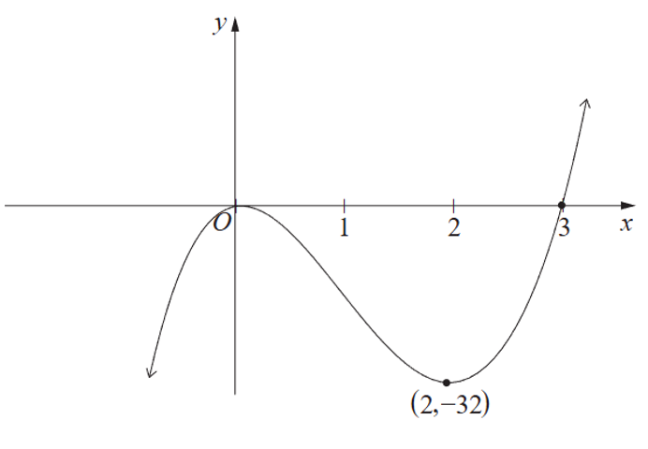
Sketch the graph of $y = 4f\left(2x\right)$ showing the $x$-intercepts and the coordinates of the turning points.
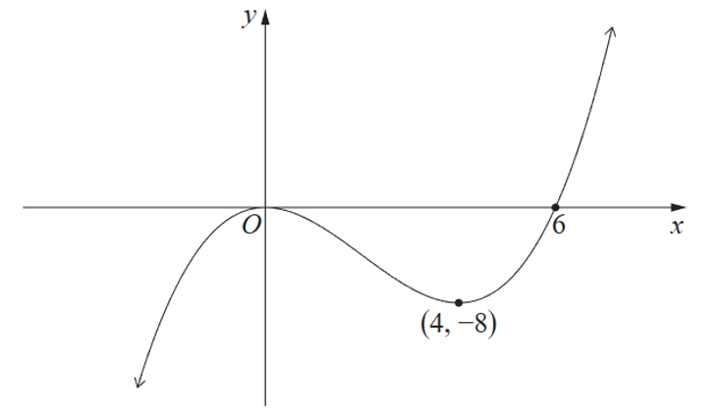

Dilation by factor $\frac{1}{2}$ from $y$-axis: $x$-coordinates halved
Dilation by factor 4 from $x$-axis: $y$-coordinates multiplied by 4

- 2022 HSC Advanced Band 5
The graph of the function $f(x) = x²$ is translated $m$ units to the right, dilated vertically by a scale factor of $k$ and then translated 5 units down. The equation of the transformed function is $g(x) = 3x² - 12x + 7$.
Find the values of $m$ and $k$.
Horizontal translation $m$ units right: $x² → {\left(x - m\right)}^{2}$
Dilated vertically by scale factor $k$: $(x - m)² → k{\left(x - m\right)}^{2}$
Vertical translation 5 units down: $k{\left(x - m\right)}^{2}→ k{\left(x - m\right)}^{2}- 5$
$$y = k{\left(x - m\right)}^{2}- 5$$
$$= k\left(x^{2}- 2mx + m^{2}\right)- 5$$
$$= kx² - 2kmx + \left(km^{2}- 5\right)$$
Comparing with $g\left(x\right)= 3x^{2}- 12x + 7:$
$$k = 3$$
$$-2km = -12$$
$$-2\left(3\right)m = -12$$
$$∴ m = 2$$
- 2025 HSC Advanced Band 5
The parabola with equation $y = \left(x - 1\right)\left(x - 5\right)$ is translated both horizontally to the right and vertically up by $k$ units, where $k$ is positive.
The translated parabola passes through the point $(6, 11)$.
Find the value of $k$.
$$y = (x - 1)(x - 5)$$
Translate $k$ units to the right: $y = \left(x - k - 1\right)\left(x - k - 5\right)$
Translate $k$ units vertically up: $y = \left(x - k - 1\right)\left(x - k - 5\right)+ k$
passes through (6, 11): $11 = \left(6 - k - 1\right)\left(6 - k - 5\right)+ k$
$$11 = \left(5 - k\right)\left(1 - k\right)+ k$$
$$11 = 5 - 6k + k^{2}+ k$$
$$0 = k^{2}- 5k - 6$$
$$0 = \left(k - 6\right)\left(k + 1\right)$$
$$∴ k = 6 \left(k > 0\right)$$
- 2023 HSC Advanced Band 5
The graph of $y = f(x)$, where $f\left(x\right)= a\left|x - b\right|+ c$, passes through the points ($3, -5), (6, 7)$ and $(9, -5)$ as shown in the diagram.
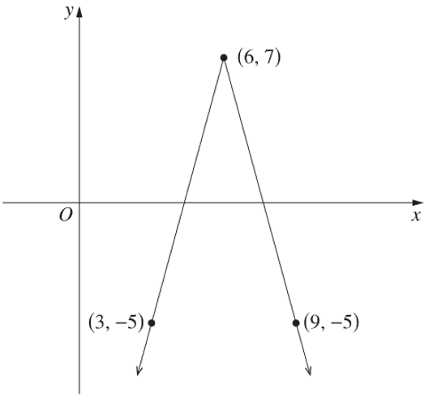

  - Find the values of $a, b$and $c$.
Consider transformation of y = −|x|
Translate 6 units right:
y = −|x| → y = −|x − 6|
∴ b = 6
Translate 7 units up:
y = −|x − 6| → y = −|x − 6| + 7
∴ c = 7
f(x) = a|x − 6| + 7 passes through (3, −5):
−5 = a|3 − 6| + 7
−5 = 3a + 7
3a = −12
∴ a = −4
  - The line $y = mx$ cuts the graph of $y = f(x)$ in two distinct places. Find all possible values of $m$.
$y = mx$ passes through (0, 0)
One solution when $y = mx$ passes through (0, 0) and (6, 7):
$$m =\frac{7 - 0}{6 - 0}=\frac{7}{6}$$
As graph gets flatter and turns negative ⇒ 2 solutions
2 solutions continue until $y = mx$ is parallel to the line joining (6, 7) to (9, −5):
$$m =\frac{7 - \left(-5\right)}{6 - 9}=\frac{12}{-3}= -4$$
$∴$ 2 solutions when $-4 < m <$ $\frac{7}{6}$

- 2013 HSC Advanced Band 6
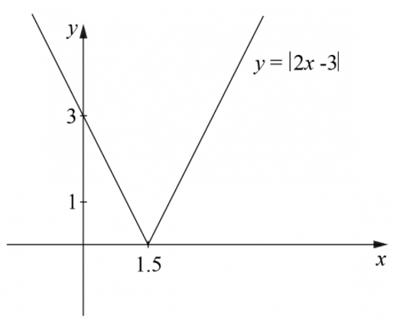
  - Sketch the graph $y = |2x - 3|.$
$$y = |2x - 3|$$
x-intercept: $x =$ $\frac{3}{2}$
y-intercept: $y = 3$
V-shape with vertex at $\left(\frac{3}{2}, 0\right)$

  - Using the graph from part a, or otherwise, find all values of $m$ for which the equation
$\left|2x - 3\right|= mx + 1$ has exactly one solution.
Line of intersection $y = mx + 1$ passes through $(0, 1)$
If it also passes through $\left(\frac{3}{2}, 0\right)$ ⇒ 1 solution
$$m =\frac{1 - 0}{0 -\frac{3}{2}}= -\frac{2}{3}$$
Gradients of $y = |2x - 3|$ are $2$ or $-2$
Considering a line through $(0, 1):$
If $m ≥ 2$, only intersects once.
If $m < -2$, only intersects once.
∴ Only one solution when $m = -\frac{2}{3}, m ≥ 2$ or $m < -2$

